COUNCIL ASSESSMENT REPORT

DEVELOPMENT SERVICES

APPLICATION FOR DEVELOPMENT APPROVAL



|  |  |
| --- | --- |
| ***APPLICATION SUMMARY*** | |
| **Division:** | 2 |
| **Applicant:** | Ms AF Holloway, BW Morrisson Tte |
| **Consultant:** | NA |
| **Proposal:** | Development Permit for Material Change of Use (additional shop area for the purposes of an art gallery and caretakers residence) |
| **Properly Made Date:** | 23/01/2018 |
| **Street Address:** | 1 Roderick St MOFFAT BEACH |
| **RP Description:** | Lot 102 RP 8430 |
| **Assessment Type:** | Code |
| **Number of Properly Made Submissions:** | Not Applicable - Code Assessable |
| **State Referral Agencies:** | Not Applicable. |
| **Referred Internal Specialists:** | * Development Engineer * Environment Office * Urban Designer |

**PROPOSAL:**

The application seeks approval for a Development Permit for Material Change of Use (additional shop area for the purposes of a gallery). The application also proposes modifications to a caretakers residence on site.

The site is within the Local centre zone.

There is an existing shop, and until very recently, an existing caretakers residence on the site.

The existing shop (gallery) and caretakers residence are acknowledged to have ‘existing use rights’. The existing shop has an area of 78.3m². The caretakers residence has recently been demolished (but is a code assessable use in the zone).

The shop extension is comprised of three tenancies set behind the existing gallery with a combined total floor area of 137m².

The caretakers residence would comprise 3 bedrooms and be situated above the new gallery spaces.

Car parking spaces and motorcycle/bicycle parking is required to be provided. The only location for this is at the rear of the site, with access provided over an access easement on an adjoining lot.

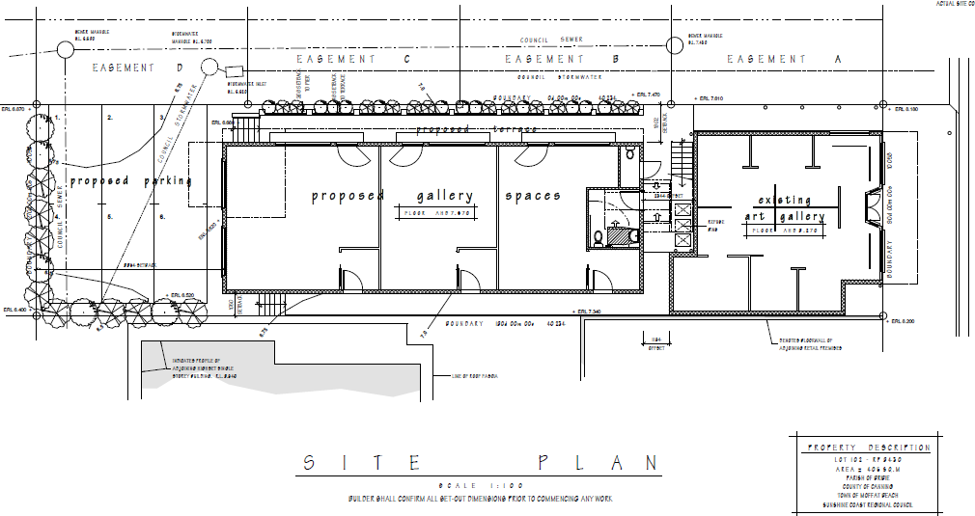

Figure : Site Plan

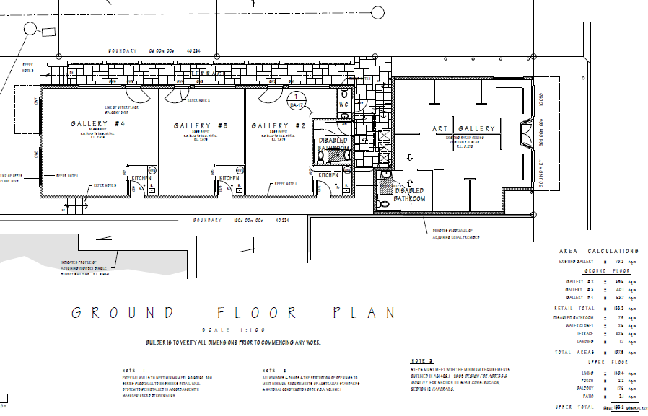

Figure : Ground Floor (gallery) Plan

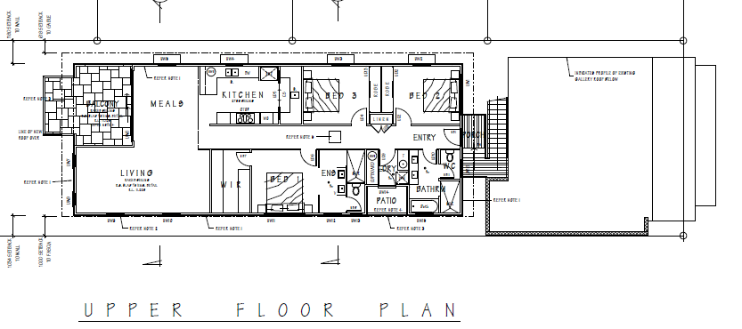

Figure : Upper Floor (caretakers residence) Plan

**SITE DETAILS:**

Site Features and Location

|  |  |
| --- | --- |
| ***SITE AND LOCALITY DESCRIPTION*** | |
| **Land Area:** | 405m² |
| **Existing Use of Land:** | Art gallery with caretakers residence (recently demolished) |
| **Road Frontage:** | Approximately 10m to Roderick Street |
| **Significant Site Features:** | Nil |
| **Topography:** | Generally flat |
| **Surrounding Land Uses:** | Mixture of commercial and residential uses. |

The location of the subject site in relation to its surrounds is shown below:

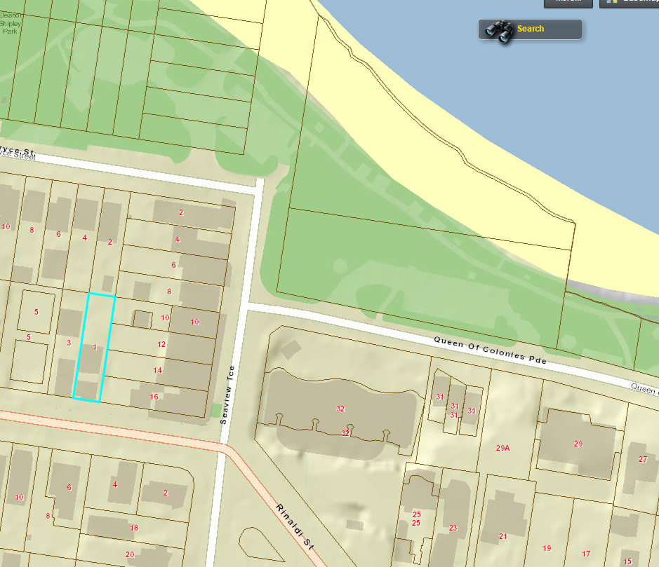

Figure : Street map

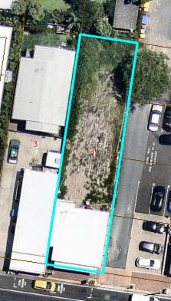

Figure : Site aerial

Development History of Site

The site supported 2 separate buildings until very recently. The front building of which is currently being used to support an art gallery (defined as a Shop under the planning scheme) and the rear building being a Caretaker’s Accommodation (which has recently been demolished). These buildings are understood to have been constructed ‘as of right’ under the 1987 Caloundra planning scheme (Council Ref. 1992/BLD1384).

ASSESSMENT:

Framework for Assessment

Categorising Instruments for Statutory Assessment

For the *Planning Act 2016*, the following categorising instruments may contain assessment benchmarks Applicable to development applications:

* the *Planning Regulation 2017*
* the Planning Scheme for the local government area
* any temporary local planning instrument
* any variation approval

Of these, the planning instruments relevant to this application are discussed in this report.

Assessment Benchmarks Related to the *Planning Regulation 2017*

The *Planning Regulation 2017* (the Regulation) prescribes assessment benchmarks that the application must be carried out against, which are additional or alternative to the assessment benchmarks contained in council’s Planning Scheme.

These assessment benchmarks are prescribed as being contained in:

* the SEQ Regional Plan and Part E of the State Planning Policy, to the extent they are not appropriately integrated into the Planning Scheme; and
* Schedule 10 of the Regulation.

|  |  |
| --- | --- |
| ***PLANNING REGULATION 2017 DETAILS*** | |
| **Applicable Assessment Benchmarks:** | State Planning Policy   * State Planning Policy, Part E |
| **SEQ Regional Plan Designation:** | * Urban Footprint |
| **Koala Habitat Designation:** | Nil. |

Assessment Benchmarks Related to the Planning Scheme

The following sections relate to the provisions of the Planning Scheme.

|  |  |
| --- | --- |
| ***PLANNING SCHEME DETAILS*** | |
| **Planning Scheme:** | Sunshine Coast Planning Scheme 2014 |
| **Strategic Framework Land Use Category:** | Urban Footprint |
| **Local Plan Area:** | Caloundra local plan area |
| **Zone:** | Local centre zone |
| **Consistent/Inconsistent Use:** | Consistent |
| **Applicable Assessment Benchmarks:** | * Local centre zone code * Caretakers accommodation code (no other codes are assessable for this component of the application) * Caloundra local plan code * Business uses and centre design code * Prescribed other development codes |

Planning Scheme Codes

The application has been assessed against each of the Applicable codes and found to be compliant with, or can be conditioned to comply with, each. The pertinent issues arising out of assessment against the codes are discussed below:

*Car parking*

The existing shop (gallery) 78.3m² and caretakers residence are acknowledged to have ‘existing use rights’ and therefore additional parking is required only for the expanded shop use at the rate of 1 space/20m² shop area (137m²/20m² = 6.8 spaces which is rounded to 7) under the *Transport and parking code*.

Plans show that it is possible for the applicant to provide 3 complying spaces at the rear of the site for parking but there are problems associated with obtaining lawful access which is only available over an easement within the adjoining properties (café’s fronting Seaview Tce), i.e.: there is no existing access within the site to the rear of the lot (refer image below). Consent from these landholders for use of the easement has not been forthcoming thus far.

The applicant is continuing to try and obtain the consent of the adjoining landholders and is hopeful of obtaining this soon, however likely outside of the DA timeframe. Should the applicant obtain legal access, the only remaining issue is the shortfall in the number of spaces required for the development.

Seven spaces are required and three can be provided. Motorcycle parking can be accommodated on the site.

It is considered reasonable to issue a development permit, regardless of the parking shortfall because:

* The site is located in a small local centre which contains multiple public car parking areas. The Moffat Beach area is small, contained and lively due to the abundance of foot traffic. It is highly likely that the location of the site in this area would contribute to heavy crossutilisation of parking (most likely within the available public parking areas in close proximity to the site), whereby patrons would access the site, as well as surrounding local businesses on foot.
* There is no ability in this location for the applicant to contribute to Council in lieu of the unsupplied spaces due to a lack of planned parking upgrade works in the vicinity. This ability to provide cash in lieu is available to most other areas of the local government area.
* The lack of planned public parking upgrade works in the vicinity suggests that the area is not currently experiencing parking stress and thus it is appprioriate for the wider parking provision to accommodate the minor shortfall as a result of this application.

Conditions would require formal easement access and car parking to be provided for the use prior to its commencement, subject to an operational works application. The applicant is aware that should the formal easement access not be provided, the use can not commence.

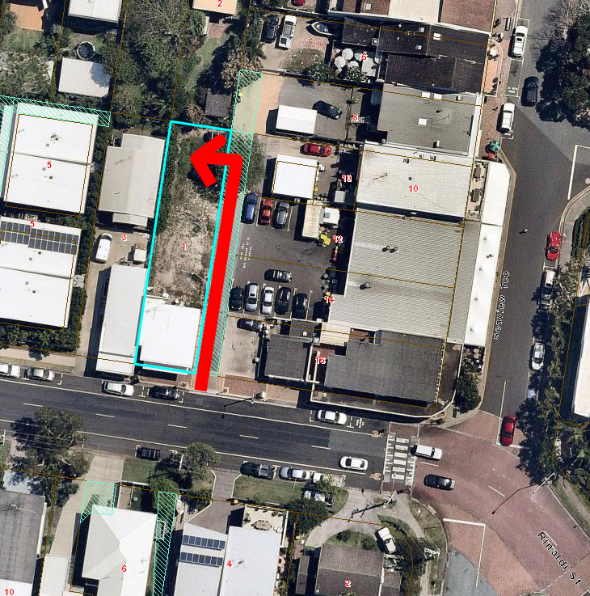

Figure : Location of easement access over adjoining lots

There are no other matters of concern in relation to the shop/gallery component of the application. Matters such as hours of operation and the like can be managed through conditions.

The caretakers residence complies with the provisions of the *Caretakers accommodation code*, with sufficient boundary setbacks and private open space areas achieved.

Assessment Benchmarks Related to a Variation Approval

Not Applicable.

Assessment Benchmarks Related to a Temporary Local Planning Instrument

Not Applicable.

**CONSULTATION:**

**Referral Agencies**

The application did not require referral to any Referral Agencies.

Other External Referrals

The application did not require any other external referrals.

**Public Notification**

The application was code assessable and did not require public notification in accordance with the *Planning Act 2016*.

**CONCLUSION:**

The proposed development sufficiently complies with the requirements of the Planning Scheme and does not raise any significant issues that cannot be addressed by reasonable and relevant conditions. The application is therefore recommended for approval.

|  |
| --- |
| **RECOMMENDATION** |

**APPROVE WITH CONDITIONS** application no. MCU18/0008 for a Development Permit for Material Change of Use (additional shop area for the purposes of an art gallery and caretakers residence) situated at 1 Roderick St MOFFAT BEACH as identified in the attached details recommended for the decision notice.

|  |
| --- |
| APPLICATION DETAILS |

|  |  |
| --- | --- |
| Application No: | MCU18/0008 |
| Street Address: | 1 Roderick Street, MOFFAT BEACH |
| Real Property Description: | Lot 102 RP 8430 |
| Planning Scheme: | Sunshine Coast Planning Scheme (31 July 2017) |

|  |
| --- |
| APPROVAL DETAILS |

|  |  |
| --- | --- |
| Nature of Approval: | Approval with conditions |
| Type of Approval: | Development Permit for Material Change of Use (Additional Shop Area for the Purposes of an Art Gallery and Caretakers Residence) |

|  |
| --- |
| CURRENCY PERIOD OF APPROVAL |

The currency period for this development approval is 6 years starting the day that this development approval first took effect (Refer to Section 85 “Lapsing of approval at end of currency period” of the *Planning Act 2016*).

|  |
| --- |
| INFRASTRUCTURE |

Unless otherwise specified, all assessment manager conditions of this development approval relating to the provision of infrastructure are non-trunk infrastructure conditions for Chapter 4 of the *Planning Act 2016*.

|  |
| --- |
| ASSESSMENT MANAGER CONDITIONS |

**PLANNING**

**When conditions must be complied with**

1. Unless otherwise stated, all conditions of this development approval must be complied with prior to the use commencing, and then compliance maintained at all times while the use continues.

**Approved Plans**

1. Development authorised by this approval must be undertaken generally in accordance with the Approved Plans listed within this development approval.

**Nature and Extent of Approved Use**

1. Non-residential uses on the premises must not operate outside the hours of:
2. 7am to 10pm Monday to Thursday
3. 7am to 11pm Friday and Saturday
4. 9am to 10pm Sunday or any public holiday
5. Service vehicle movements associated with non-residential uses on the premises (including loading and unloading) must not occur outside the hours of 7am to 6pm Monday to Saturday and not at all on Sundays or public holidays. The requirements of this condition must be included in the Community Management Statement for any body corporate for the subject site.
6. Formal legal access rights must be obtained for use of the easement on the adjoining prioperties to the east prior to submission of an application for building work or operational work. Evidence of the formal access rights must be submitted to the assessment manager with any application for building work or operational work.

**Building Appearance**

1. The approved building must be constructed such that its external appearance achieves a high quality design finish, including the degree building form articulation, window coverage, clear glazing, openings, roof overhangs, feature cladding materials, finishes, varied building treatments and finishes, lightweight timber elements, glazed balustrades shown on the Approved Plans, with no inclusions or future alterations being made without approval in writing by council.
2. All air conditioning units or other mechanical equipment must be visually integrated into the design and finish of the building, or otherwise fully enclosed or screened such that they are not visible from the street frontages nor adjoining properties.
3. All deck and balcony areas above ground floor must not be enclosed by permanent fixtures such as shutters, louvres, glass panelling or the like*.*

**Fencing and Walls**

1. A minimum 1.8m high solid screen fence is provided and maintained along the full length of any side or rear boundary where practicable.

**Building Height**

1. The maximum height of the development must not exceed 8.5m above natural ground level at any point.

**Clothes Drying Areas**

1. The caretakers residence must be provided with an outdoor non-mechanical (natural) clothes drying facility that is screened from public view by the use of fixed or operable screens incorporated into the building design. Where individual outdoor clothes drying facilities are not provided for each unit, one or more clothes drying areas fitted with robust clothes lines must be provided in accessible and screened communal locations to meet the clothes drying needs of occupants. The requirement for screening of outdoor clothes drying by occupants must be included in the Community Management Statement for any body corporate for the subject site.

**Street Identification**

1. The street address of the development must be clearly visible and discernible from the primary frontage of the site by the provision of a street number and, where appropriate, the building name.

**Renewable Energy (Sustainable design code)**

1. The development must implement the use of solar power or other pollution reducing renewable energy sources to supply part or all of the development’s energy needs.

**ENGINEERING**

**On-site Parking**

1. A minimum of 3 car parking spaces must be provided and marked on the site and made available and accessible at all times while the use is open for business.

The works must be undertaken in accordance with an operational works approval and must include in particular:

1. a minimum 5.8m wide aisle, 300mm widening to car parks adjacent to walls and a 1m wide blind aisle extension, in accordance with AS2890.1.
2. dimensions, crossfalls and gradients in accordance with *AS 2890* - Parking facilities.
3. A minimum of 2 motorcycle/scooter parking spaces must be provided and marked on the site and made available and accessible at all times while the use is open for business. The works must be undertaken in accordance with an operational works approval and must include in particular dimensions, crossfalls and gradients in accordance with *AS 2890 - Parking facilities*.

**Bicycle Facilities**

1. Bicycle facilities must be provided for the development. The works must be undertaken in accordance with an operational works approval and must include in particular:
2. a minimum of 4 visitor bicycle parking spaces, in accordance with *AS 2890.3 – Bicycle parking*

**Easements**

1. Unless otherwise agreed in writing by the relevant service provider, any public or third party infrastructure located on the subject site must be placed within an easement registered against the title of the property.
2. All easements must be designed in accordance with the planning scheme and granted at no cost to the Grantee. Where the Grantee is Council or a service authority, the easement documentation must be in accordance with the Grantee’s standard easement terms. Draft easement documentation must be submitted to Council for endorsement.
3. All works must be kept clear of any existing or proposed easements on the subject land, unless agreed otherwise in writing by the Grantee.

**Damage to Services and Assets**

1. Any damage caused to existing services and assets as a result of the development works must be repaired at no cost to the asset owner at the following times:
2. where the damage would cause a hazard to pedestrian or vehicle safety, immediately; or
3. where otherwise, upon completion of the works associated with the development.

Any repair work which proposes to alter the alignment or level of existing services and assets must first be referred to the relevant service authority for approval.

|  |
| --- |
| REFERRAL AGENCIES |

Not Applicable.

|  |
| --- |
| DEVELOPMENT PLANS |

The following development plans are Approved Plans for the development:

**Approved Plans**

|  |  |  |  |
| --- | --- | --- | --- |
| **Plan No.** | **Rev.** | **Plan Name** | **Date** |
| DA01 | C | Site Plan, prepared by Taylor’d Distinction | March 2018 |
| DA07 | C | Ground Floor Plan, prepared by Taylor’d Distinction | March 2018 |
| DA09 | C | Upper Floor Plan, prepared by Taylor’d Distinction | March 2018 |
| DA11 | C | Roof Layout and Building Height Plan, prepared by Taylor’d Distinction | March 2018 |
| DA12 | C | South and East Elevations, prepared by Taylor’d Distinction | March 2018 |
| DA13 | C | North and West Elevations, prepared by Taylor’d Distinction | March 2018 |
| DA14 | C | 3D views, prepared by Taylor’d Distinction | March 2018 |

|  |
| --- |
| REFERENCED DOCUMENTS |

Not Applicable.

|  |
| --- |
| ADVISORY NOTES |

The following notes are included for guidance and information purposes only and do not form part of the assessment manager conditions:

**Equitable Access and Facilities**

1. The plans for the proposed building work have NOT been assessed for compliance with the requirements of the *National Construction Code - Building Code of Australia (Volume 1)* as they relate to people with disabilities. Your attention is also directed to the fact that in addition to the requirements of the National Construction Code as they relate to people with disabilities, one or more of the following may impact on the proposed building work:
2. *the Disability Discrimination Act 1992 (Commonwealth)*
3. *the Anti-Discrimination Act 1991 (Queensland)*
4. *the Disability (Access to Premises – Buildings) Standards.*

**Aboriginal Cultural Heritage Act 2003**

1. There may be a requirement to establish a Cultural Heritage Management Plan and/or obtain approvals pursuant to the *Aboriginal Cultural Heritage Act 2003*.

The *ACH Act establishes a cultural heritage duty of care which provides that: “A person who carries out an activity must take all reasonable and practicable measures to ensure the activity does not harm Aboriginal cultural heritage.”* It is an offence to fail to comply with the duty of care. Substantial monetary penalties may apply to individuals or corporations breaching this duty of care. Injunctions may also be issued by the Land Court, and the Minister administering the Act can also issue stop orders for an activity that is harming or is likely to harm Aboriginal cultural heritage or the cultural heritage value of Aboriginal cultural heritage.

You should contact the Cultural Heritage Unit on 07 3247 6212 to discuss any obligations under the *ACH Act*.

**Easements and Future Works over External Land**

1. Should the conditions of this development approval require easements or works to be undertaken over land external to the site, council recommends that easement and works requirements are negotiated with the relevant land owner/s prior to advancing to detailed design stages of the development to avoid unexpected costs or delays.

**Other Laws and Requirements**

1. This approval relates to development requiring approval under the Planning Act 2016 only. It is the applicant’s responsibility to obtain any other necessary approvals, licences or permits required under State and Commonwealth legislation or council local law, prior to carrying out the development. Information with respect to other council approvals, licences or permits may be found on the Sunshine Coast Council website (www.sunshinecoast.qld.gov.au). For information about State and Commonwealth requirements please consult with these agencies directly.

**Restriction on Building Approval until all other Permits are Effective**

1. Pursuant to the statutory provisions of the Building Act, a private building certifier must not grant any building development approval related to this development until all necessary development permits for the development (including, for example, operational works approvals) have taken effect under the *Planning Act 2016*. This legislative requirement is critical to ensure that a private certifier’s approval about a component of the development is consistent with the assessment managers’ decisions on other aspects of the overall development.

**Infrastructure Charges**

1. Infrastructure charges, determined in accordance with council’s Infrastructure Charges Resolution, apply to this development approval. The Infrastructure Charges Notice, for council’s proportion of the infrastructure charge, has been issued. Unitywater may issue an infrastructure charges notice for their proportion of the infrastructure charge.

**Development Compliance Inspection**

1. Prior to the commencement of the use, please contact council's Development Audit & Response unit to arrange a development compliance inspection.

**Use many not commence until access easement resolved**

1. The applicant is advised that the approved use cannot commence until formal legal access rights for use of the adjoining access easement have been granted for use of the easement to gain access into the rear parking area.

|  |
| --- |
| PROPERTY NOTES |

Not Applicable.

|  |
| --- |
| VARIATION APPROVAL |

Not Applicable.

|  |
| --- |
| FURTHER DEVELOPMENT PERMITS REQUIRED |

* Development Permit for Operational Work (Engineering)
* Development Permit for Building Work

|  |
| --- |
| SUBMISSIONS |

Not Applicable.

|  |
| --- |
| INCONSISTENCY WITH EARLIER APPROVAL |

Not Applicable.

|  |
| --- |
| ENVIRONMENTAL AUTHORITY |

Not Applicable.

|  |
| --- |
| RIGHTS OF APPEAL |

You are entitled to appeal against this decision. A copy of the relevant appeal provisions from the *Planning Act 2016* is attached.

|  |
| --- |
| OTHER DETAILS |

If you wish to obtain more information about council’s decision, please refer to the approval package for the application on Council’s PD Online webpage at [www.sunshinecoast.qld.gov.au](http://www.sunshinecoast.qld.gov.au), using the application number referenced herein.