**DETAILED ASSESSMENT REPORT**

**APPLICATION FOR CHANGE TO DEVELOPMENT APPROVAL**

**Link to Development.i:**

<https://developmenti.sunshinecoast.qld.gov.au/Home/FilterDirect?filters=DANumber=MCU18/0008.01>

|  |  |
| --- | --- |
| ***SUMMARY SHEET*** | |
| ***APPLICATION DETAILS*** | |
| **Applicant:** | Ms AF Holloway, BW Morrisson |
| **Owner:** | Ms AF Holloway, BW Morrisson |
| **Consultant:** | Not applicable. |
| **Proposal** | Change to Approval for Development Permit for Material Change of Use (Additional Shop Area and Caretakers Residence) |
| **Properly Made Date:** | 19/10/2018 |
| **Information Request Date:** | Not applicable. |
| **Information Response Received Date:** | Not applicable. |
| **Decision Due Date** | 16 November 2018 |
| **Number of Submissions** | Not applicable – code assessable |
| ***PROPERTY DETAILS*** | |
| **Division:** | 2 |
| **Property Address:** | 1 Roderick Street MOFFAT BEACH |
| **RP Description:** | Lot 102 RP 8430 |
| **Land Area:** | 405m² |
| **Existing Use of Land:** | Art gallery with caretakers residence (recently demolished) |
| **STATUTORY DETAILS** | |
| **Planning Scheme:** | Sunshine Coast Planning Scheme (31 July 2017) |
| **SEQRP Designation:** | Urban footprint |
| **Strategic Plan Designation:** | Urban area |
| **Planning Area / Locality:** | Caloundra local plan area |
| **Planning Precinct / Zone:** | Local centre zone |
| **Assessment Type:** | Code |

**Proposal**

The application seeks to delete four conditions in relation to providing on-site vehicle parking for an approved extension to a shop/art gallery. This approval also covered construction of a caretaker’s residence, but as this is to replace a previously existing residence on the site, the caretaker’s residence and existing gallery are acknowledged to have existing use rights for the purposes of parking, with no provision required for these uses.

The approved development comprises three new tenancies (with a total floor area of 137m²) behind an existing gallery.

Based on the gross floor area, seven car parking spaces and motorcycle/bicycle parking would be required to be provided for the approved extension. Council agreed to reduce the required parking bays to three noting the cross utilisation of car parking bays in the Moffat Beach area.

The following relevant conditions were imposed on the development approval as follows:

1. *Formal legal access rights must be obtained for use of the easement on the adjoining properties to the east prior to submission of an application for building work or operational work. Evidence of the formal access rights must be submitted to the assessment manager with any application for building work or operational work.*

***On-site Parking***

1. *A minimum of 3 car parking spaces must be provided and marked on the site and made available and accessible at all times while the use is open for business.*

*The works must be undertaken in accordance with an operational works approval and must include in particular:*

1. *a minimum 5.8m wide aisle, 300mm widening to car parks adjacent to walls and a 1m wide blind aisle extension, in accordance with AS2890.1.*
2. *dimensions, crossfalls and gradients in accordance with AS 2890 - Parking facilities.*
3. *A minimum of 2 motorcycle/scooter parking spaces must be provided and marked on the site and made available and accessible at all times while the use is open for business. The works must be undertaken in accordance with an operational works approval and must include in particular dimensions, crossfalls and gradients in accordance with AS 2890 - Parking facilities.*

***Bicycle Facilities***

1. *Bicycle facilities must be provided for the development. The works must be undertaken in accordance with an operational works approval and must include in particular:*
2. *a minimum of 4 visitor bicycle parking spaces, in accordance with AS 2890.3 – Bicycle parking*

The applicant has advised that they have been unable to obtain formal legal access rights from the adjoining owners as per Condition 5 above and are therefore unable to provide access to the rear of the site for construction, nor the ongoing use of the required car parking spaces. No documentation has been provided by the applicant to support this statement.

The location of the access easement is shown below.

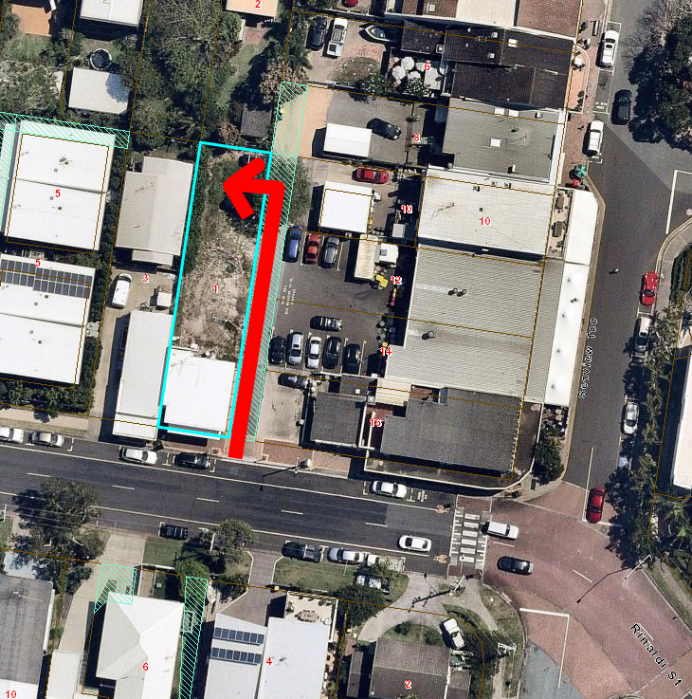

Figure 1: Location of access easement on adjoining lots

The applicant is therefore in the position that they are unable to provide any parking on the site and requests that the above conditions be deleted.

**SITE DETAILS:**

|  |  |
| --- | --- |
| ***SITE AND LOCALITY DESCRIPTION*** | |
| **Land Area:** | 405m² |
| **Existing Use of Land:** | Art gallery with caretakers residence (recently demolished) |
| **Road Frontage:** | Approximately 10m to Roderick Street |
| **Significant Site Features:** | Nil |
| **Topography:** | Generally flat |
| **Surrounding Land Uses:** | Mixture of commercial and residential uses. |

**Site** **Description**

The location of the subject site in relation to its surrounds is shown below:

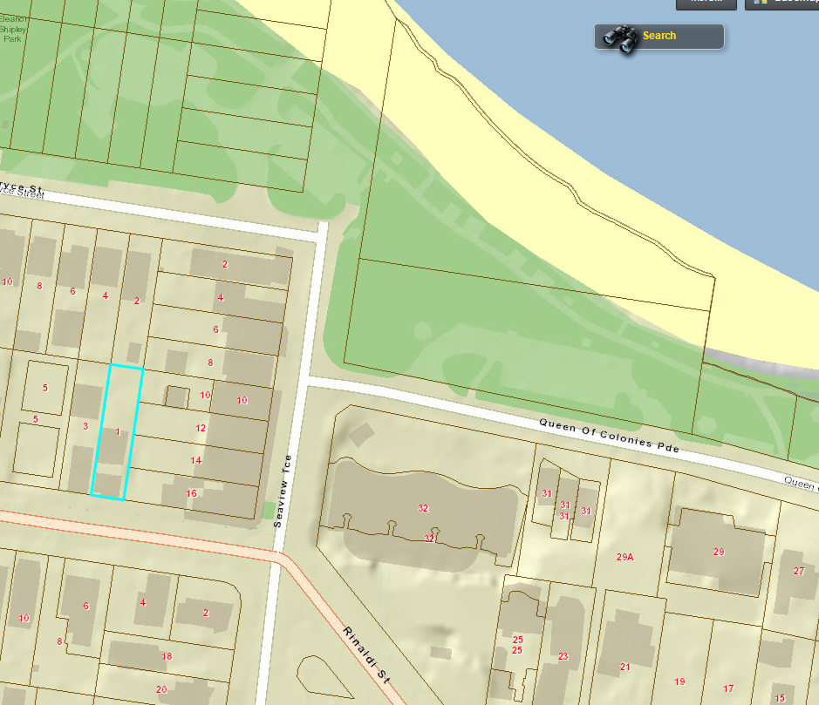

Figure 2: Street map with site highlighted in blue

**Surrounding Land Uses**

The surrounding land uses are a mix of residential development (in the form of dwelling houses as well as multi-unit developments) and small scale commercial development.

**Background / Site History**

|  |  |
| --- | --- |
| ***APPLICATION NO.*** | ***DECISION AND DATE*** |
| MCU18/0008 | This application was approved on 6 June 2018 for a Development Permit for Material Change of Use (additional shop area for the purposes of an art gallery and caretakers residence). |

An excerpt of the approved plans is shown below:

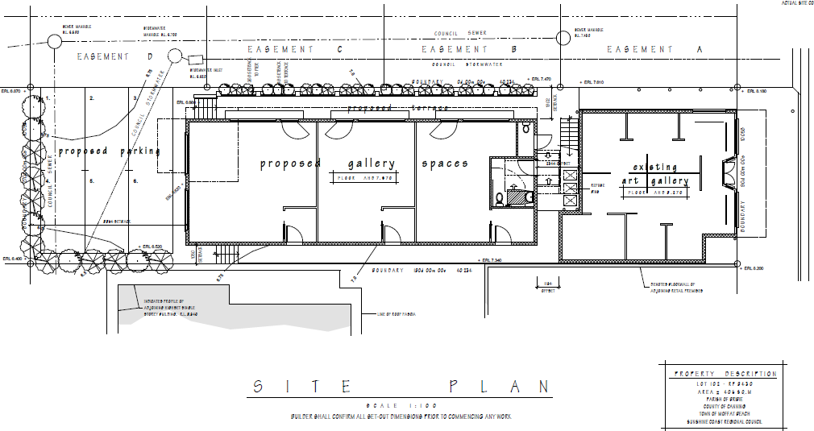

Figure 3: Approved Site Plan

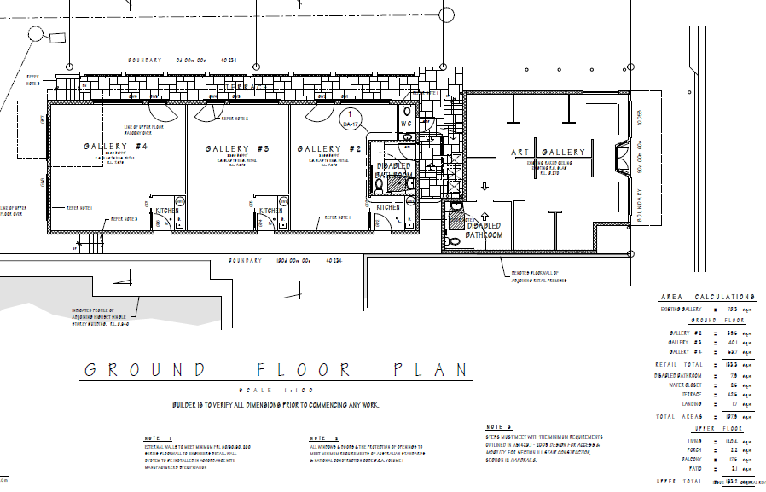

Figure 4: Approved Ground Floor (gallery) Plan

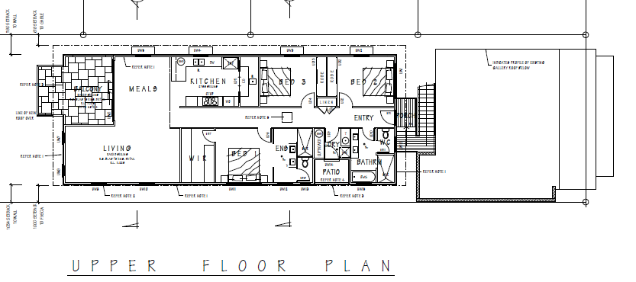

Figure 5: Approved Upper Floor (caretakers residence) Plan

**ASSESSMENT**

**Framework for Assessment**

Categorising Instruments for Statutory Assessment

For the *Planning Act 2016*, the following Categorising Instruments may contain Assessment Benchmarks applicable to development applications:

* the *Planning Regulation 2017*
* the Planning Scheme for the local government area
* any Temporary Local Planning Instrument
* any Variation Approval

Of these, the planning instruments relevant to this application are discussed in this report.

**Assessment Benchmarks Pertaining to the *Planning Regulation 2017***

The following Assessment Benchmarks from the *Planning Regulation 2017* are applicable to this application:

|  |  |
| --- | --- |
| ***PLANNING REGULATION 2017 DETAILS*** | |
| **Assessment Benchmarks:** | Nil. |
| **SEQ Regional Plan Designation:** | Urban footprint |

**Assessment Benchmarks Pertaining to the Planning Scheme**

The applicable planning scheme for the application is Sunshine Coast Planning Scheme (31 July 2017). The following sections relate to the provisions of the Planning Scheme.

|  |  |
| --- | --- |
| **Planning Scheme:** | *Sunshine Coast Planning Scheme (31 July 2017)* |
| **Strategic Framework Land Use Category** | Urban footprint |
| **Local Plan Area:** | *Caloundra local plan area* |
| **Zone:** | *Local centre zone* |
| **Consistent/Inconsistent Use:** | Consistent |
| **Assessment Benchmarks:** | * *Local centre zone code* * *Caretakers accommodation code* * *Caloundra local plan code* * *Business uses and centre design code* * *Prescribed other development codes* |

Strategic Framework

The Strategic Framework considers the following matters:

* Settlement Pattern
* Economic Development
* Transport
* Infrastructure and Services
* Natural Environment
* Community Identity, Character and Social Inclusion
* Natural Resources
* Natural Hazards

The Strategic Framework does not form part of the Assessment Benchmarks. The *Planning Act 2016* requires that code assessable applications must only be assessed against the Assessment Benchmarks.

Assessment Benchmarks – Planning Scheme Codes

The original application was assessed against each of the applicable codes and found to be compliant with, or able to be conditioned to comply with, each, inclusive of the *Transport and parking code*.

However, in this case, the applicant is unable to comply with the conditions pertaining to provision of parking for the expanded use. A summary of the issue is provided below.

*Provision of Parking*

The existing shop (gallery) 78.3m² and caretakers residence are acknowledged to have ‘existing use rights’ and therefore additional parking is required only for the expanded shop use at the rate of 1 space/20m² shop area (137m²/20m² = 6.8 spaces which is rounded to 7) under the *Transport and parking code*.

Plans show that it is possible for the applicant to provide 3 car complying spaces at the rear of the site and the original approval was conditioned on this basis. Motorcycle and bicycle parking were not shown on the plan, however it was understood that there was sufficient space available for provision of these in the same area. At the time of the original approval, the applicant was hopeful of obtaining approval for use of the easement access however the applicant has advised they have not been able to obtain agreement for use of the easement. As such, there is no legal access to the rear of the site.

It is noted that the whole of the expanded use formally triggered provision of 7 parking spaces under the *Transport and parking code*, however it was considered reasonable to issue a development permit, regardless of the parking shortfall because:

* The site is located in a small local centre which contains multiple public car parking areas. The Moffat Beach area is small, contained and lively due to the abundance of foot traffic. It is highly likely that the location of the site in this area would contribute to heavy cross utilisation of parking (most likely within the available public parking areas in close proximity to the site), whereby patrons would access the site, as well as surrounding local businesses on foot.
* There is no ability in this location for the applicant to contribute to Council in lieu of the unsupplied spaces due to a lack adopted policy for the provision of a contribution in lieu.
* There are no planned public parking upgrades in the vicinity. This suggests that the area is not currently experiencing parking stress and thus it is appropriate for the wider parking provision to accommodate the minor shortfall as a result of the application.

The applicant is now seeking that the conditions requiring parking provision be deleted. If approved, this would result in no on-site parking provision for the development and a reliance on public street parking for the entirety of the parking demand.

The *Transport and parking code* requires provision of appropriate on-site parking in two Acceptable Outcomes, AO1 and AO3.1.

Acceptable outcome AO1.1 provides that:

*AO1.1 - Development provides access driveways, internal circulation and manoeuvring areas, service areas and parking areas in accordance with the standards specified in the Planning scheme policy for the transport and parking code, including ensuring:- (a) the number and type of vehicles planned for the development can be accommodated on-site; (b) on-site vehicle parking and manoeuvring areas provide for vehicles to enter and leave the site in a forward motion.*

The associated performance outcome is PO1, which provides that:

*PO1 - Development ensures that the layout and design of vehicle access, on-site circulation systems and parking areas and systems is safe, convenient and legible for all users, including people with disabilities, pedestrians, cyclists and public transport services, where relevant.*

Removal of the conditions requiring parking provision on site would cause the development to be inconsistent with both AO1 and PO1.

Acceptable outcome AO3.1 also requires provision of parking in accordance with the prescribed minimum rates. The development as originally approved did not meet strict application of the minimum rates (with 3 spaces provided, instead of 7), however was considered to meet the performance outcome:

*PO3 - Development provides on-site car parking for the demand anticipated to be generated by the development.*

Where development cannot physically provide car parking, AO3.1 also provides that:

*Where development is physically unable to provide the required number of car parking spaces on-site, an Infrastructure Agreement is entered into between the developer and the Council which provides for contributions in lieu of on-site car parking spaces.*

During assessment of the application, the ability for the applicant to enter into an Infrastructure Agreement to pay a contribution in lieu of physical provision of parking was investigated.

In this regard, Council adopted the Sunshine Coast Parking Management Plan and 37 Local Area Parking Plans including one for Moffat Beach in October 2017.

The Parking Management Plan raises the possibility of contributions-in-lieu for new development. However, the Parking Management Plan makes it clear that the full quantity of required parking must be provided within the development site. The Parking Management Plan highlights that “agreements that allow development to occur with less than the minimum parking supply places increased pressure on a limited public resource. Allowing development to partly rely on existing public parking would impact all existing users, increase costs to ratepayers and is not equitable to those developments that have provided the required parking”.

In this case, Council’s Transport & Infrastructure Policy Branch have advised that there is currently no adopted contributions-in-lieu policy to cover this or similar cases. Therefore, to comply with PO3, physical provision of spaces (albeit at a reduced rate in the case of the subject application) is required.

Removal of the conditions requiring parking provision on site would also cause the development to be inconsistent with PO3.

In addition to the above, it is further noted that the purpose and overall outcomes of the *Transport and parking code* require that:

*(d) development provides for on-site parking, access, circulation and servicing areas that are safe, convenient and meet the reasonable requirements of the development.*

If approved, the proposal would result in the provision of nil on-site parking for the approved development which in inconsistent with the purpose and overall outcomes of the *Transport and parking code*.

Of note, within the Moffat Beach locality, there are multiple sites also zoned Local Centre (light blue below) that could be developed into the future for similar uses, and have similar constraints regarding parking as shown in the map below.

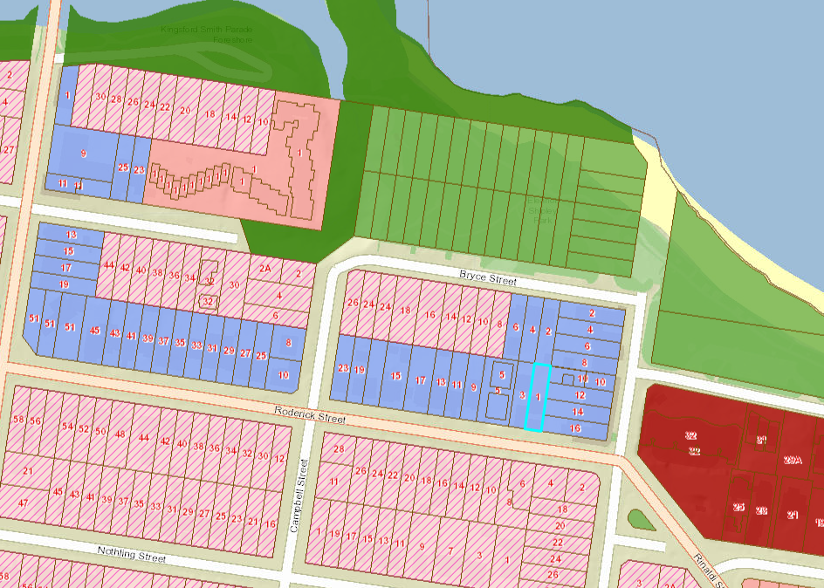

Figure 6: Zoning map of section of Moffat Beach

A proposal similar to this could be proposed on other sites, and could set a precedent that is replicated by others.

The proposal to delete Conditions 5, 14, 15 and 16 is therefore recommended for refusal as it does not comply with the provisions of the *Transport and parking code*.

Other circumstances where contributions in lieu of parking have been accepted

It is acknowledged that in some circumstances, council has considered and approved a contribution in lieu of parking. Council’s Transport & Infrastructure Policy Branch were therefore consulted on the matter and have advised that in response to the current request to delete the condition to provide parking:

* The Parking Management Plan raises the possibility of contributions-in-lieu for parking, but clearly states that development should provide the full quantity of required parking as detailed in the Planning Scheme within the development site.
* Council, in numerous parking workshops, has been clear that development will provide the required parking on-site.
* Specific Local Area Parking Plans have indicated those locations where there is potential for Council to provide future consolidated parking. This provides opportunities for contributions-in-lieu to be used to fund parking unable to be provided on-site.
* Local Area Parking Plans for Caloundra and Coolum Beach propose investigation of adding consolidated public parking and this has allowed the application of contributions-in-lieu for those locations to absorb this pressure as you have noted.
* The contribution rate per parking space should be based on the combined cost of purchasing land in the immediate vicinity plus constructing at- grade parking infrastructure.
* If contributions-in-lieu are applied, then the contribution rate per parking space should be applied to the full number of parking spaces required by the planning scheme.
* The Moffat Beach Local Area Parking Plans indicates that Council has no plans to increase parking supply in Moffat Beach.
* Moffat Beach has no spare public parking capacity to absorb additional displaced private parking at high use times.
* Collecting contributions-in-lieu may place pressure on Council to providing additional parking within a reasonable timeframe. In Moffat Beach this would require the conversion of limited beachfront open space or the purchase and redevelopment of an existing residential or commercial property for parking. There is currently no commitment to do this.

**CONSULTATION**

**Referral Agencies**

The application did not require referral to any Referral Agencies.

**Other Referrals**

The application was forwarded to the following internal council specialists:

* Senior Transport Planner, Transport & Infrastructure Policy Branch
* Manager, Transport and Infrastructure Planning

Their assessment forms part of this report.

**Public Notification**

The application was code assessable and did not require public notification in accordance with the *Planning Act 2016*.

**CONCLUSION**

The proposed change application for deletion of conditions requiring provision of on-site vehicle parking for MCU18/0008 is inconsistent with the planning scheme. Specifically, the proposal would result in the provision of no parking for the approved extension to the existing gallery.

The proposal conflicts with the *Transport and parking code* and the application for change to the development approval is therefore recommended for refusal.