Submarine cable installation

Sunshine Coast Council is facilitating the landing of a new international submarine cable to Maroochydore by mid-2020. The project includes the installation of a 550km undersea fibre optic cable that will connect the Sunshine Coast to the 9700km Japan-Guam-Australia (JGA) submarine cable.
The cable, which is laid on or buried under the sea floor, land will connect to a cable landing station adjacent to the new Maroochydore City Centre. The project will help stimulate local business, generate new investment, and improve telecommunications diversity to Australia’s east coast. The cable will help to futureproof the Sunshine Coast’s telecommunications capacity and increase our region’s smart city capability by ensuring access to important data networks.
Connecting the submarine cable to the cable landing station will require landside works to be undertaken. These works will start in late July 2019 and are expected to be completed by early October 2019 (weather and site conditions permitting).
Most people will not experience any impacts from installation. Council will liaise directly with residents and businesses along the installation route as required.
Infrastructure
The international broadband submarine cable is much like any other telecommunications or underground electricity infrastructure in terms of physical presence and installation.
The submarine cable uses fibre-optic technology and is wrapped in layers of plastic, and sometimes steel wire, for protection. For most of its journey across the ocean a cable is typically as wide as a garden hose.

The cable which is laid in the sea and underground on land will not be visible to the public and most people will not notice installation taking place (see Figure 1).
Burying the cable under the seabed protects the cable from movement and allows for recreational fishing, boating, surfing and swimming to be undertaken as usual.
There are strict environmental guidelines in place for all submarine cables across the world. With this cable being one of 11 currently in Australia, and with many more around the world, the installation processes are well established.
Underground route
Installation has been scheduled to start in July, outside of key tourism seasons to further minimise disruptions to residents and businesses.
The installation requires a two-stage process:
- Horizontal drilling and beach manhole construction.
This inshore installation will involve hydraulic drills and pipes, with the use of boats and divers. The drill rig will set up in the car park on Melrose Parade, Maroochydore and drill under the beach to 680 metres off shore. Some water traffic control will be in place when required. This stage will not impact the community’s use of the beach.
Construction will occur primarily between 7am–5pm on weekdays and Saturdays.
The public car park on Melrose Parade will be temporarily closed during installation, while the project office and drilling rig are positioned in this location close to the beach.

Noise barriers will be installed around the site compound, and the nearby public toilets and playground in Pierce Park on Melrose Parade (next to the Maroochydore Beach Holiday Park) will remain open.
Necessary approvals for the works have been obtained and the methodology being used was specifically designed to minimise any impact to the environment, beach access, water activities and marine life.
- Installation of telecommunications duct underground (on-land)
Underground pits with flat lids (like manholes) will be built at intervals of approximately 250 metres along the route to allow access to the telecommunications duct for service and maintenance.
The duct will be installed along a route from Pierce Park on Melrose Parade (next to the Maroochydore Beach Holiday Park), along Kingsford Smith Avenue and Aerodrome Road, along Rose Street, Park Street, Second Avenue and Bungama Street, then to the landing station in the CBD (see Figure 2).

This stage will have very minimal impact on the community. There will be some minor disruptions including demolition and replacements of footpath sections, with all works occurring on council or state government road reserve (not on roads/traffic lanes or private property).
The on-land installation will require a minimal amount of vegetation removal, only in locations where this is necessary and unavoidable. Offset planting will occur, with semi-mature native trees to be planted.
Further information
For further details about the submarine cable, please visit council’s website at www.sunshinecoast.qld.gov.au and search “cable”.
If you have any questions about the cable installation, please contact council on 5475 7272 or mail@sunshinecoast.qld.gov.au

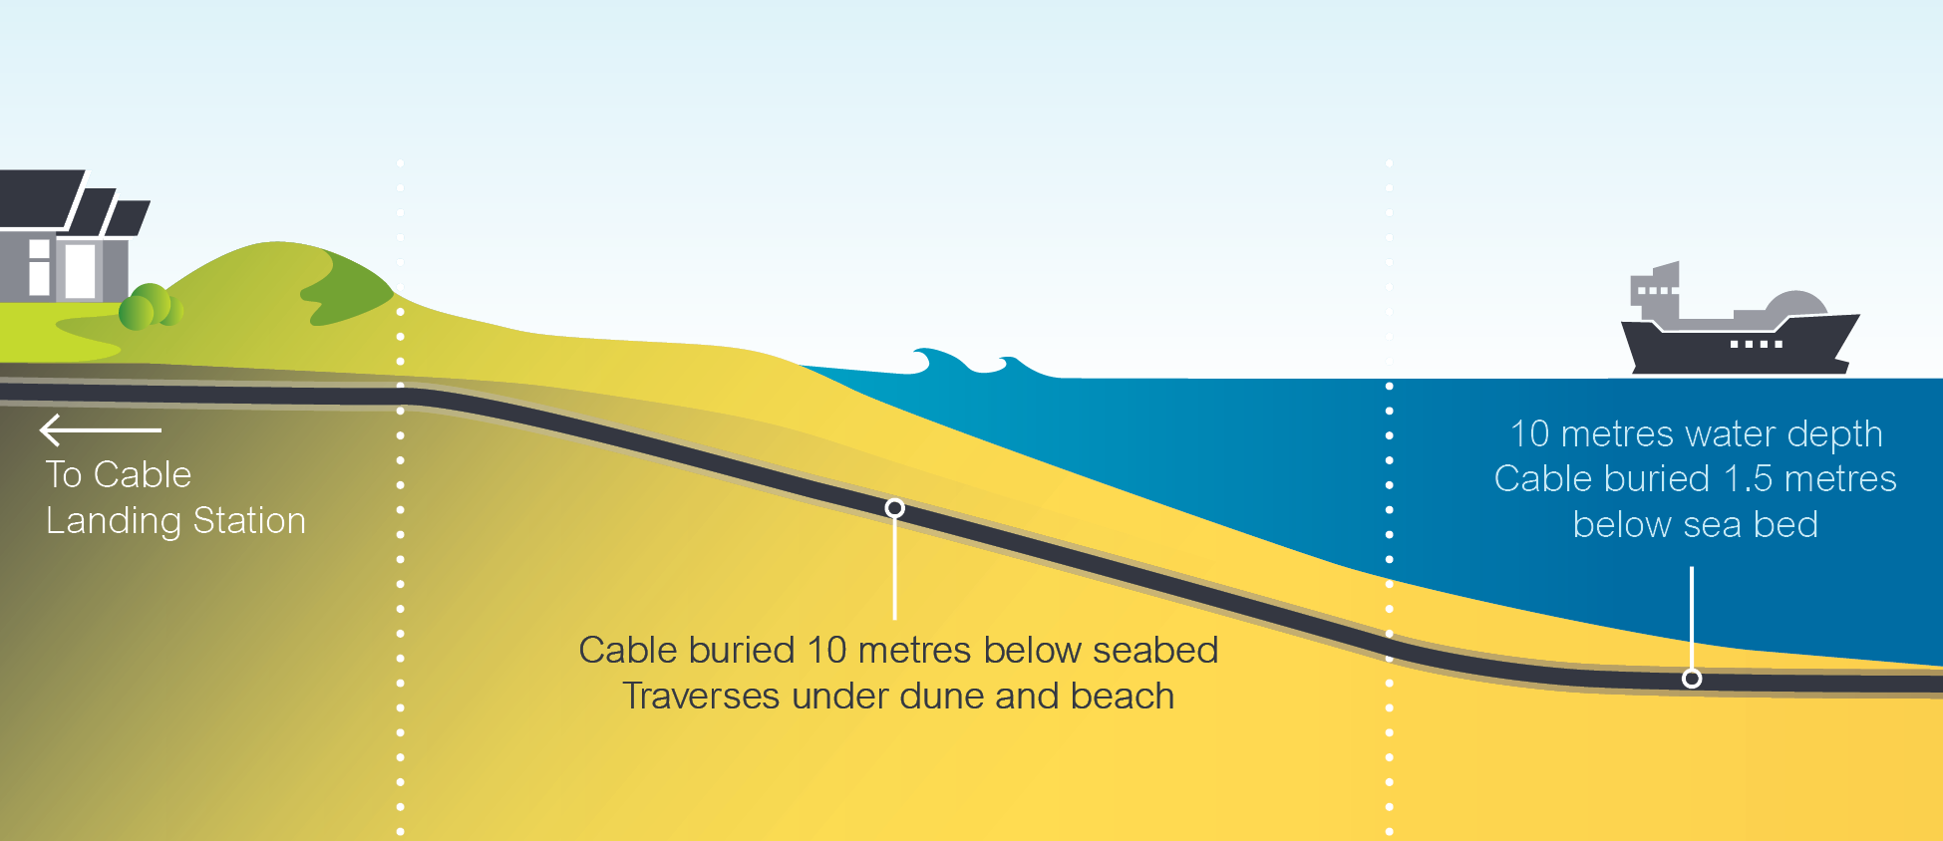
Figure 1: Undersea cable diagram

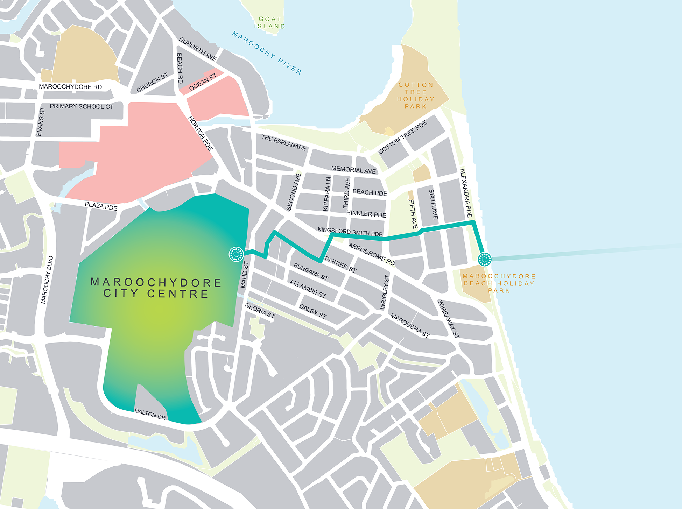

Figure 2: Underground route

