MODULE 7
Let's Get Ready –

Preparing for Disasters

Natural disasters impact thousands of Queenslanders every year and when it comes to extreme weather events in Queensland, it's not a matter of 'if' but 'when.'

Each disaster has lasting effects on people, their property and their possessions. Disasters can happen fast and without much or any warning. This means that it is hard to react to a disaster if you have not planned for one.

When preparing for a natural disaster, as a priority you should focus on how to prepare your home, your loved ones (including pets) and protect what’s most important to you.

Emergency plan Emergency kit

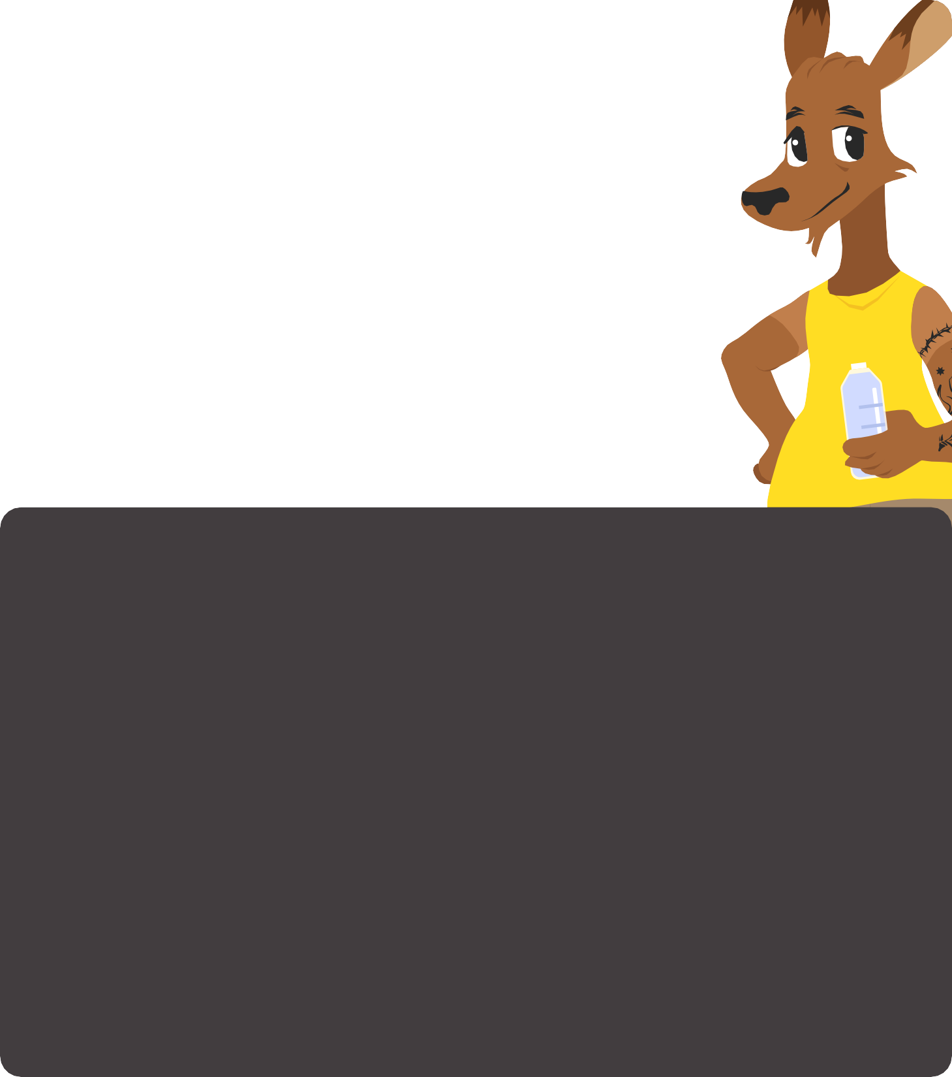
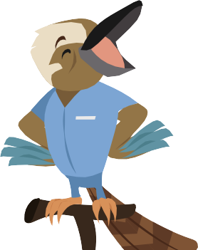
- The best way to protect you and your family is to have a good emergency plan. Having a household emergency plan means that everyone in your household knows what to do if dangerous weather happens.
- The emergency plan should have important contact information for people in your home or people who can help you.
- An emergency plan can also include ways to get your home ready for bad weather and information on where to go if you had to leave.

DISCUSSION QUESTIONS
  - What do you think about having a dangerous weather emergency plan for your home?
  - What would an emergency plan look like?
  - What information would you put in your emergency plan?
  - Where can you find an emergency plan template?
- An emergency kit has items that will
keep your household safe for 3 days after bad weather, even if the power (electricity), water or Internet are not working.
- Put your items in a strong waterproof storage container and store it in a safe place.

Get current information about bushfires from the radio, television, social media or https://disaster.sunshinecoast.qld.gov. au/#Dashboard

- What do you think about having an emergency kit or box at home?
- What items would you put into an emergency kit?
- How long should you be ready to stay at home for during and after bad weather?
- Where should you keep your emergency kit?
- Where can you find information about emergency kits?

