Creating a wildlife friendly backyard

Create a wildlife friendly backyard and bring your garden to life.
Attracting wildlife to your backyard naturally is both easy and rewarding. It can be very enjoyable watching native birds flitting about the garden feeding on flowers and insects or listening to the croaking of frogs before the summer rains.
However, it is important to create natural habitats with native foods to attract wildlife. Feeding animals by hand from bird feeders and dishes can create many headaches for you and your neighbours and spread disease amongst animals.
To create a wildlife friendly backyard that has both resident fauna species and regular wildlife visitors you need to include some of the essential habitat features that animals would require and look for in natural bushland environments.
These include a permanent source of water, and opportunities for foraging with sufficient natural food resources throughout the year. Shelter, protection from the weather and predators and suitable habitat and opportunities for breeding and raising young also need to be available.
By incorporating a combination of these resources and by utilising some of the following ideas you can significantly increase the habitat opportunities and value of your backyard for local native wildlife species.
Frog ponds
Building a frog pond is a great way to attract frogs to your backyard while also providing an alternate source of water for other species. You can build a frog pond of your design in a sheltered area of your garden or convert a wet or boggy area into frog friendly habitat by planting appropriate native grasses, sedges and shrubs.
Provide suitable habitat and protection from predators with rocks or logs for frogs to sit on and hide under, have some deeper and shallow areas for frogs and tadpoles to swim and exit the water. Plant suitable local native plants for shelter and food and ensure you only use clean unpolluted water.
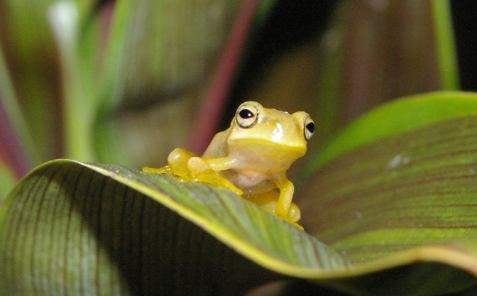
Dwarf green tree frog in an urban garden
Note: refrain from using chemical sprays in and around your frog pond. Chemicals can be harmful to frogs and poison the insects they feed on.
Bird baths and water sources
The provision of a clean water supply for wildlife is one of the simplest resources you can include in your backyard habitat. For those wildlife species that cannot acquire their water needs from the food they eat, a reliable water supply is essential, particularly during hot weather and dry periods.
Water can be provided in different ways, either by a bird bath on a pedestal, water dishes hanging in a tree or placed at ground level, a pond or formal water feature.
It is recommended to have multiple water sources and drinking sites. This will cater for different species needs and also provide alternate drinking sites should you have any aggressive birds that chase others away or neighbourhood cats that may learn to prey on animals coming in for a drink.
Nest boxes
Many of Australia’s wildlife species live and/or nest in native tree hollows. Different species have different requirements for example, type and orientation of opening, vertical or horizontal chamber/hollow.
The size of the hollow required usually depends on the size of the animal. However, as the size of the hollow increases so does the time it takes to be created in the tree.
Large hollows suitable for possums, kookaburras and cockatoos can take up to 100 years to develop and often require the assistance of termites to get started. Unfortunately, in many of our urban area’s old eucalyptus trees and especially those with termites are usually the first to be cut down for safety concerns.
Nest boxes are a type of ’artificial hollow’and can be used to provide a form of substitute habitat in areas that don’t contain or cannot support large hollow bearing trees. Nest boxes can be erected in existing smaller trees or can be attached to a purpose-built pole located in or adjacent to existing vegetation/landscaping.
Erecting a nest box (or 2) in your backyard can provide valuable nesting habitat and housing for many birds, bats, gliders and possums. It may also help prevent possums using your roof as one ‘very big hollow’.
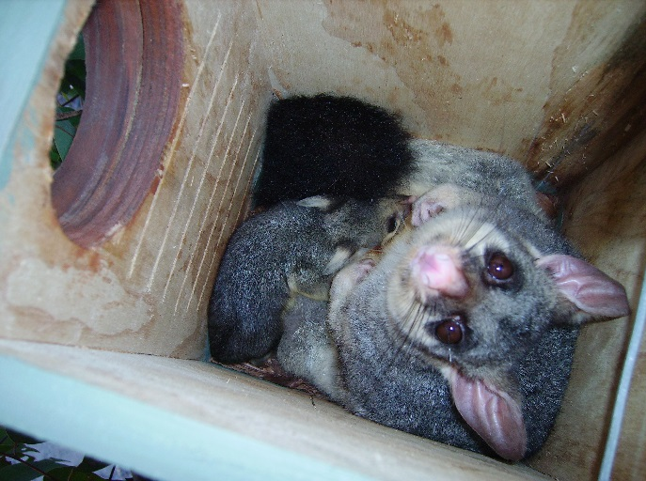
Brushtail possum and baby in nest box
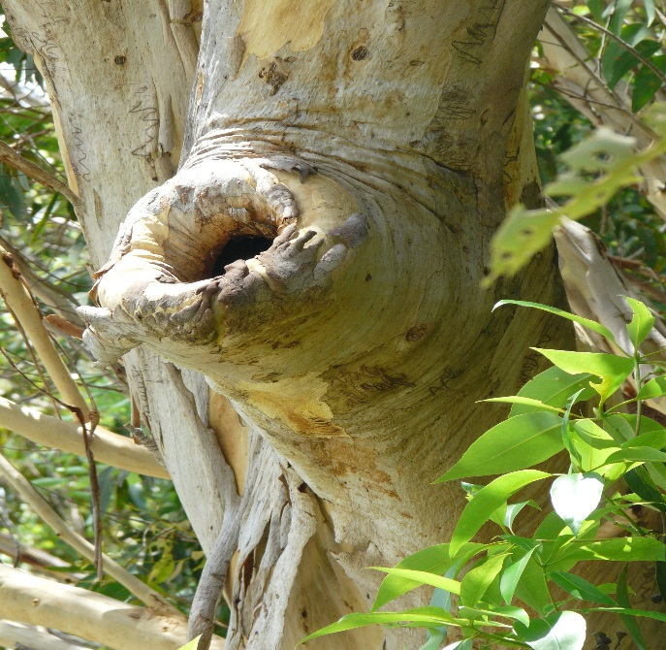Natural hollow in a scribbly gum (Eucalyptus racemosa)
Natural garden habitat
When designing your backyard habitat try to include as many natural habitat features as possible. Put some logs and rocks in your garden to provide shelter, protection and resting spots for ground dwelling species such as lizards, geckos, antechinus, frogs and the many invertebrates they feed on.
Allow a thick layer of leaf litter, twigs, seed pods, old flowers heads and bark to build up in your garden as a natural composting mulch layer. Leaf litter, twigs and logs in your garden also provide important habitat for fungi to grow. Fungi is an important food source for invertebrates who in turn become food for birds, lizards, skinks, geckos and frogs.
Include some plants that have dense, prickly or sharp foliage to provide a protective micro-habitat for small birds.
Larger trees provide perching, look out and roosting (sleeping) sites for birds. Trees that have connecting canopies within and across urban backyards also provide opportunities for arboreal species to move around our neighbourhood, safely out of the reach of dogs, cats and cars. Plant to provide year round food supply
Attracting wildlife and in particular, native birds to your backyard can be as simple as planting some native flowering trees or shrubs. However, if you want to have birds and other native wildlife all year round you will need to provide them with a reason stay or to continue to return through the different seasons. This is done by planting a broad variety of native plant species that flower, fruit and produce seed at alternate times throughout the year. By planting a diversity of plant species, you will create a valuable food resource for a variety of native wildlife species throughout the entire year rather than just for one season.
Connected backyards and wildlife corridors
When designing your backyard habitat or choosing where to plant any new plants consider any opportunities to connect your habitat or garden to adjoining or neighbouring gardens and /or bushland vegetation, to create a larger area of habitat and to form vegetated corridors through urban areas.
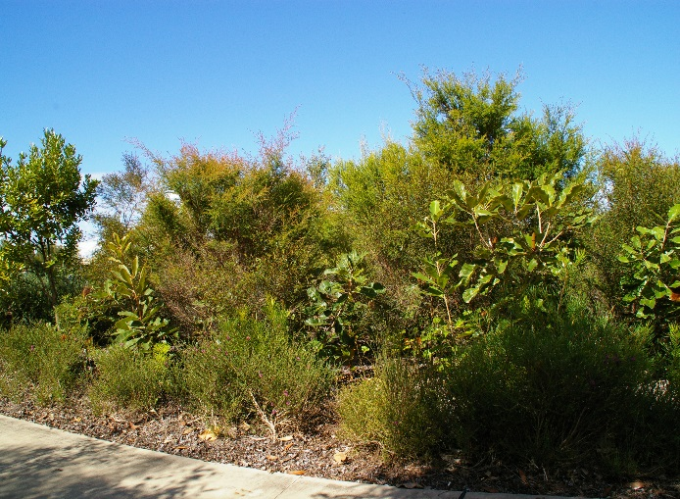
By connecting vegetation and gardens through urban areas we can link backyards, front yards, drainage reserves, parks and bushland to create vegetated corridors and stepping stones. These corridors and links will assist a variety of wildlife species to move between larger bushland areas and will also increase foraging, roosting and nesting opportunities.
Dense prickly shrubs provide habitat for smaller native birds
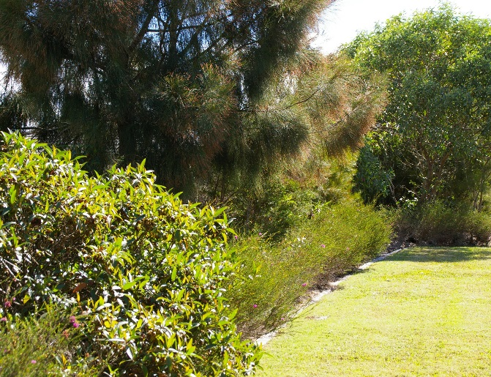
Native gardens can be neat with formal edging
Fungi
The thought of fungi in the backyard garden often sparks panic in the home gardener with thoughts of spreading fungal diseases and dead and dying plants. However not all fungi are a threat to our gardens. They are an essential component in our ecological processes and cycles.Two key groups of fungi in our backyards include:
- decomposer fungi play an important role in the recycling of nutrients and breaking down of organic material into nutrient rich natural compost.
- mycorrhizal fungi are a beneficial group of fungi that attach themselves to the roots of plants and assist the plants in the uptake and processing of water and organic nutrients from the soil.
Plants grown in healthy living soils containing decomposed organic matter and mycorrhizal fungi are healthier, stronger and more resistant to disease and drought.

Current as at May 2020

