MODULE 3

Sinister Cyclones
Cyclones are a part of life in Queensland s coastal areas. Cyclones are powerful weather systems generating severe winds, strong rain and flooding that can cause significant damage to buildings, gardens and roads.

As a cyclone approaches, the wind and rain gradually increases over several hours. Winds caused by cyclones are powerful enough to break large trees, roll over sea containers, and blow away unsecured caravans, garden sheds and poorly constructed roofed patios.

Prepare – Clean-up your yard, pack a kit and have a plan.
Get current information about cyclones from the radio, television, social media or https://disaster.sunshinecoast. qld.gov.au/#Dashboard
Find a safe place in your home to shelter in a cyclone. Small rooms are best. If you need to leave, go to a family or friend’s house to stay safe. Your council may also have a centre for you to stay in.

After a cyclone, there might be fallen trees and powerlines.
Be careful outside.

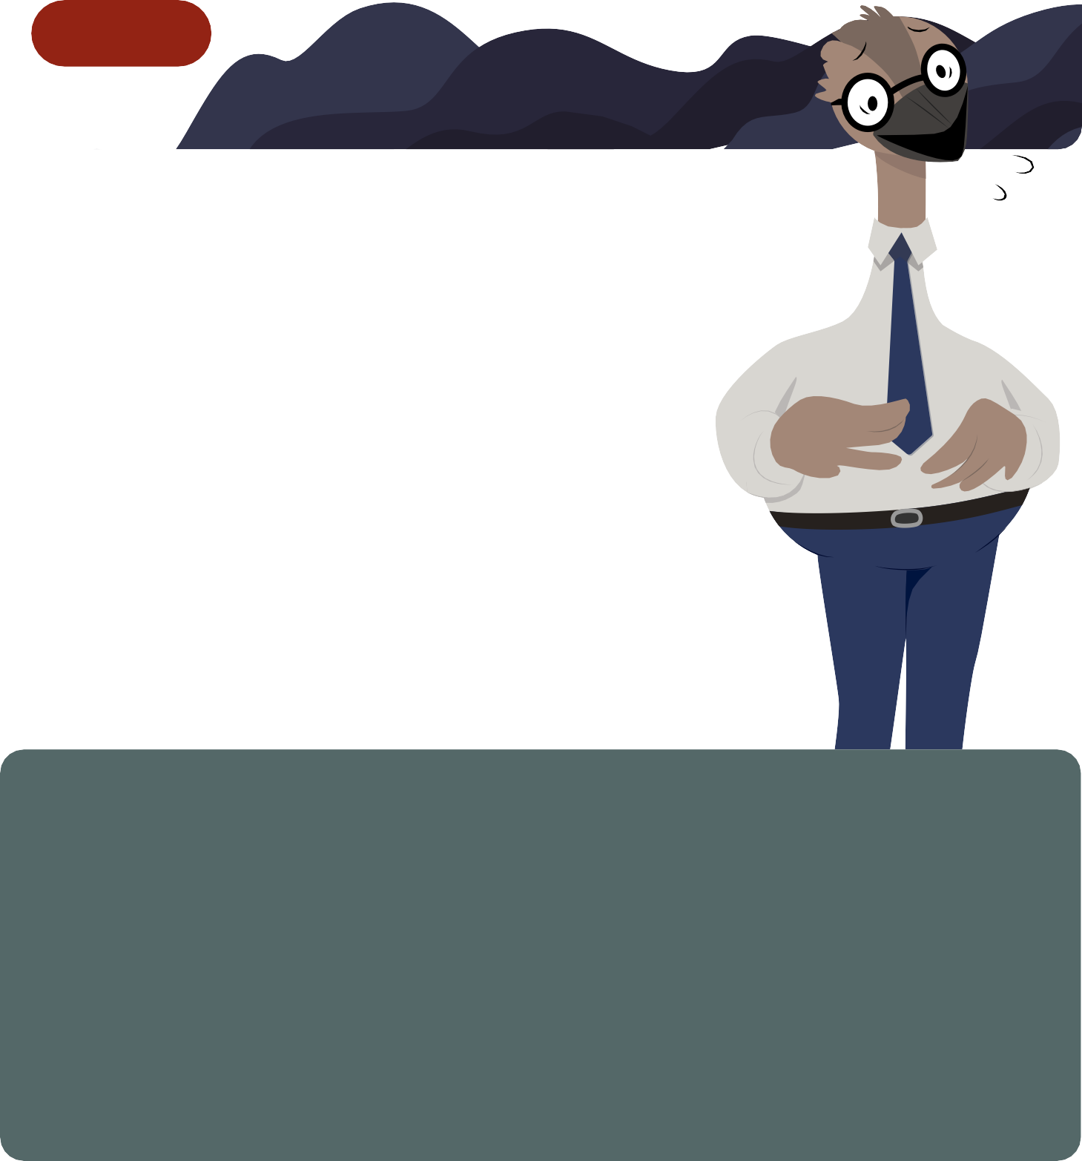
DISCUSSION QUESTIONS
- Have you ever been in a cyclone? What was it like?
- What do you think about cyclones?
- How do you know when a cyclone is coming?

- What could happen to your home or vehicle in a cyclone?
- How can you get your family, home and backyard ready for a cyclone?

