The Resident
Warana Coastal Pathway – Construction Update

Overview
The coastal pathway is the Sunshine Coast’s longest and most popular shared pathway, extending 73 kilometres from Bells Creek in the south to Coolum in the north.
Sunshine Coast Council’s vision is for this pathway to be a world-class scenic route, connecting the coast through beaches, parks and open spaces. The pathway provides people with the opportunity to explore the coast’s natural beauty, services and businesses.
Project scope
The Coastal Pathway Master Plan was endorsed by council in 2017 following significant community support for the project. The master plan identifies the Bokarina to Warana section as a ‘high priority missing link’.
Construction work will commence between Beach Access 236 (Minkara Street, Warana) and north of Beach Access 235 (Langura Street, Warana)
Contractor selection is currently in progress for the construction of the raised walkway north and south of Beach Access 234, Palkana Park. The path will then continue construction north towards to Beach Access 233, Coonang Crescent, Warana.
The concept plan (see page 2) shows the proposed alignment of the pathway.
Council holds an Operational Works Approval from the Queensland Government for construction of the new pathway and the design has been endorsed by the Department of Transport and Main Roads.
Construction program
Construction of the new section of pathway from Beach Access 236 to 235 is due to start in late September and will continue through October.
Treatment of weed species and clearing has already occurred in the lead-up to construction starting.
Environmental considerations
Council takes pride in preserving our natural environment and delivering projects for the community to experience the natural beauty of our region. The alignment of the pathway is designed to minimise impacts on native plants and fauna. A fauna and flora assessment has been completed and a fauna spotter will be present during clearing operations. Council creates and protects new habitat areas to offset unavoidable vegetation loss from development.
Revegetation and weed removal is a major component of the project and will continue following completion of the pathway construction. Long-term bush revegetation will also continue within the reserve
Access considerations
Beach Access 235 will be closed from the 5 October to facilitate construction activities and ensure public safety.
All efforts will be made to minimise any inconvenience and alternative routes to the beach will be signed.
Beach Access 235 is expected to be reopened to the public prior to the 10 December. For the latest access closures and updates please check Council’s website.

A note from your local councillor
Residents have been looking forward to the continuation of the Coastal Pathway for some time and I am pleased to advise work will commence shortly. This new section of pathway will complete the Coastal Pathway through Division 3 providing a much loved and utilised piece of community infrastructure for all to enjoy. Council will endeavour to minimise inconvenience during the construction and I thank residents in advance for their patience.
Cr Peter Cox

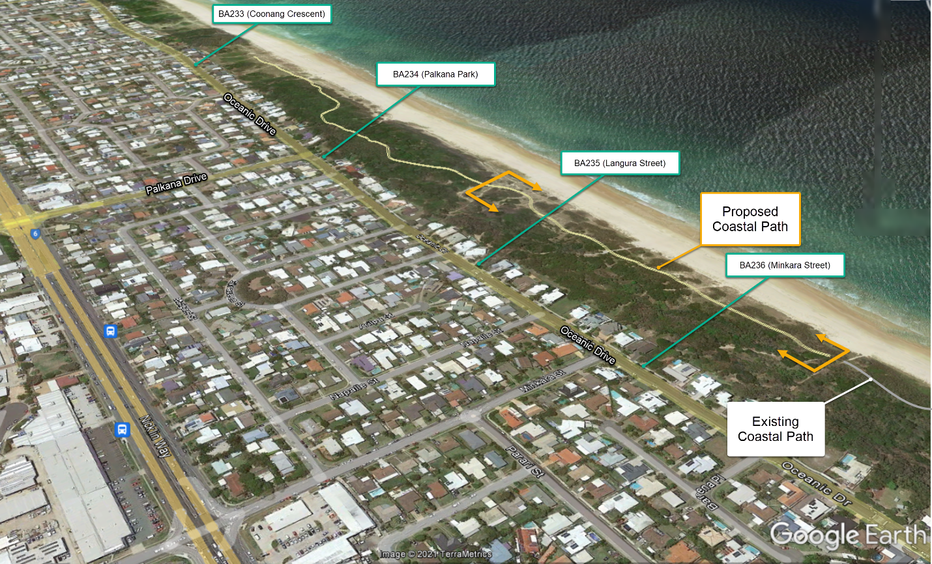
Figure 1: Warana Coastal Path Proposed Alignment

Further information
If you would like to contact Council about this project please contact Council’s Project Officer, Chris Lloyd on the details in the footer, quoting the project number H9537.

