Currimundi Lake Closure

Currimundi Lake is the largest of the four Intermittentely Closed and Open Lakes and Lagoons (ICOLLs) on the Sunshine Coast.

Under natural conditions the entrance behaviour of Currimundi Lake is influenced primarily by sand movement at the mouth and inputs from stormwater. Historical photographs suggest that closure during periods of low freshwater input or high sand movement on the beach are natural characteristics of the entrance of this ICOLL.

Purpose of the Closure

The closure of Currimundi Lake as part of the midge management program has been carried out by council on an as needs basis since 2005. Council performs works to close Currimundi Lake in Spring to be in sync with the most desirable part of the lunar cycle and biting midge larval levels. Biting midge are similar to mosquitoes as only the female midge bite and require a blood meal to fertilise their eggs. Biting midge do not transmit disease to humans, however they are common nuisances along the coast of Australia.

The midge that are present on the Sunshine Coast are particularly active during the warmer summer months of September through to April. During dawn and dusk midges are more active and most prevalent in suburbs close to inter-tidal zones (Refer to Sunshine Coast Council’s Biting Midges Fact Sheet).

These works aim to assist council in the management and mitigation of local midge populations. Lake water levels are raised up to approximately 500mm below the top of the upstream revetment walls. This inundates low lying sand banks which are used for the midge breeding cycle.

The larvae are drowned in the process which has proven to be a very effective treatment.

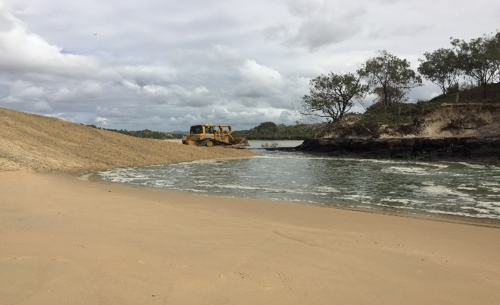

Currimundi Lake closure as at September 2016

Large machinery is used to close the lake. Council officers are on-site monitoring the operation and lake water levels throughout the operation. Public access to the beach and park areas are maintained throughout the bulk of these works, with the only closure being at the mouth of Currimundi Lake. The planned length of the lake closure is approximately 6 weeks to coincide with the midge breeding cycle, however the duration is dependent on water volume inputs into the lake and resultant levels. For example, the sand berm will be removed if rainfall levels cause overtopping of revetment walls and the outlet pipe’s limited capacity breached. In 2016 the annual budget allocation for these planned works was $30,000.

What triggers a closure?

The midge larval data for Currimundi Lake is recorded every week and compared against previous years.

The trigger to recommend a lake closure is larval densities increasing consistently over a number of months, as evident in the graph below with July levels being almost twice the long term average.

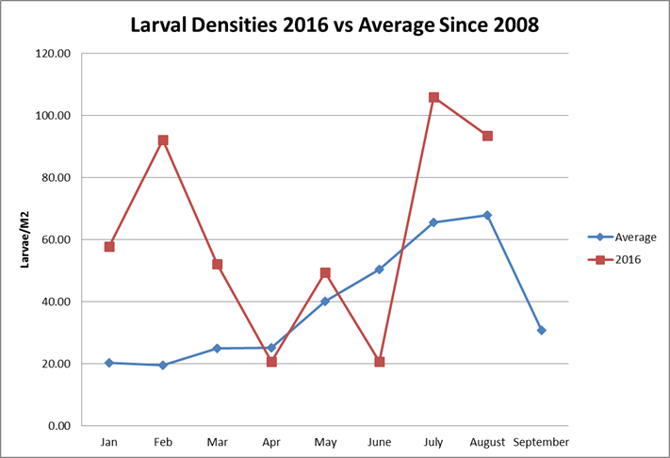

The monitoring data suggests that there is a significant hatch of adult midges anticipated for spring 2016. Based on monitoring larvae, levels are expected to continue to increase and may reach similar levels to last year when August recorded an average of over 200 larvae/m2. As per the graph below, larval abundance after closures consistently decrease.

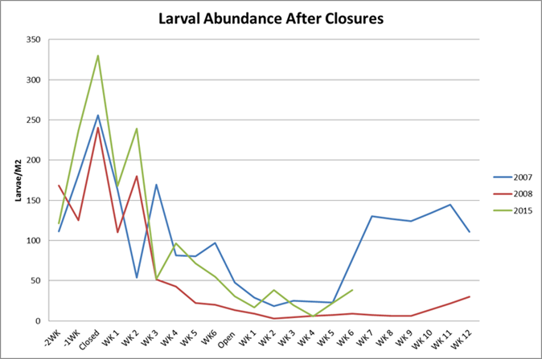

Flood mitigation (pipe and sluice gate)

The pipe and sluice gate is a temporary structure in its second generation trial. The primary purpose is to maintain a consistent water level of the lake during closure.

The sluice gate is opened or closed in response to lake water level changes e.g. from high rainfall events.

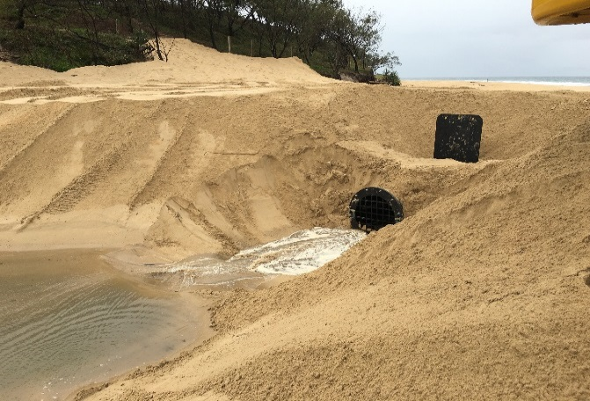

Sluice gate

Water quality monitoring

Water quality monitoring is conducted in Currimundi Lake during the biting midge management program to assess potential changes in the systems overall health. The parameters tested include temperature, pH, turbidity, salinity, bacteria, dissolved oxygen and nutrient levels. Focussed water quality testing will occur before, during and after the planned closure. If the monitoring indicates unacceptable levels, council will implement warning signage and potentially re-open the Lake.

Monitoring for fish diversity

A total of 61 fish species have been recorded over five fish surveys in Currimundi Lake (1993, 1997, 2000, 2013 and 2015).

The diversity of fish species caught in the lake has increased consistently over the five surveys, with substantially more fish species caught in the previous two surveys compared to the others. It is highly likely that the observed increase in fish species diversity over time is likely to be related to the system becoming more marine dominated. To complement the program mangrove monitoring and mapping is also carried out by council.

