 |  |  | Triple Zero (000)
 | Police, Fire and Ambulance
 | State Emergency Service (SES) for flood and storm emergency assistance |  | 132 500
 | Sunshine Coast Council |  | 07 5475 7272
 | Poisons helpline |  | 13 11 26
 | 13HEALTH |  | 13 432 584
 | Energex |  | 13 19 62
 | Ergon Energy |  | 13 16 70
 | Policelink (general enquiries) |  | 13 14 44
 | Road traffic and travel information |  | 13 19 40
 | Marine Rescue Queensland |  | 1800 073 7283
 |  | Tsunami warning | 1300 878 6264
 |  | RSPCA QLD 24/7 Animal emergencies | 1300 264 625
 | RSPCA QLD Lost and found |  | 1300 363 736
 | Biosecurity Queensland - for stranded livestock |  | 13 25 23

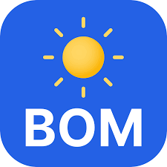
Bureau of Meteorology
MODULE 6
Sunshine Coast Heroes
Key Contacts
http://www.bom.gov.au/
The Bureau of Meteorology (BoM) is Australia’s national weather and climate agency.
Its expertise and services assist Australians in dealing with the harsh realities of their natural environment, including drought, floods, fires, storms, tsunami and tropical cyclones. The BoM provide regular forecasts, warnings, monitoring and advice spanning the Australian region.

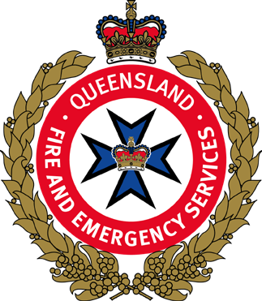
Queensland Fire and Emergency Services
https://www.qfes.qld.gov.au/
Queensland Fire and Emergency Services (QFES) is the state’s primary provider of fire and emergency services.
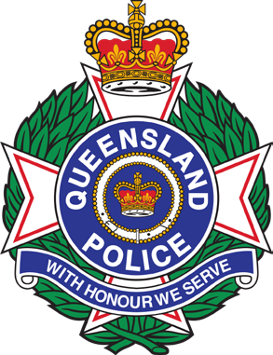
QFES services include Fire and Rescue, State Emergency Service, Rural Fire Service Queensland and other capabilities such as Emergency Management.

Queensland Police Service
https://www.police.qld.gov.au/
Every day the Queensland Police Service works tirelessly to ensure the safety and security of the community.

MODULE 6
Sunshine Coast Heroes

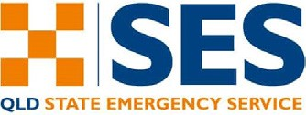 SES Assistance
https://www.qfes.qld.gov.au/about-us/frontline-services/state-emergency-service/ses- assistance

SES volunteers carry out temporary repairs to help people protect themselves and their property from further damage in circumstances, such as
- Damaged walls, windows and roofs
- Trees down blocking access
- Rising flood water
- Storm damage posing a threat to life or property.
Contact SES 132 500 from anywhere in Queensland for non-life threatening flood and storm emergency assistance during severe weather events. If the situation is life threatening, always call Triple Zero (000).

Sunshine Coast Council Disaster Hub
https://disaster.sunshinecoast.qld.gov.au/#Dashboard
Disaster Hub brings together disaster and hazard related information from within Council and external sources, building community disaster resilience, raising community awareness to natural hazards and risks, and protecting communities during disaster events.

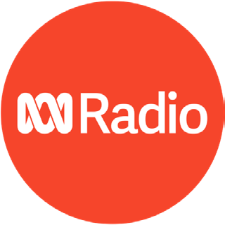
ABC Radio
https://www.abc.net.au/sunshine/live
Reliable media coverage, raising community awareness to natural hazards and risks during disaster events.
