MODULE 2

Ferocious Flooding

There are four main types of flooding experienced in Queensland.

River Flooding happens when widespread and prolonged rain falls over a river catchment.

Overland flow happens as water travels over the land during heavy rainfall events and generally occurs over a short period of time.
Creek flooding happens when intense rain falls over a creek catchment causing the creek levels to rise, which often occurs quickly with limited warning.
Storm tide flooding happens when a low pressure system or strong onshore winds force
sea levels to rise above normal levels, creating a storm surge that can cause flooding of
low-lying areas close to tidal waterways and foreshores.

Floods are dangerous because the rising water can injure people as well as damage buildings and cars. Floods can be caused by rising rivers, creeks, ocean tides and drains.

What else might your family need if you are stuck at home during a flood?
- Do not swim or play in flood waters because the water carries rubbish and other dangers.

- Do not drive in flood waters because there are dangers in the water that could damage your car and injure people inside.

- Flood water might damage your home, stop electricity supply, and close roads.

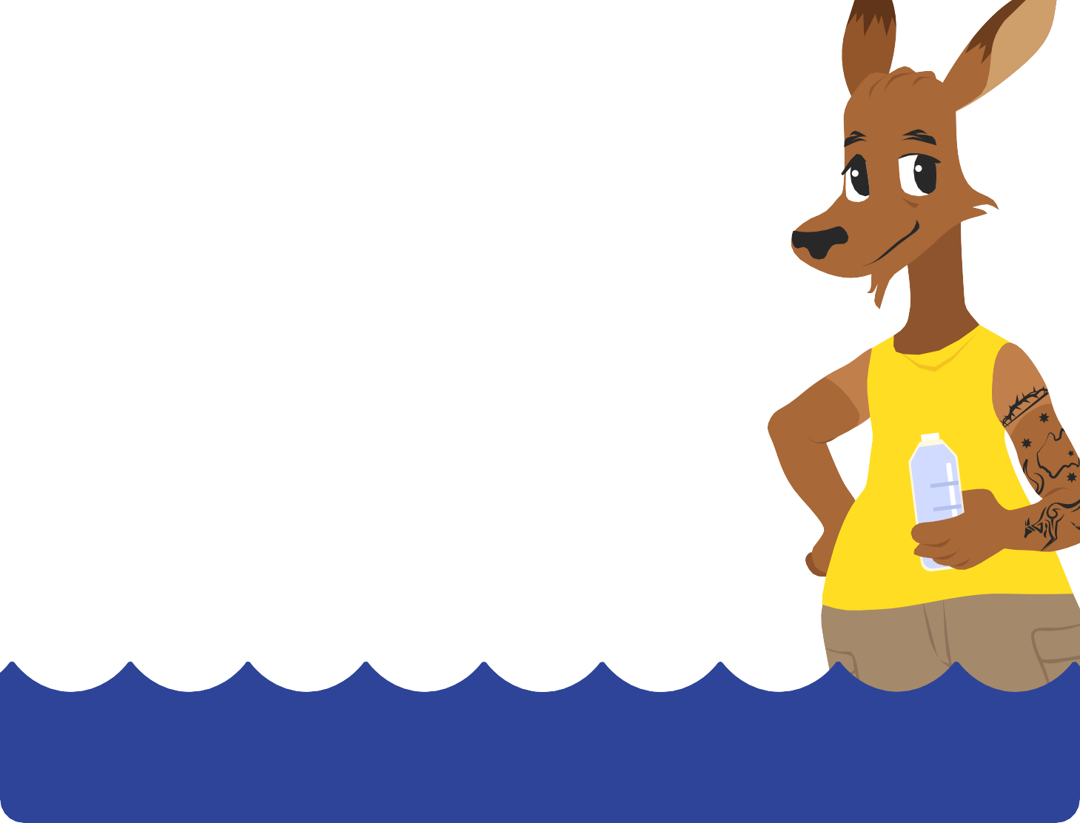
DISCUSSION QUESTIONS
  - Have you been in a flood? What was it like?
  - What do you think about floods?
  - What might cause a flood where you live?

  - How do you know if a flood is coming?
  - What would happen if water came into your home?
  - How would you prepare if you knew a flood was to happen?

