EVENT WASTE CALCULATIONS GUIDE
1. HOW TO CALCULATE THE NUMBER OF BINS REQUIRED
The number of bins required depends on:
- Expected number of attendees
- Time of day
- Duration of the event
- Number of meal times
- Food, drink or alcohol being served
- Waste management minimisation strategies utilised
Calculation
Guide  - NO food and drink being served:  1 x 240L general waste bins + 1 x 240L recycling bins for every 100 attendees  - Food and drink being served:  2 x 240L general waste bins + 2 x 240L recycling bins for every 100 attendees  - More than a 1000 attendees also add 1 x 3m³ general waste + 1 x 3m³ recycling for each 1000 people attending | Working example  For 2000 attendees with food and drink being served /sold  40 x 240L general waste  40 x 240L recycling  2 x (1 x 3m³) general waste  2 x (1 x 3m³) recycling

If you can demonstrate that steps have been taken to reduce the amount of waste generated, a reduction in bin infrastructure might be acceptable.

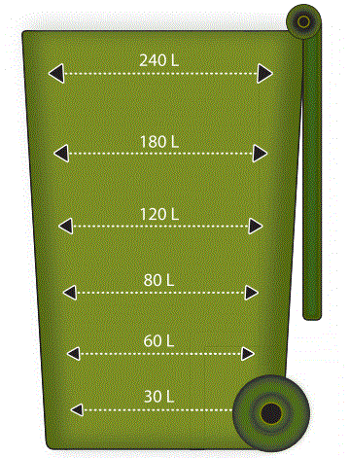
2. HOW TO RECORD WASTE AMOUNTS FOR THE DIFFERENT WASTE STREAMS
How to assess quantities in a 240 litre bin
FULL | = 240L
¾ full | = 180L
½ full | = 120L
1/3 full | = 80L
¼ full | = 60L
To estimate the quantities of materials in a wheelie bin you need to estimate how full it is as part of its
240 litre capacity. This graphic provides you with a guideline on how to estimate the volume of materials in these bins.
How to assess quantities in skips
To report the amount of cardboard or other materials placed in a skip, it is easier to estimate it in square metres. Most skips for cardboard are 3 cubic metres in size. Apply a similar calculating method to the one shown above (though you will often find most skips are completely full of cardboard by the end of the day).
Collating the information
As you or your team members walk around the event towards the end of the day, do these calculations for each bin or skip and add them to the following ‘waste calculation sheet’. (Be careful to take note, during the day, of how many bins have been emptied and add amounts from these bins to the total.)
Finally add up all amounts.

WASTE CALCULATION SHEET
EVENT |  |  |  | DATE
NAME OF TEAM MEMBER DOING COUNT
NUMBER OF BINS
Number of waste bins |  | Number of recycling bins |  | Number of composting bins
Number of waste skips |  | Number of recycling skips |  | Number of cardboard bins
(If you are counting only a percentage of overall bins/skips, indicate how many you are counting)
VOLUMES IN BINS (These are the ones presented for collection by the waste contactor)
Waste (240L)
Waste skip (m³)
Other waste bins/ skips emptied during the day
TOTAL ESTIMATED WASTE VOLUMES
Recycling bins (240L)
Recycling skip (m³)
Cardboard skip (m³)
Other recycling bins/ skips emptied during the day
TOTAL ESTIMATED RECYCLING VOLUMES
Compost bins (240L)
Other compost bins/ skips emptied during the day
TOTAL ESTIMATED COMPOSTING VOLUMES

