MODULE 1

What is a Disaster?

Natural disasters affect Queenslanders more than anyone else in Australia. Being prepared for severe weather is an important part of living here.

A natural disaster can happen at anytime and things can change very quickly. There can be bushfires one month and floods the next.
Our weather is unpredictable, so you should have a plan.

The most common types of disasters that can happen in Queensland are:

Cyclones and storm surges
Storms
Floods Bushfires

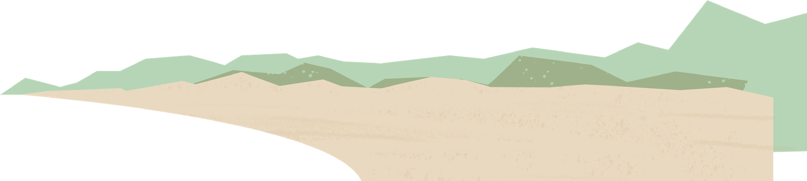
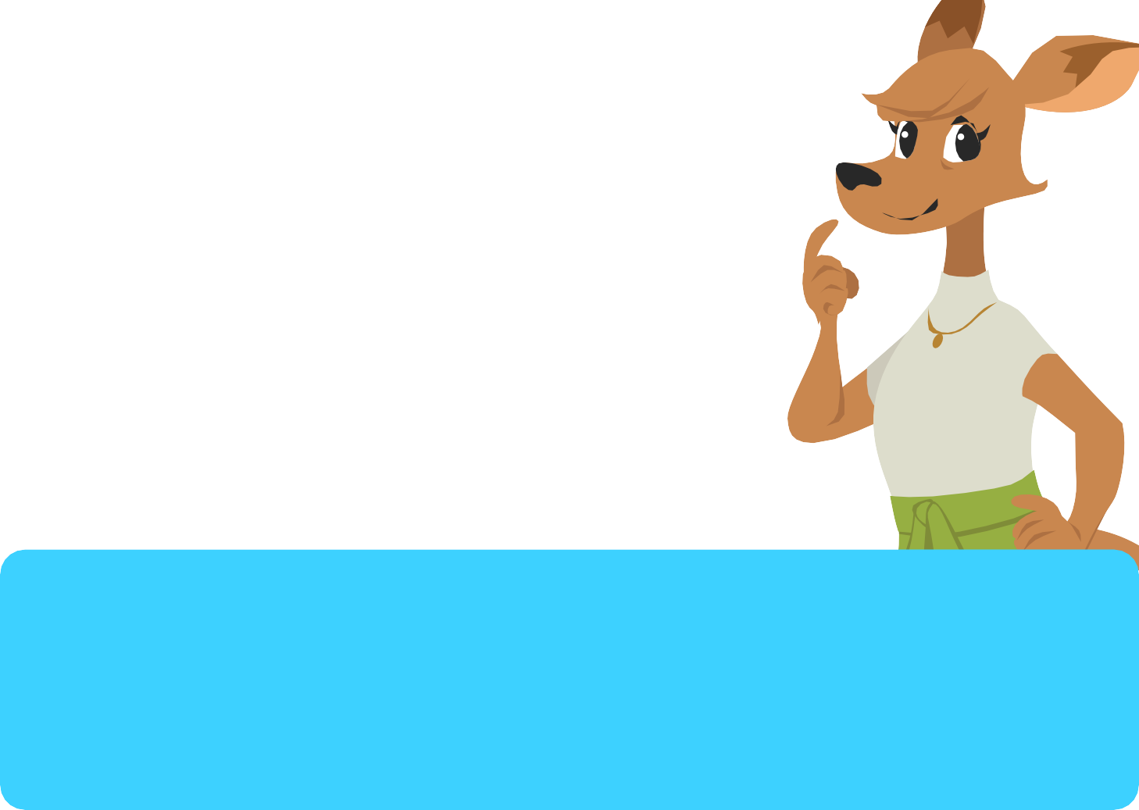
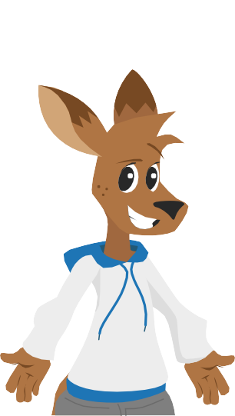
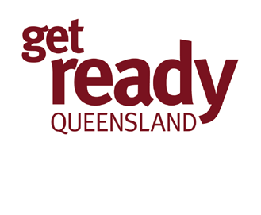

Everyone's disaster risk is different. Where you live determines the types of natural disasters that affect you.

- Storms can happen anywhere in Queensland. They can happen all year round but are more common during Summer.

- Floods happen after big rain events. People who live near water and in low lying areas are more likely affected.

A bushfire is more likely to affect people who live in dry, rural areas.
Cyclones are common for people in North Queensland who live in warm, humid climates.

Some disasters such as a pandemic and heatwaves can happen to anyone at any time.

- Cyclones & Storm Surges happen during warm weather. People who live in hot climates near the coast are more likely to be affected by cyclones. Cyclones are common for people in Northern Queensland.

- Bushfires happen on hot, dry days. They affect people who live in the country the most. Bushfires are dangerous for all Queenslanders who live near bushland, scrubs or forests.

