When visiting our reserves
please remember
bird checklist



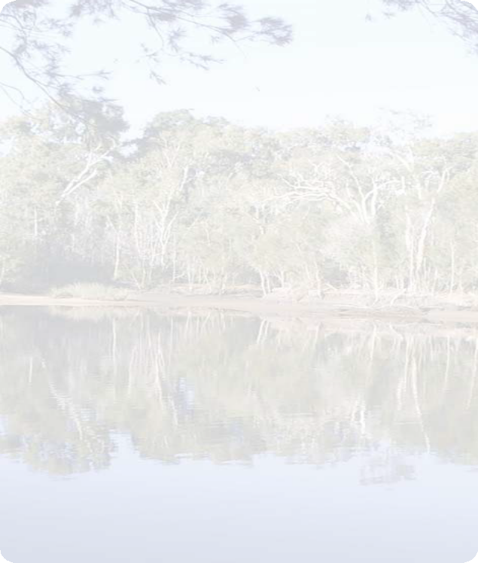
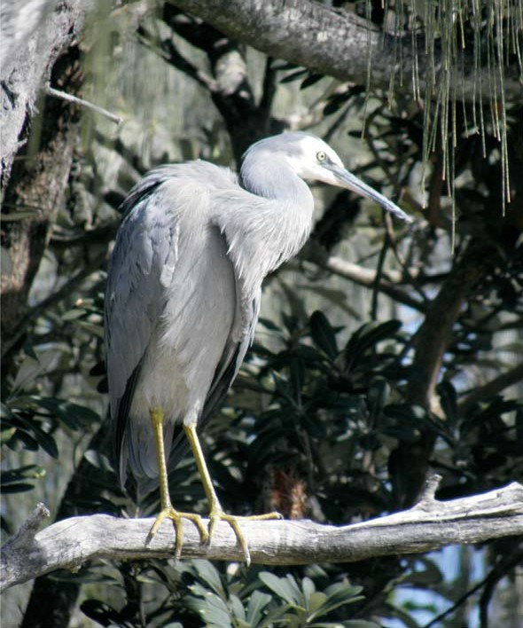
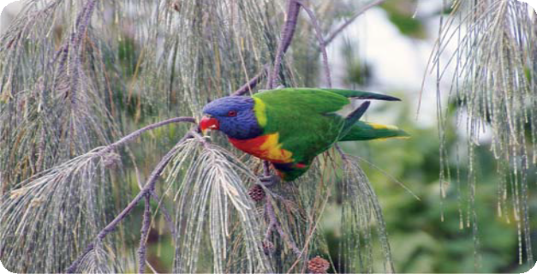
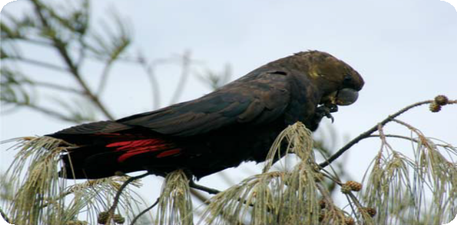
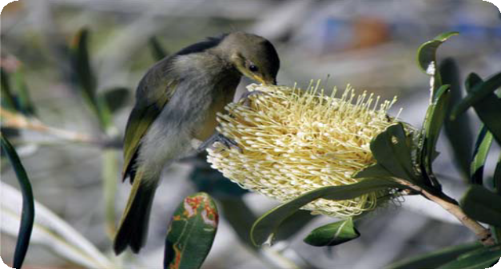

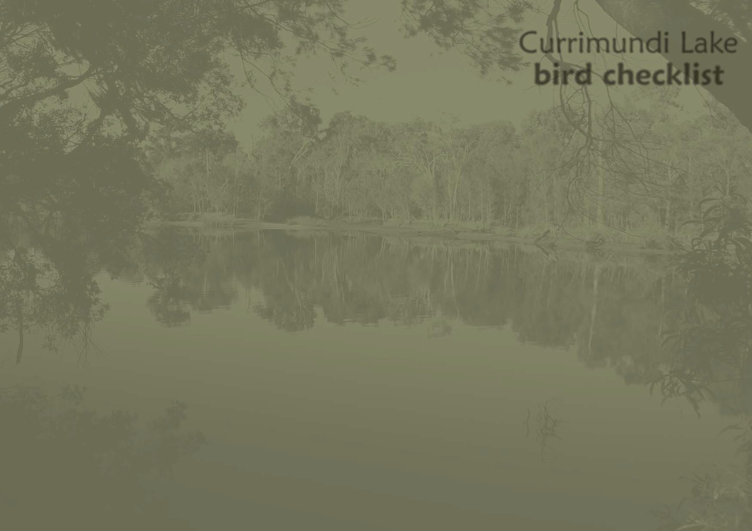

Glossy-black Cockatoo

Rainbow Lorikeet

Brown Honeyeater

* All native wildlife and plants in our reserves are protected.

* Do not feed wildlife.

* Stay on the formal paths around the lake edge.

* Dispose of rubbish in the bins provided or take it home with you for disposal.

* Dogs are welcome in the reserves but should be on leash.

* Cyclists should allow adequate space for people walking along the paths in the area.

* Canoes and other non-motorised watercraft should be launched from the designated canoe facilities. Motorised watercraft
should be launched from the boatramps provided.

* Use of other areas on a regular basis can cause bank erosion.

* Take care and supervise children when using our canoe and lakeside paths.

For further information please contact council’s Customer Service Centre
on (07) 5475 7272 or the website on
www.sunshinecoast.qld.gov.au

White-faced Heron

If you enjoy using the Currimundi Lake canoe, cycling and walking trails, you may see over 50 species of birds in the different remnant bushland ecosystems and open parkland.

This checklist can help you identify some of the most commonly seen species.

Species List:

Australian Darter – Anhinga melanogaster Australian Magpie – Gymnorhina tibicen Australian White Ibis – Threskiornis molucca
Black-faced Cuckoo Shrike – Coracina novaehollandiae Blue-faced Honeyeater – Entomyzon cyanotis Brahminy Kite – Haliastur indus
Brown Honeyeater – Lichmera indistincta Crested Pigeon – Ocyphaps lophotes Eastern Great Egret – Ardea modesta Figbird – Specotheres viridis
Grey Butcherbird – Cracticus torquatus

Grey Shrike-thrush – Colluricincla harmonica Glossy-black Cockatoo – Calyptorhynchus lathami Laughing Kookaburra – Dacelo novaeguineae Lewin’s Honeyeater – Meliphaga lewinii
Little Wattlebird – Philemon citreogularis

Magpie-lark – Grallina cyanoleuca

Masked Lapwing – Vanellus miles
Pale-headed Rosella – Platycercus adscitus Pied Butcherbird – Cracticus nigrogularis Pied Currawong – Strepera graculina
Rainbow Lorikeet – Trichoglossus haematodus

Royal Spoonbill – Platalea regia

Sacred Kingfisher – Todiramphus sanctus

Scaly-breasted Lorikeet – Trichoglossus chlorolepidotus

Silvereye – Zosterops lateralis

Spangled Drongo – Dicrurus bracteatus

Spotted Turtle-dove – Streptopelia chinensis
(introduced species)
Striated Pardalote – Pardalotus striatus Torresian Crow – Corvus orru Welcome Swallow – Hirundo neoxena White-cheeked Honeyeater
– Phylidonyris nigra

White-faced Heron
– Egretta novaehollandiae

Willie Wagtail
– Rhipidura leucophrys

Noisy Friarbird – Philemon corniculatus

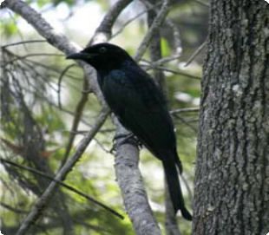
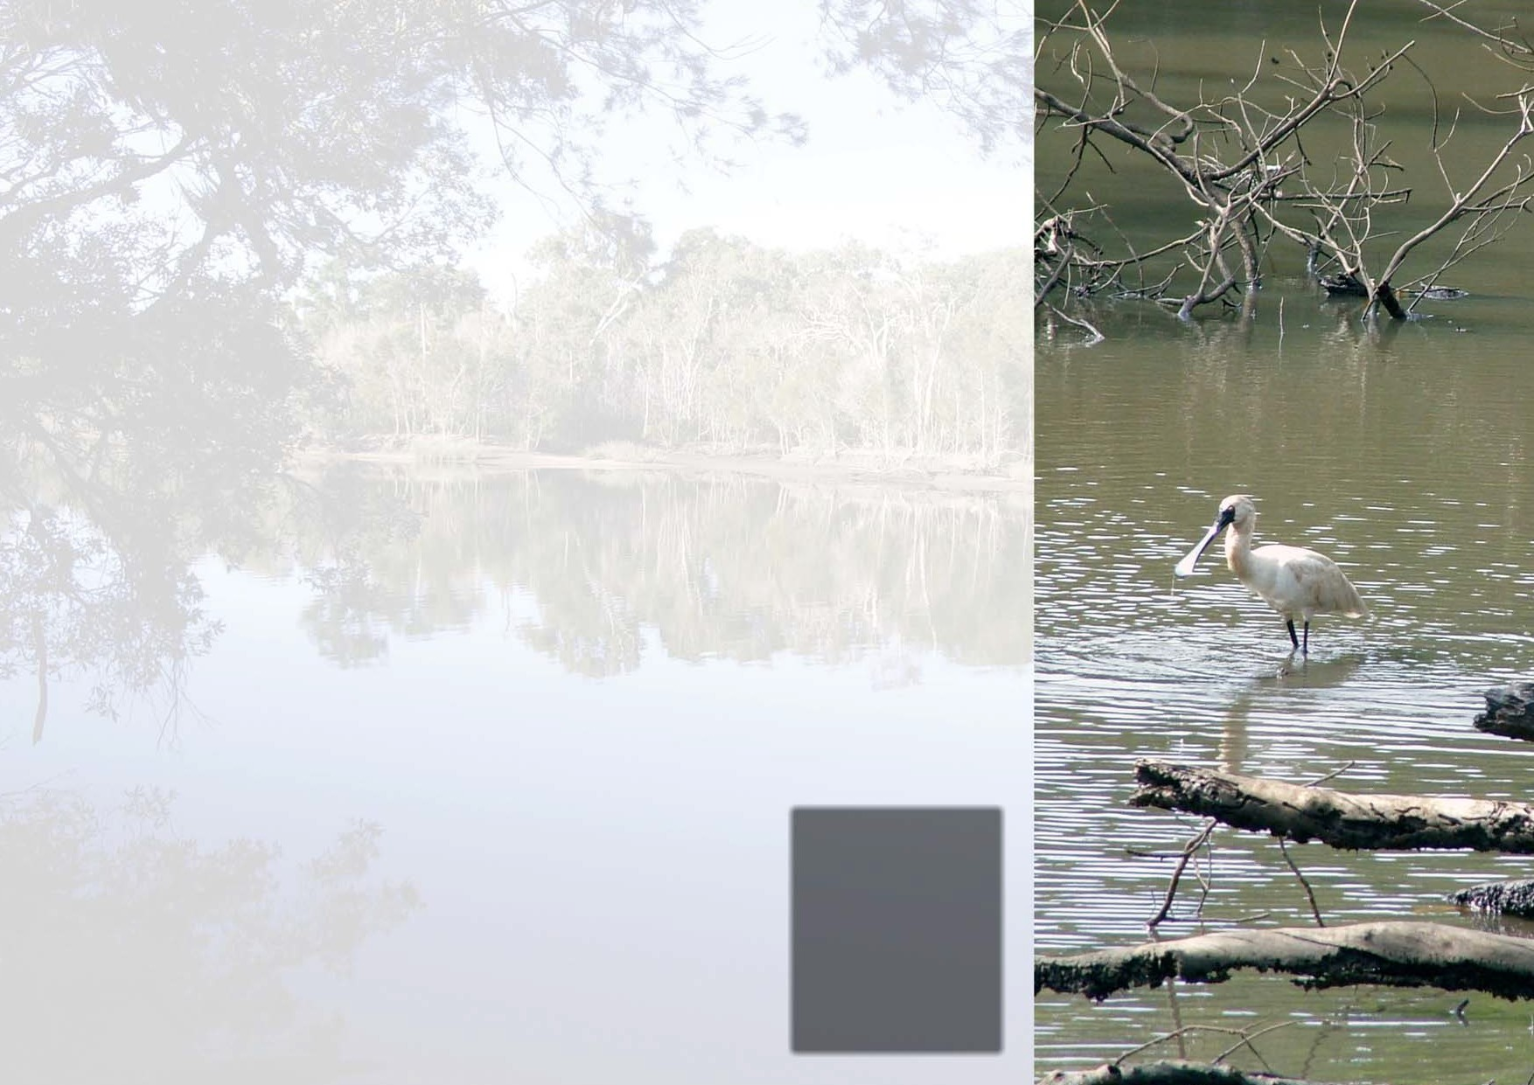
Noisy Miner – Manorina melanocephala Right:
Spangled Drongo

Royal Spoonbill

