Tenancy Opportunity – Caloundra Visitor Information Centre - 7 Caloundra Road, Caloundra

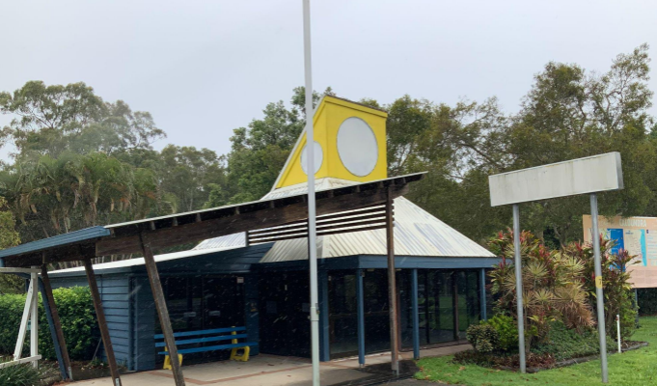

Property Details
The Caloundra Visitor Information Centre building is located prominently along Caloundra Road, Caloundra and is one of the major entrances to the region and the broader Caloundra precinct. Council is Trustee of the land for which the approved purpose is Visitor Information Centre and no other purpose whatsoever.
The location benefits from additional accessibility via a convenient internal access road (Caloundra Road Service Lane) with the surrounding land comprising of parklands, seating areas, public amenities and recreational vehicle stop.
The Caloundra Visitor Information Centre building is approximately 80m² in area and provides a mix of office space, open multiuse space, service counter with small undercover outdoor spaces.
An opportunity exists for interested parties to utlise the Caloundra Visitor Information Centre with the only compatible use being a Visitor Information Centre.
Key Features
- Approximately 80m² building in a prominent high exposure location.
- Parkland, seating, car parking, public amenities and recreational vehicle stop in close proxiomity.
- Mix of spaces and layout ready to make your vision a reality.

Indicative Agreement Details
- A three-year tenancy agreement is proposed for the offered property. Approximate costs to establish the tenancy arrangement are $2,500 to $4,000 and are payable by the successful applicant.
- Applicants will be required to provide any upgrades to the premises to meet their proposed use.
- Applicants will be responsible for all outgoings and maintenance of the property.

Application Details
Council will be accepting applications from the market, from Monday 28th October 2024 with the closing date for submissions being Monday 25th November 2024 at 5:00 pm
An Information Session will be held on Wednesday 6th November 2024 from 2:00 pm to 3:00 pm. Registration is mandatory via propertymanagement@sunshinecoast.qld.gov.au
Applicants will be required to submit both:-
- The Offer: Tenancy Application Form in this information pack; and
- Documentation requested in the Application Requirements Table in this information pack.

Tenancy Application Form
Land | Lot 460 on CG4280
Premises | The Caloundra Visitor Information Centre building located on part of the Land.
Relevant Area | 80m²
Owner | Sunshine Coast Regional Council
Applicant <insert>

ABN/CAN <insert>

Commencement Date | The date on which the Tenancy Agreement is singed by both parties.
Term <insert>

Annual Commencing Tenancy Fee Payable | $ plus GST  The AnnualTenancy fee is payable in advance in equal monthly instalments.  Council Rates, Land Tax and other Statutory Charges included in the Tenancy Fee
Bank Guarantee | Bank Guarantee will be a minimum of $1,500 or equal to 3 months of the Annual Commencing Tenancy Fee whichever is greater.
Proposed Use <insert> | Visitor Information Centre and no other purpose.
Liquor Licence Requirements (if any) <insert>

Estimated Fit-Out Cost <insert>

Estimated Fit-Out Timeframe <insert>

Outgoings and Utilities | The Applicant will be responsible for all outgoings and utilities for the Premises including but not limited to water, electricity, gas and insurances.
Repairs and Maintenance and Fit-Out | The Applicant is solely responsible for the fit-out, repairs and maintenance of the Premises. Council doesn’t warrant the Premises fit for any purpose.
Applicants Proposed Special Conditions (e.g. liquor licence, outdoor seating licence, requirements incentives (if any) <insert>

Application Requirements
Table Text | Table Text
Tenancy Application Form | Completion of the Tenancy Application Form attached.
Business Plan | Applicants should detail their vision for the tenancy including:-  - Current structure and background of the organisation.  - Outline your vision for the permitted area.  - Proposed offering and proposed hours of operation.  - Demonstration of financial viability of the business plan.  - Evidence of strong financial stability including all funding streams and their providers.
Fit Out Concept Plans | Provide high level concept plans for the Applicants proposed fit-out of the premises (labelled “Fit-Out Concept Plans”) outlining at a minimum how the proposed fit-out:  - Caters for the proposed number and type of customer.  - Signage design and locations (both internal and external) at applicants expense.  - Any additional relevant information.
Experience and Referees | Describe your experience in conducting similar Requirements.  - Demonstrated experience in managing, owning or operating a similar service. Include details of the location.  - Provide a CV for the applicant’s key personnel who will be directly involved in the management and day-to-day operations of the business including skills, qualifications, and relevant experience.  - Provide contact details (including names, titles, telephone numbers and/or email addresses) for a minimum of two (2) referees who can specifically attest to the applicants experience in the operation of similar or comparable business.  - Any additional information.
Social and Cultural Benefits | Outline any specific social benefits the proposal provides the Sunshine Coast Region.

Contact Details
For further information on this property please contact Council’s Land Management team via email at propertymanagement@sunshinecoast.qld.gov.au

Submissions to apply for this property can be made to Sunshine Coast Regional Council attaching all required application materials via email to propertymanagement@sunshinecoast.qld.gov.au

