Maroochy Arts and Ecology Centre

The Federally funded Maroochy Arts and Ecology Centre opened in August 2011. Nestled in the heart of the Maroochy Regional Bushland Botanic Gardens, it is an inviting venue for art and environment workshops, exhibits, talks and research programs. The building includes a multi-function room, workshop space, reading room and cafe, with themed landscaping showcasing local native plants.

An exemplar of sustainable design, the
Centre is energy and water efficient with solar panels, rainwater harvesting and use, and
natural lighting and ventilation.

Functional and Adaptable

Designed to be flexible, adaptable and expandable, the key features include:
connected and flexible workshop, multi-purpose room, outdoor space and storage areas
cavity sliding walls, modular grid and internal planning flexibility
visual and acoustic privacy between spaces flexible power and communication equipment and dimmable track lighting
minimal maintenance: polished concrete floors, durable internal wall linings, fibre cement sheet and plywood cladding
structure designed as a slab, columns and roof, so that all internal walls can be adapted for future uses.

Water Management

Stormwater

Two feature gutters along the central spine of the building minimize downpipe connection and leaf clearance. Stormwater runoff is directed into four 23,000L rainwater tanks, with overflow to a small bioretention pond. The landscape channels excessive rainfall via overland flow paths to the bioretention pond to remove nutrients and heavy metals.

Stormwater bioremediation pond

Roof runoff for potable water, toilets and irrigation

Roof runoff is gathered in four 23,000L rainwater tanks. Water is filtered by first flush diversions and a two stage cartridge filter system with a final UV filter. Water saving features include: motion sensors for taps; low water use toilets and basins; dual flush systems; and a mechanical
lever for wash basins. A heat pump on the hot water system helps to reduce energy use.

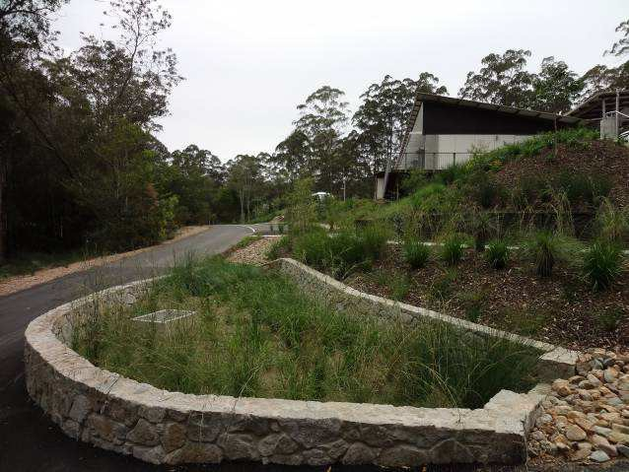
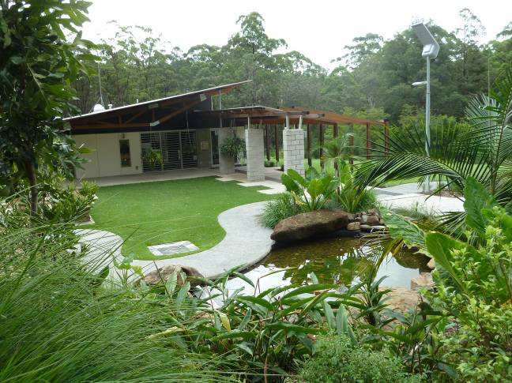


1 of 2 Maroochy Arts and Ecology Centre - Building Design and Water Management

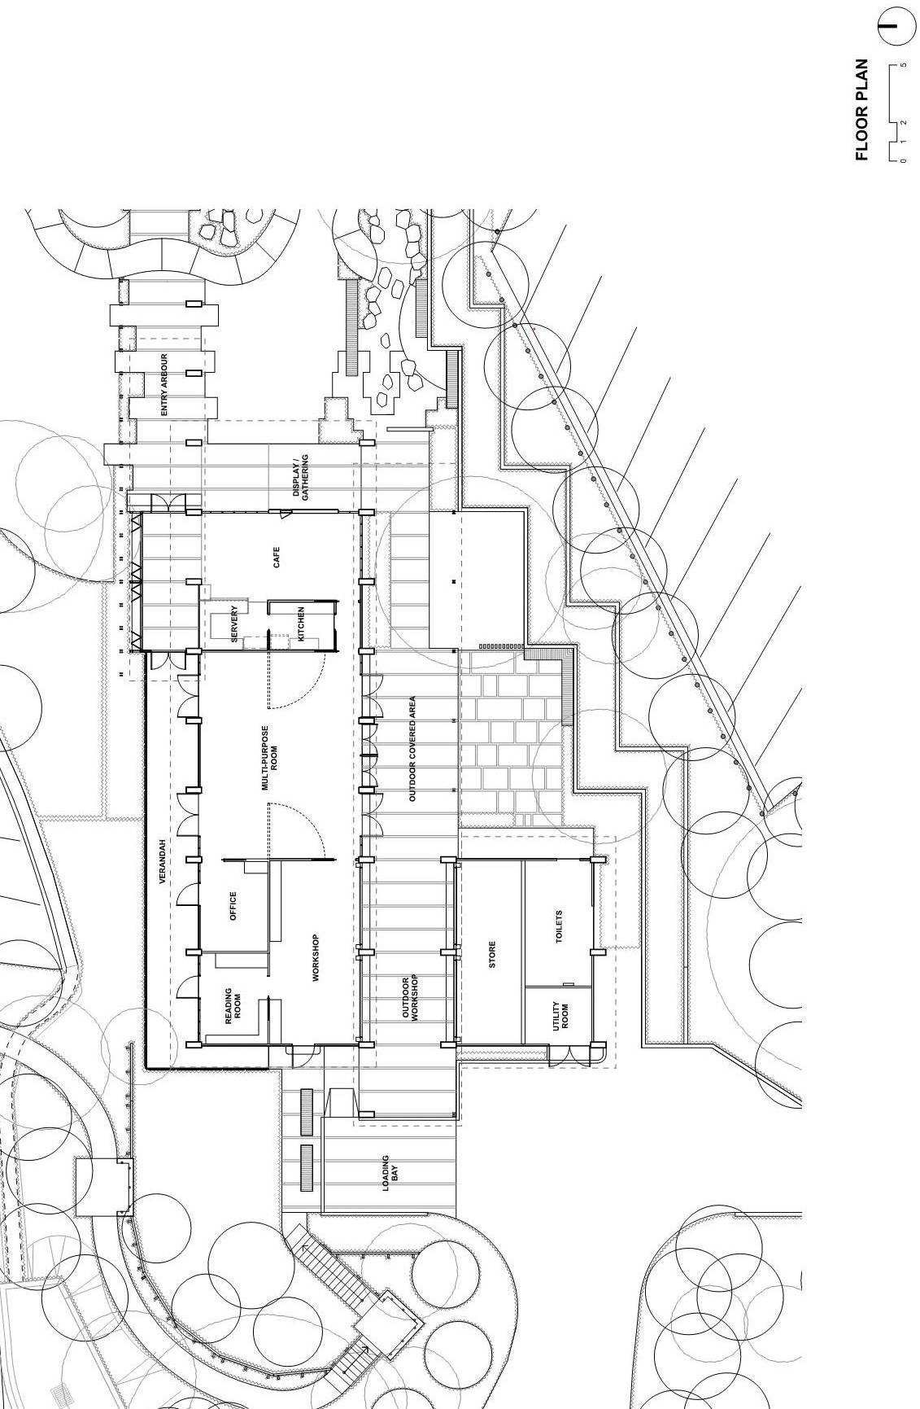



Figure 1 – Floor Plan of Arts and Ecology Building

2 of 2 Maroochy Arts and Ecology Centre - Building Design and Water Management

