Elizabeth Daniels Sports Complex Master Plan 2013 – 2028: Part 1
Elizabeth Daniels Sports Complex Master Plan 2013 - 2028

October 2013

Prepared by:

Strategic Leisure Group
Leisure Planning and Management Consultants

Brisbane Office
Suite 8, 29 Mt Cotton Rd
[PO Box 1358]
Capalaba Qld 4157
Ph: (07) 3823 5688
Fax: (07) 3823 5689
E: brisbane@strategicleisure.com.au
Web: www.strategicleisure.com.au

And

DFS Group
Town Planning and Landscape Architecture
Level 6, 57 The Esplanade
Cotton Tree Qld 4558
Ph: (07) 5430 8300
E: planners@dfstp.com.au
Web: http://www.dfstownplanners.com.au

2013 Strategic Leisure Pty Ltd t/a The Strategic Leisure Group. This document may only be used for the purposes for which it was commissioned and in accordance with the terms of engagement for the commission. Unauthorised use of this document in any form whatsoever is prohibited.

© Sunshine Coast Regional Council 2013.
www.sunshinecoast.qld.gov.au
mail@sunshinecoast.qld.gov.au
T 07 5475 7272 F 07 5475 7277
Locked Bag 72 Sunshine Coast Mail Centre Qld 4560
Acknowledgements
Council wishes to thank all contributors and stakeholders involved in the development of this document.
Disclaimer
Information contained in this document is based on available information at the time of writing. All figures and diagrams are indicative only and should be referred to as such. While the Sunshine Coast Regional Council has exercised reasonable care in preparing this document it does not warrant or represent that it is accurate or complete. Council or its officers accept no responsibility for any loss occasioned to any person acting or refraining from acting in reliance upon any material contained in this document.
TABLE OF CONTENTS

1. Project Background 1
1.1. Project Methodology 5
2. Background Research 6
2.1. Literature Review 6
3. Site Investigation and Constraints 15
3.1. Site Overview 15
3.2. Site Assessment and Observations 17
3.2.1 Site Assessment 17
3.2.2 Site-in-use Observations 18
3.3. Site Utilisation 19
3.3.1 Maroochydore Cricket Club 19
3.3.2 Headland Bowls Club 20
3.3.3 Maroochydore SES 20
3.3.4 Sunshine Coast Gem & Fossicking Club 21
3.3.5 Sunshine Coast Cricket Association 21
3.3.6 Sunshine Coast Contract Bridge Club 22
3.3.7 St John Ambulance 23
3.3.8 Headland Buderim Croquet Club 23
3.3.9 Maroochydore Eagles Basketball Association 24
3.3.10 Sunshine Coast Art Group 25
3.3.11 Combined Usage Analysis 26
3.3.12 Implications of Site Usage 26
3.4 Site Constraints 27
4 Consultation 38
4.1 Council 38
4.2 Community/School Consultation 39
4.3 Community Groups 39
4.3.1 Buderim Men’s Shed 40
4.3.2 Mooloolaba Lions Club 40
4.3.3 Buderim Billiards and Snooker 40
4.3.4 Implications for Master Plan 41
5 Traffic Advice 43
5.1 Transport 43
5.2 Internal Movement 46
5.3 Pedestrian Access 46
5.4 Parking 46
5.5 Implications for Master Plan 47
6 Catchment 48
6.1 Population/Membership 48
6.2 Catchment Facilities 50
7 Trends Analysis 52
7.1 Participation Trends 52
7.2 General Trends 53
8 Key Findings 55
9 Consultation on Draft Master Plan 57
10 Proposed Facility Mix 58
11 Master Plan Design 65
12 Management/Tenure Analysis 68
12.1 Current Arrangements 68
12.2 Future Tenure and Management Arrangements 70
12.2.1 Car Parking and Internal Road Network 70
12.2.2 Establishment of Advisory Group 70
13 Funding Opportunities 72
13.1 Council Grant Opportunities 72
13.1.1 Sports Field Maintenance Funding Program 72
12.3.2 Community Grant Program (On Hold) 72
12.3.3 Community Partnership Program 72
12.4 External Funding Sources 73
12.4.1 Federal Government 73
12.4.2 Queensland State Agencies 73
12.4.3 Non-Government Organisations 75
12.5 Business Plaza 76
12.6 Commercial Sources 77

Project Background
Elizabeth Daniels Sports Complex (the Complex) is an important district sport and recreation facility with regional elements servicing the Buderim locality and the Sunshine Coast community. It is the headquarters for Sunshine Coast Cricket Association and accommodates a wide range of sport, recreation and community activities that are valuable assets to the surrounding community and/or the wider region. There are some unique factors that must be considered as part of the master plan process for this Complex, particularly the proposed widening of the Sunshine Motorway, neighbouring bushland and the site’s prior use as a land fill site.
Earlier Master Plans have been developed for the Elizabeth Daniels Sports Complex in 1998 and 2004. Since the most recent Master Plan in 2004 a range of factors have influenced the need to update council’s strategic vision for the Complex, including:
- The potential impacts to the site of any works associated with the Department of Transport and Main Roads Multi Modal Transport Corridor and the Caloundra to Maroochydore Corridor Study;
- Sunshine Coast Sport and Active Recreation Plan 2011 – 2026 recommendations including:
  - Where road/rail corridor developments outside council’s control are likely to impact on existing sporting facilities, ensure no net loss of capacity and, where relocation is required, provide good access and redevelopment to an equal or better standard.
  - Liaise with stakeholder clubs and undertake a master plan for Elizabeth Daniels Reserve, incorporating the following elements:
    - Development of an additional cricket oval
    - Upgrading of facilities on the main cricket oval (spectator seating, sightscreen) in keeping with the venue’s regional status
    - Upgrade signage from the Sunshine Motorway; and
- Adoption of the Sunshine Coast Open Space Strategy 2011.
On this basis, council wishes to establish a long-term vision which determines the optimal layout and use for the Complex to 2028 through the development of this Master Plan.

The Master Plan considers the interrelationships between:
- Functionality, configuration, usage and capacity of the sites, including with local schools;
- Current character and functionality of the landscape;
- Needs across various sports and recreation uses, including current and future tenants;
- Emerging trends and issues;
- Priorities, levels of service and resources;
- Catchment area and current and future population demographic demands;
- Events and sport and recreation delivery;
- Car parking and traffic movement/management requirements;
- Community expectations and needs;
- Current and known future economic, social, environmental and legislative context;
- Sunshine Coast Sport and Active Recreation Plan 2011 – 2026 and Sunshine Coast Open Space Strategy 2011;
- Relevant planning constraints and opportunities, including environmental, flood immunity, land zonings, development approval requirements, proposed infrastructure improvements, surrounding site, etc; and
- Current and proposed tenure arrangements.
With an increasing regional population, there will be greater pressure on council to ensure adequate provision of sport and recreation facilities to service the current and future needs of the community. The immediate Buderim locality of interest (comprising Buderim, Kuluin, Mons and Kunda Park) experienced rapid growth from the early 1990s with the population doubling between 1991 and 2006. In addition to this local population catchment, the Complex services the broader Sunshine Coast region for many activities.
Given the inevitable increase of sport and recreation groups, in line with the broader Sunshine Coast population growth, it is essential that council determines a long-term vision for the site. The Master Plan is an important step in determining how the Complex can continue to service user groups and provide a valuable community resource into the future given the diversity of users and competition for sport and recreation open space.

Elizabeth Daniels Sports Complex is situated on Lot 664 CP901247, owned by the State (Department of Environment and Heritage Protection) with Sunshine Coast Council as Trustee. The total site area is 23.4ha. A further separate parcel is located within the north west corner of the site, being Lot 737 CG3836 which is approximately 0.28ha in size.
The site incorporates a number of users, including:
- Maroochydore Cricket Club
- Sunshine Coast Cricket Association
- Maroochydore Eagles Basketball Association
- Headland Bowls Club
- Headland Buderim Croquet Club
- St John Ambulance
- Maroochydore SES
- Sunshine Coast Gem & Fossicking Club
- Sunshine Coast Art Group; and
- Sunshine Coast Contract Bridge Club.
Figure 1 indicates the location of these activities on the site.
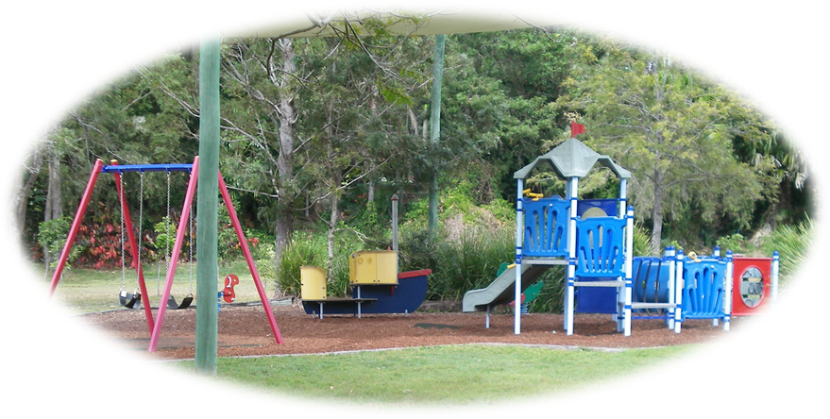
Figure 1 – Elizabeth Daniels Sports Complex Location and User Group Map

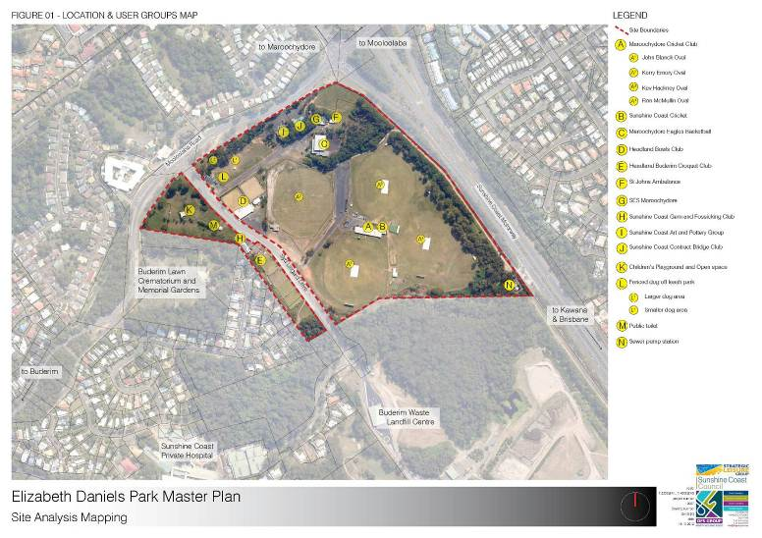
  - Project Methodology
A four stage study approach was adopted which enabled the research and consultation to be undertaken in a logical and progressive fashion and recommendations to be presented within an agreed framework. These stages were:
- Stage 1: Situational Analysis and Consultation
  - Inception
  - Review background planning documents
  - Catchment Analysis
  - Internal Council Consultation
  - Site Investigation
  - Site in use Observations
  - Traffic Assessment
  - Management Analysis
  - Trends Analysis
  - Community Engagement
  - Situational Analysis Report
- Stage 2: Developing Options
  - Design Brief
  - Design Options
  - Management Options
- Stage 3: Draft Master Plan
  - Detailed Master Plan
  - Draft Report
  - Present Draft Master Plan to Steering Committee
- Stage 4: Final Master Plan
  - Public Review Process
  - Final Master Plan

Background Research
  - Literature Review
The following documents were reviewed as part of the background research process to set the study in context and to ensure study outcomes are aligned with council’s corporate direction:
- Sunshine Coast Council Corporate Plan 2009 – 2014
- Sunshine Coast Open Space Strategy 2011
- Sunshine Coast Sport and Active Recreation Plan 2011 -2026
- Sunshine Coast Council - Capital Works Program Listing 2011/2012 - 2020/2021
- Sunshine Coast Council Sports Field Maintenance Funding Program
- Sunshine Coast Cemetery Plan 2012 – 2027
- Sunshine Coast Public Art Policy
- Sunshine Coast Social Infrastructure Strategy 2011
- Sunshine Coast Sustainable Transport Strategy 2011 - 2031
- Sunshine Coast Active Transport Plan 2011 - 2031
- Sunshine Coast Biodiversity Strategy 2011
- Sunshine Coast Access and Inclusion Plan 2011 – 2016
- Sunshine Coast Recreation Trail Plan 2011
- Sunshine Coast Place Making Charter: People, Place and Partnerships
- Sunshine Coast Wellbeing Charter 2010
- Sunshine Coast Youth Strategy 2010 - 2015
- Sunshine Coast Positive Ageing Strategy 2011-2016
- Sunshine Coast Affordable Living Strategy 2010
- Sunshine Coast Reconciliation Action Plan 2011
- Elizabeth Daniels Sport and Recreation Reserve Master Plan 2004
- Ballinger Park Sports Complex Master Plan 2011-2026
- Feasibility Study for the Maroochydore Indoor Sports Centre “In Progress”.
Those issues, needs or opportunities relevant to the Elizabeth Daniels Sports Complex or relevant to master planning of sport and recreation facilities generally are documented in Table 1.
Table 1- Key issues, needs or opportunities emerging from background literature
Issue/Strategy Relevant to Elizabeth Daniels Sports Complex | Source
The Corporate Plan 2009-2014 is a key planning document outlining the priorities and strategies council will pursue over time to achieve its vision to become Australia’s most sustainable region.  One of the key themes of the Plan is “Health and Well-being” which defines an active and healthy community as being one that is resilient and enhances people’s quality of life. Council plays a role in community well-being through safety initiatives, preventative health and education programs, provision of community sport and recreational opportunities and facilitating community interaction. It also has responsibility for ensuring the region’s preparedness to deal with natural disasters.  Emerging priorities include:  - Safe and healthy communities - Adopt and encourage ‘crime prevention through environmental design’ principles in design of public/private spaces  - Active lifestyles - Promote physical activity and recreation and Support community-based sport and recreation organisations and programs. | Sunshine Coast Council Corporate Plan 2009 - 2014
The main purpose of this study was to develop a robust Sport and Active Recreation Plan to guide the current and future provision of facilities and services to meet the needs of the Sunshine Coast’s diverse communities over the next 15 years.  The Plan recommendations, relevant to this study include:  - Where road/rail corridor developments outside council’s control are likely to impact on existing sporting facilities, ensure no net loss of capacity and, where relocation is required, provide good access and redevelopment to an equal or better standard.  - As a general principle, council should approve the relocation of sports from their existing playing areas if relocation:  - Addresses safety or usage constraints  - Is likely to result in an overall improvement in servicing the needs of sport  - Will not reduce the capacity of new playing areas to cater for future residents  - Results in greater efficiencies in the co-location of sports and/or social activities  - Results in no net loss of playing areas for sport.  - Liaise with stakeholder clubs and undertake a master plan for Elizabeth Daniels Reserve, incorporating the following elements:  - Development of an additional cricket oval  - Upgrading of facilities on the main cricket oval (spectator seating, sightscreen) in keeping with the venue’s regional status  - Upgrade signage from the sunshine motorway. | Sunshine Coast Sport and Active Recreation Plan 2011 - 2026 Sunshine Coast Council
The Sunshine Coast Open Space Strategy concentrated on council controlled and managed open space and identified the key challenges and issues shaping open space on the Sunshine Coast. Further, the Strategy provides policy direction to grow and enhance parks, sports grounds, recreation trails and reserves. The actions relevant to this study include:  - Identify recreation parks, sports grounds and amenity reserves that have suitable attributes or capacity to support biodiversity outcomes and link core habitat areas.  - Prepare design guidelines that promote the utilisation of existing sports grounds for recreation space for the local communities, outside sports usage times (e.g. shade, seating and paths).  - Identify park locations with opportunities for public transport, cycle links and integration into transport planning.  - Integrate ‘whole of life’ costs into open space planning, landscape development and infrastructure selection.  - Apply resource efficient and effective strategies in park and sports ground development (e.g. water reuse and native planting).  The study identifies the Elizabeth Daniels Sports Complex as a District Sports Ground. District sports grounds are facilities for formal sporting and active recreation activities including ovals, courts and circuits. They may also provide local recreation park facilities outside of formal sporting hours as well as recreation facilities for families attending sporting events. Further, district sports grounds should contribute to the amenity and local biodiversity by appropriate vegetation planting on boundaries.  The Strategy identified “Currently, there is poor provision of local recreation parks west and north west of Buderim”.  The Strategy recommended:  - The development of the Elizabeth Daniels Sports Complex Master Plan;  - Identify opportunities to acquire land to compensate for losses arising from the multi-modal transport corridor;  - One District Recreation Park to be provided south of Elizabeth Daniels Park; and  - One additional District Sports Grounds south of Elizabeth Daniels Park. | Sunshine Coast Open Space Strategy 2011 Sunshine Coast Council
This program includes the following indicative allocations for the Elizabeth Daniels Sports Complex towards detailed design and implementation of Stage 1 of the Master Plan:  - $75,000 2011/12  - $200,000 2013/14  - $300,000 2014/15. | Sunshine Coast Council - Capital Works Program Listing  2011/2012 - 2020/2021 Sunshine Coast Council
The Sports Field Maintenance Funding Program aims to provide consistent, equitable and appropriate support for sports field maintenance across the region. Funding is a contribution towards field maintenance costs. The intent of the program is to partner with sporting organisations to maintain their facilities to district competition level.  In administering the Sports Field Maintenance Funding Program, council aims to:  - Achieve the objectives of the Corporate Plan through the active engagement of sporting organisations;  - Acknowledge the contribution of community sport clubs, and their volunteers, to the community in line with council’s vision for the future;  - Provide a standard approach and framework to establishing new community partnerships and maintaining existing partnerships;  - Distribute funds in an equitable manner under the principles of good governance;  - Encourage long-term planning for cost-effective facility development;  - Ensure that funding is provided to eligible organisations on an equitable basis; and  - Encourage and work with organisations to enable groups to become more sustainable. | Sunshine Coast Sports Field Maintenance Funding Program Sunshine Coast Council
This Plan reflects the policy directions for cemetery facilities established within council’s Social Infrastructure Strategy 2011 and has been developed to provide further detail to guide the management, operations and planning of council’s cemeteries over the next 15 years.  The Plan introduces the following vision for cemetery services:  “Sunshine Coast Council is committed to long term provision of cemetery facilities that are responsive to the communities needs and promotes community well being and involvement”.  The Plan confirms six out of nineteen of council’s cemeteries are already closed to new burials. Beerburrum, Buderim, Diddilibah, Nambour Garden, Old Nambour and Woombye only have capacity to accommodate for burials in reserved grave sites where available. Buderim Cemetery is situated on the north west border of the Complex. | Sunshine Coast Cemetery Plan 2012 -2017
The purpose of this policy is to outline the framework and principles which guide the provision of public art in the Sunshine Coast region. This policy is supported by a set of guidelines which outline the processes for the identification, commissioning, procurement, management, maintenance and de-accessioning of public art. The outcomes of this policy include:  - Development of an innovative, environmentally and economically sustainable, well-maintained public art program;  - Increased expression and acknowledgement of the unique characteristics of local communities through innovative and appropriate public art projects;  - Enhanced public spaces across the region through appropriate public art projects;  - Implementation of consistent, transparent and equitable processes for the identification, commissioning, management, maintenance and de-accessioning of public artworks;  - Promotion of community cultural development through increased community participation in public art processes;  - Increased cultural tourism opportunities, and  - Development of a sustainable and strong creative industry through increasing the capacity of local artists. | Sunshine Coast Public Art Policy
The Social Infrastructure Strategy seeks to identify council’s long-term direction for social infrastructure over which council has primary responsibility. The strategy provides the framework for the planning and delivery of council’s social infrastructure. This Strategy does not consider sporting facilities.  The Strategy addresses how council plans to service community infrastructure and includes a facility blueprint overview that provides clear policy direction and informs the planning, development and upgrade of facilities on the Sunshine Coast. The overview identifies the locality number, locality name, facility type and action required.  Actions are subject to council prioritisation and funding consideration annually. Actions include:  - planning – part of a precinct planning process  - new – planning, design and delivery  - upgrade – expansion/improvement of an existing facility.  In terms of servicing community needs within the Elizabeth Daniels Sports Complex catchment, the Strategy identifies:  - In the short and medium term, continue the planning and delivery of facilities funded through the Kawana Waters Facilities Fund and Bundilla Lakes Development Agreement including a new local level community centre at Mountain Creek (Brightwater);  - Investigate additional facilities in the short term through shared/partnership arrangements at Mountain Creek;  - Undertake ongoing planning for shared/partnership arrangements for additional facilities in the longer term, including at Buderim; and  - Undertake precinct planning in Buderim to determine the preferred long term needs and functions of these core areas. | Sunshine Coast Social Infrastructure Strategy 2011 Sunshine Coast Council
The Sunshine Coast Sustainable Transport Strategy outlines the emerging priorities and key strategies council will pursue to deliver a sustainable transport system. Any parking and access solution for the Elizabeth Daniels Sports Complex will need to ensure the goals of this Strategy are addressed.  The Strategy provides a user hierarchy as detailed below:  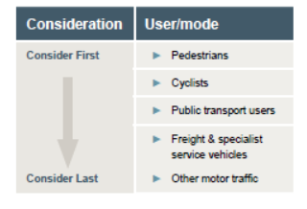  The Strategy maps the proposed hierarchy and function of transport corridors for the Sunshine Coast for 2031 and beyond and guides the planning and implementation of transport to achieve the sustainable transport vision.  The Strategy identifies a fundamental objective in active transport planning is to improve community mobility and amenity by providing connected networks and facilities based on people’s needs and location.  The goal within the Strategy is to provide pedestrians and cyclists with safe, comfortable, direct connections to where they want to go including homes, schools, work places, shopping areas, services, recreational opportunities and public transport. The Strategy outlines that planning will support and encourage walking and cycling as an alternative to private car use and as healthy recreational activity for all ages.  The Strategy incorporates the Sunshine Coast Active Transport Plan 2011-2031 (Active Transport Plan) which provides additional detail and guidance in support of this Strategy. | Sunshine Coast Sustainable Transport Strategy/  Sunshine Coast Active Transport Plan 2011 -2031 Sunshine Coast Council
This Strategy is the greenprint for the future of the Sunshine Coast region’s natural assets. It outlines the emerging priorities and key strategies council will pursue to maintain and enhance the region’s unique biodiversity for future generations.  A key focus of the Strategy is to protect, enhance and connect Sunshine Coast’s natural assets using a range of existing and innovative approaches.  Strategies and actions focus on building green infrastructure across the landscape to strengthen and reconnect high value natural assets and optimise the services to the community that healthy, functioning ecosystems provide.  The site falls within 'connecting' and 'linkage' habitat as per the Biodiversity Strategy 'Core and Connecting Habitat Areas' map. | Sunshine Coast Biodiversity Strategy 2010 – 2020 Sunshine Coast Council
The Access and Inclusion Plan 2011-2016 sets out five key focus areas and aims to guide council towards improving access and inclusion for community members in the region. Under each of these focus areas a table of strategies has been developed that will direct actions to reduce physical, social and economic barriers.  The Plan identifies a series of elements for consideration aimed at reducing access barriers, including relating to the following focus areas:  - Focus Area 1: Pedestrians, Parking and Transport  - Focus Area 2: Community Facilities, Amenities and Open Space  - Focus Area 3: Planning and Services  - Focus Area 4: Training, Employment and Participation  - Focus Area 5: Communication and Community Engagement. | Sunshine Coast Access and Inclusion Plan 2011 Sunshine Coast Council
The Recreation Trail Plan 2011:  - Reviews existing legislation and both state and local policy to identify impacts on trail development;  - Analyses the current level of supply, range and diversity of existing signed recreation trails and the quality of council managed trails within the Sunshine Coast; and  - Examines key issues relating to recreation trail provision for walkers/mountain bike riders/horse riders within urban/non-urban environments.  A Recreation Trail Plan was developed for the Buderim, Kuluin, Mons and Kunda Park for future trails. This plan identified the existing pathways at Elizabeth Daniels Sports Complex, however did not recommend any future expansion. | Sunshine Coast Recreation Trail Plan 2011
A core objective of place making is to preserve and enhance the unique character of each place, which reflect the values of the local community. Infrastructure contributes significantly to the character of a place, the design of which requires a context sensitive approach that balances unique design solutions with standardised treatments. | Sunshine Coast Council Place Making Charter To 2030
The Wellbeing Charter outlines the Sunshine Coast Council’s goal for wellbeing on the Coast is “to be an active and healthy community which is resilient and enhances the quality of people’s life”.  Further, the Charter confirms council’s commitment to enhancing the quality of people’s lives through:  - Providing strong leadership and always improving  - Sharing the responsibility and welcoming new partnerships  - Creating supportive healthy spaces and places  - Being innovative, adopting evidence based approaches and being open to positive change. | Sunshine Coast Wellbeing Charter 2010
The Youth Strategy was developed with input from the region’s young people, youth sector and many areas across council, to ensure that youth needs, issues and aspirations are embedded into existing and future functions, facilities, services and resources of council.  The guiding principles and associated commitments of the Strategy were developed from the Speak Up Engage Program and the outcomes of the Sunny Coast Youth Survey 2010. The guiding principles of the Strategy are:  - Youth voice and action  - Access and opportunity for all  - Speaking up for youth  - Working together  - Youth and community connections.  A series of council commitments are included for each guiding principle. | Sunshine Coast Youth Strategy 2010 - 2015
The Sunshine Coast Positive Ageing Strategy 2011-2016 focuses on council's commitments to older people on the Sunshine Coast over the next five years.  The strategy recognises the many significant contributions older people make to communities and emphasises the need to work in partnership with other key agencies to address the changing needs of older people on the Sunshine Coast.  The principles that underpin the Positive Ageing Strategy are:  - Equitable access for all - Ensuring all older people have equitable access to services, community infrastructure and programs that enhance their quality of life.  - Dignity and respect - Ensuring older people’s rights are upheld, they continue to live in dignity, and their valuable place in the community is acknowledged and respected by all.  - Diversity - Recognising the diversity among seniors including their age, ability, gender, sexuality, cultural and linguistic background, and geographic location.  - Safety - Supporting initiatives that help older people feel physically and emotionally safe in their homes and in the community.  - Participation and connectedness - Enhancing opportunities for older people to remain socially connected through participation in community life and decision-making processes.  - Opportunities for all to an independent lifestyle - Facilitating opportunities for older people to live the lifestyle of their choice.  - Collaborative partnerships - Engaging and partnering with all levels of government, non-government, business, and the community in working towards shared outcomes. | Sunshine Coast Positive Ageing Strategy 2011-2016
The Sunshine Coast Affordable Living Strategy provides a framework to implement change which will improve affordability and sustainability. The Strategy includes challenges and opportunities, lists outcomes and principles and contains a detailed action plan with timelines, opportunities for partnerships and mechanisms to communicate affordable living with the wider community.  The Strategy identifies a series of recommendations to achieve affordable living through:  - Housing diversity  - Housing affordability  - Self contained neighbourhoods  - Transport options  - Supportive environments  - Resource efficiency  - Economic development. | Sunshine Coast Affordable Living Strategy 2010
This Plan is council’s commitment to the Aboriginal and Torres Strait Islander peoples to create an inclusive community that respects the culture, history and heritage of its people.  The Plan highlights the success of achieving each of the principles (Enriching Relationships; Respect; Creating Opportunities) is dependent upon council addressing the following focus areas:  - In the Spirit of Reconciliation  - Deadly Dreaming (Visioning)  - Yarning (Consultation)  - Learning Circles (Formal Meeting). | Sunshine Coast Reconciliation Action Plan 2011
The 2004 Master Plan aimed to ensure the coordinated development of Elizabeth Daniels Reserve as a major provider of sports and recreation opportunities for residents. Further, the study was to address:  - A development strategy detailing the facilities to be developed on site, and the configuration of leased areas.  - The priorities and approximate cost of proposed developments and/or reconfigurations of lease boundaries.  Key recommendations, included:  - Improved car parking;  - Expansion of netball courts;  - Extension to arts and bridge buildings;  - New SES building;  - New St John Ambulance building;  - New community room;  - New indoor basketball stadium;  - Future joint use clubhouse;  - Extension to croquet and gem club buildings.  The total cost to develop the recommendations of the Master Plan was estimated at $1,805,000. | Elizabeth Daniels Sport and Recreation Reserve Master Plan 2004
The Ballinger Park Sports Complex Master Plan provides a 15 year vision for the complex, identifying what it should look like and how it should function into the future. The master plan is used to guide and inform staged development from 2011-2026 and provides a framework for:  - Improved recreation opportunities for users of the complex  - Modifications to sports field layout to maximise and rationalise use as demand increases  - Essential improvements to vehicular & pedestrian access  - Management strategies for the natural areas of the site and their interface with sporting activities.  The key recommendations of the Master Plan include:  - Improved community pedestrian/cycle access;  - Investigate future (long term) relocation opportunities for Alcooringa/Fusion to a more central location;  - New multi-use junior sized cricket oval;  - Investigate potential to expand archery range to meet regional standards;  - Expansion area for second synthetic hockey surface;  - Area suitable for continuing Pony Club use; and  - Provide opportunities for future connections to Regional Trail Network. | Ballinger Park Sports Complex Master Plan 2011-2026
Sunshine Coast Council is currently undertaking a feasibility study to determine the site, location, facility mix, indicative capital costs, concept plans, financial projections, potential partners and management arrangements for the development of a multi court indoor sporting facility at the Maroochy Multi Sports Complex (MMSC), Fisherman’s Road, Maroochydore or an alternative site in the Maroochydore/Buderim area. | Feasibility Study for the Maroochydore Indoor Sports Centre “In Progress”.

Site Investigation and Constraints
  - Site Overview
Elizabeth Daniels Sports Complex is a district level facility with regional elements and is situated on Lot 664 CP901247, Mooloolaba Road, Buderim immediately adjacent to the Sunshine Motorway. The site is approximately 23.4 ha in size and is classified as a Reserve for Recreation with Sunshine Coast Council as trustee. Approximately 5% of the south east corner of the site is flood prone. A further separate parcel is located within the north west corner of the site, being Lot 737 CG3836 which is approximately 0.28 ha in size.
The Complex is used for a combination of sporting and passive recreation use through:
- Formal sporting facilities;
- A local recreation park located in the western corner of the site known as Buderim Lions Park; and
- Buderim Dog Park (a designated dog off leash park).
Further, the Buderim Fire Tower is located in the northern corner of the Complex.
Biodiversity considerations include:
- The wetland buffer (100m) identified in the south east corner of the site;
- An interim connecting habitat area is designated along the southern boundary;
- Native vegetation communities and habitat areas are able to be protected and enhanced through innovative management practices; and
- Avoid development in areas of environmental significance.
Planning undertaken as part of the Caloundra and Maroochydore Corridor Options Study (CAMCOS), indicate the area at the north east corner and potentially along the entire eastern boundary of the site may be impacted from planned expansion works in this locality.
Council has committed to the expansion of the existing bowls club car park to the south. The following existing user groups lease land from Sunshine Coast Council:
- Maroochydore Cricket Club
- Sunshine Coast Cricket Association
- Maroochydore Eagles Basketball Association
- Headland Bowls Club
- Headland Buderim Croquet Club
- St John Ambulance
- Maroochydore SES
- Sunshine Coast Gem & Fossicking Club
- Sunshine Coast Art Group; and
- Sunshine Coast Contract Bridge Club.
The Complex is used for school and district standard cross country events.
Each group is responsible for the management and maintenance of their respective lease areas. Council is responsible for maintaining recreation parks and facilities. This results in the groups being responsible for any building, playing, amenity, spectating and car parking facilities within their leased area. Council does provide a contribution towards some works (e.g. recent car park extension south of the bowls club).
The site is the home of Sunshine Coast Cricket Association and hosts local to major cricket events (e.g. matches for the recent 2012 U19 cricket World Cup were hosted at the Complex.) The basketball stadium is the major indoor basketball facility within this locality and is home to the Maroochydore Clippers teams participating in the Queensland Basketball League. The remaining users are local standard clubs hosting and competing in broader regional competitions. Each user group attracts a broader membership base beyond the immediate catchment of the Complex, however the majority are from within the surrounding community.
  - Site Assessment and Observations

3.2.1. Site Assessment
Outlined below is a site assessment summary for the Complex based on site inspections undertaken by the study team.
Table 2: Elizabeth Daniels Sports Complex Site Assessment
Site attributes, constraints, functionality for purpose, visual amenity | - Bordered by two major roads being Mooloolaba Road and Sunshine Motorway.  - Main access road, Syd Lingard Drive also primary access to local waste station situated south of the Complex and a secondary access road to the Sunshine Coast Private Hospital.  - Approximately 23.4 ha in size, plus additional 0.28 ha in the north west corner.  - Crown land Reserve for Recreation with Sunshine Coast Council as trustee.  - Local recreation and dog off leash park situated within the Complex.  - Council considers the local recreation park in the western corner of the site generous in terms of council’s Desired Standards of Service for local recreation parks.  - The site is relatively flat, however is steepest at the north east and western areas.  - With the exception of the north east corner and the bowls club, the majority of the site is classified as open space.  - The south east corner is mapped as wetland.  - The south eastern most cricket field has a portion considered flood prone and includes an area within the wetland buffer.  - A pump station is situated in the south east corner of the site.  - The southern border of the site includes a portion within nature conservation management and bush fire prone areas.  - The south east corner of the site is mapped as a koala management and protection area.  - The site is designated as a “special purpose” planning area in the Maroochy Plan 2000.  - There is poor pedestrian connectivity across the site.  - The site has a lack of clear safe pedestrian connection across Syd Lingard Drive and safe vehicular access across the drainage swale.  - Parked cars are prone to encroaching onto the footpath due to undefined parking areas and lack of separation of parking area and footpaths.  - The site has potential pedestrian and vehicle conflict.  - There is a pedestrian pathway to the west of Syd Lingard Drive.  - The playground in the north west corner of the site is isolated from other activities and lacks suitable access and parking.  - The site is experiencing some erosion and scouring from stormwater run-off.  - The site erosion is causing a potential slip hazard and erosion issues on the edge of grounds with steep embankments on the southern end of the Complex.  - The current design of the concrete stormwater slipway causes erosion and velocity issues.  - There is currently no sewerage connection to the bowls and croquet facilities.
Facilities | Recreation  - Dog off leash park  - Playground and picnic area  - Public toilets  - Some pathways (poor connectivity)  Bowls  - 2 greens  - Clubhouse  - Storage sheds  Basketball  - Single sprung timber indoor court  - Outdoor courts  - Mezzanine area  - Kiosk  - Change rooms  - Offices  - Administration offices  Croquet  - 4 courts  - Clubhouse  Cricket  - 4 full-size cricket ovals  - 1 junior cricket oval overlapping onto south east full size field  - 4 turf wicket blocks  - 1 synthetic wicket  - Clubhouse, including change rooms, canteen/bar  - Practice nets  - Storage sheds  - Old netball clubhouse, change rooms  Dedicated buildings  - Arts group  - Bridge club  - Maroochydore SES  - St John Ambulance  - Fire tower  - Gem & Fossicking club

Site-in-use Observations
The project team conducted several site assessments in order to understand how the site operates during peak and off-peak operating times. The site assessments were conducted over a series of differing time periods, including mid-week mornings and afternoons and a Saturday. The key observations and trends from the site assessments were:
- Minimal traffic congestion was experienced;
- There is a variation amongst the peak times of users (i.e. bowls, croquet and recreational users predominately mid-week days; cricket late mid-week afternoons and weekend days; and basketball mid-week evenings and weekends);
- The dog off leash park is well utilised by the community during most days;
- Traffic along Syd Lingard Drive is not excessive;
- The Complex is used for recreational walking/running by members of the surrounding community;
- The playground and park in the north west corner of the site is underutilised by the community; and
- Some informal parking occurs along the western side of Syd Lingard Drive extending onto the adjacent walk/cycle path.
The site assessments were conducted outside of major events times. It is noted that traffic and pedestrian congestion may intensify during periods of major events.
  - Site Utilisation
The following periods apply to all usage tables:

Maroochydore Cricket Club
The club has increased from 551 to 611 senior members in the last three years. The increase in senior participation is attributed to the improved retention of junior players transitioning into the senior ranks and the provision of a new oval. Junior membership has declined from 172 as at three years to 130 at present. A lack of lighting and overcrowding of existing facilities is believed to have contributed to junior numbers declining, however the recent development of a new oval is anticipated to overcome this barrier. The club plans to embark on a localised campaign within schools to further facilitate the growth of junior participation.
Data supplied by current users of the Complex was provided to demonstrate activity in a typical week over the seven days of the week.
A summary of the cricket activity is outlined in the table below. Day – 8am to 3pm
- Afternoon – 3pm to 6pm
- Evening – 6pm onwards.
Table 3 - Cricket Peak Usage (Summer)
User | Monday |  |  | Tuesday |  |  | Wednesday |  |  | Thursday |  |  | Friday |  |  | Saturday |  |  | Sunday
User | Day | Afternoon | Evening | Day | Afternoon | Evening | Day | Afternoon | Evening | Day | Afternoon | Evening | Day | Afternoon | Evening | Day | Afternoon | Evening | Day | Afternoon | Evening
Maroochydore Cricket
The priority development proposed by this user group is:
- Field lighting;
- Improved internal road network;
- Installation of sight screens and fencing on two ovals; and
- Spectator seating and supporting amenities.

Headland Bowls Club
The club has retained most of its membership of 186 senior members from three years ago, with a current senior membership of 182 seniors. An aging membership is a factor in not being able to grow membership at the club. Club facilities are used by other local organisations including:
- Probus;
- Business ladies function;
- Stormer group; and
- Various local functions.
A summary of the bowls activity is outlined in the table below.
Table 4- Bowls Club Usage
User | Monday |  |  | Tuesday |  |  | Wednesday |  |  | Thursday |  |  | Friday |  |  | Saturday |  |  | Sunday
User | Day | Afternoon | Evening | Day | Afternoon | Evening | Day | Afternoon | Evening | Day | Afternoon | Evening | Day | Afternoon | Evening | Day | Afternoon | Evening | Day | Afternoon | Evening
Bowls

The priority development proposed by this user group is:
- Increased car parking; and
- Sewerage connection.

Maroochydore SES
Membership has increased overall from 30 senior and 45 junior members three years ago, to a current membership of 75 seniors and 25 juniors. This increase in senior membership is as a result of the recent frequency of natural disasters. The uncertainty with regard to the potential extension of the Motorway into the Complex site is restricting expansion opportunities.
A summary of the SES activity is outlined in the table below.

Table 5- SES Usage
User | Monday |  |  | Tuesday |  |  | Wednesday |  |  | Thursday |  |  | Friday |  |  | Saturday |  |  | Sunday
User | Day | Afternoon | Evening | Day | Afternoon | Evening | Day | Afternoon | Evening | Day | Afternoon | Evening | Day | Afternoon | Evening | Day | Afternoon | Evening | Day | Afternoon | Evening
SES

The priority development proposed by this user group is:
- Improved standard of internal roads; and
- Increased parking to service SES building.

Sunshine Coast Gem & Fossicking Club
The club has increased from 124 senior and 3 junior members three years ago, to a current membership of 160 seniors and 4 juniors. This increase in senior participation is attributed to the overall increased aging of the Sunshine Coast population.
A summary of the Gem & Fossicking activity is outlined in the table below.
Table 6 - Gem & Fossicking Usage
User | Monday |  |  | Tuesday |  |  | Wednesday |  |  | Thursday |  |  | Friday |  |  | Saturday |  |  | Sunday
User | Day | Afternoon | Evening | Day | Afternoon | Evening | Day | Afternoon | Evening | Day | Afternoon | Evening | Day | Afternoon | Evening | Day | Afternoon | Evening | Day | Afternoon | Evening
Gem & Fossicking

The priority development proposed by this user group is:
- Increased land to develop new storage and maintenance areas resulting in expanded workshop area;
- Increase parking; and
- Update equipment.

Sunshine Coast Cricket Association
The Sunshine Coast Cricket Association is responsible for all senior and junior cricket in the region. Matches are played throughout the Coast, however Elizabeth Daniels Sports Complex is recognised as the regional cricket facility. The Sunshine Coast Scorchers participate in the Brisbane Premier League competition. The Scorchers train and play at the Complex.
The Association has decreased from 720 senior and 1400 junior members three years ago across the Sunshine Coast, to a current membership of 680 seniors and 1100 juniors. This decrease is considered to be as a result of changing demographics with the population aging and the economic pressures on families. Further, access to facilities is becoming increasingly difficult as several schools have reduced the size of their ovals to accommodate other school/community infrastructure. The Sunshine Coast Cricket Association is seeking direct tenancy and exclusive access to a single oval facility.
A summary of Sunshine Coast’s Cricket Association activity is outlined in the table below.
Table 7 - Sunshine Coast Cricket Association Usage
User | Monday |  |  | Tuesday |  |  | Wednesday |  |  | Thursday |  |  | Friday |  |  | Saturday |  |  | Sunday
User | Day | Afternoon | Evening | Day | Afternoon | Evening | Day | Afternoon | Evening | Day | Afternoon | Evening | Day | Afternoon | Evening | Day | Afternoon | Evening | Day | Afternoon | Evening
Sunshine Coast Cricket Association

The priority development proposed by this user group is:
- Storage;
- Training nets; and
- Additional clubhouse.

Sunshine Coast Contract Bridge Club
The club has increased from 391 senior members three years ago, to a current membership of 438. This increase is considered to be as a result of growing interest in bridge across the community. A summary of the bridge club activity is outlined in the table below.
Table 8 - Bridge Club Usage
User | Monday |  |  | Tuesday |  |  | Wednesday |  |  | Thursday |  |  | Friday |  |  | Saturday |  |  | Sunday
User | Day | Afternoon | Evening | Day | Afternoon | Evening | Day | Afternoon | Evening | Day | Afternoon | Evening | Day | Afternoon | Evening | Day | Afternoon | Evening | Day | Afternoon | Evening
Bridge

The priority development proposed by this user group is:
- Air-conditioning;
- Increased parking and improved access from lower car parks to bridge club building;
- Potential shared-use teaching/resource facility; and
- Improved external drainage, water and sewerage infrastructure.

St John Ambulance
Membership has remained largely stable decreasing slightly from 23 members three years ago to a current membership of 19. The slight decrease is considered as a result of a new branch opening in Caloundra.
A summary of the St John Ambulance activity is outlined in the table below.
Table 9 - St John Ambulance Usage
User | Monday |  |  | Tuesday |  |  | Wednesday |  |  | Thursday |  |  | Friday |  |  | Saturday |  |  | Sunday
User | Day | Afternoon | Evening | Day | Afternoon | Evening | Day | Afternoon | Evening | Day | Afternoon | Evening | Day | Afternoon | Evening | Day | Afternoon | Evening | Day | Afternoon | Evening
St John Ambulance

Headland Buderim Croquet Club
The club has decreased slightly from 70 members three years ago, to a current membership of 65. The croquet courts require regular rectification works as facilities are situated on an old tip site and are prone to land movement. The lack of lighting limits opportunities for expanded competitions at night. The croquet clubhouse is also used for other community activities, including:
- U3A;
- Yoga;
- Majong;
- Theosophical society meetings.
A summary of the croquet activity is outlined in the table below.

Table 10 - Croquet Usage
User | Monday |  |  | Tuesday |  |  | Wednesday |  |  | Thursday |  |  | Friday |  |  | Saturday |  |  | Sunday
User | Day | Afternoon | Evening | Day | Afternoon | Evening | Day | Afternoon | Evening | Day | Afternoon | Evening | Day | Afternoon | Evening | Day | Afternoon | Evening | Day | Afternoon | Evening
Croquet

The priority development proposed by this user group is:
- Improved electricity supply;
- Access to bore water;
- Replace court shelters; and
- Refurbishing clubhouse.

Maroochydore Eagles Basketball Association
The club has decreased membership from approximately 510 members three years ago, to a current membership of 430. This decrease is considered as a result of the aging nature of the basketball facility and there being only one indoor court which the Club advises is at capacity. The basketball stadium is used by other community groups, including regular use by Mountain Creek State High School.
A summary of the basketball activity is outlined in the table below.
Table 11 - Basketball Usage
User | Monday |  |  | Tuesday |  |  | Wednesday |  |  | Thursday |  |  | Friday |  |  | Saturday |  |  | Sunday
User | Day | Afternoon | Evening | Day | Afternoon | Evening | Day | Afternoon | Evening | Day | Afternoon | Evening | Day | Afternoon | Evening | Day | Afternoon | Evening | Day | Afternoon | Evening
Basketball

The priority development proposed by this user group is:
- Additional indoor courts;
- Improved parking and access roads; and
- Directional signage.

Sunshine Coast Art Group
The art group aims to:
- Foster, promote and practice creative art in all its' forms and in whatever media;
- Build on the spirit of artists' traditional sense of 'friendship & sharing'; and
- Hold or arrange exhibitions and workshops within the region and to provide a regular newsletter.
Current membership is estimated between 120 – 150. The studio buildings are available for hire by the general community outside of class times.
A summary of the art group’s activity is outlined in the table below.
Table 2- Arts Group Usage
User | Monday |  |  | Tuesday |  |  | Wednesday |  |  | Thursday |  |  | Friday |  |  | Saturday |  |  | Sunday
User | Day | Afternoon | Evening | Day | Afternoon | Evening | Day | Afternoon | Evening | Day | Afternoon | Evening | Day | Afternoon | Evening | Day | Afternoon | Evening | Day | Afternoon | Evening
Arts Group

Combined Usage Analysis
Outlined below is a table summarising the combined usage of the Complex which highlights peak usage days and times:
Table 3 - Combined Usage Current Complex Usage
User | Monday |  |  | Tuesday |  |  | Wednesday |  |  | Thursday |  |  | Friday |  |  | Saturday |  |  | Sunday
User | Day | Afternoon | Evening | Day | Afternoon | Evening | Day | Afternoon | Evening | Day | Afternoon | Evening | Day | Afternoon | Evening | Day | Afternoon | Evening | Day | Afternoon | Evening
Maroochydore Cricket
Bowls
SES
Gem & Fossicking
Sunshine Coast Cricket Association
Bridge
St John Ambulance
Croquet
Basketball
Arts Group

Implications of Site Usage
The above analysis indicates that the varied use of sporting and recreational uses across the Complex site results in a variation of peak usage. An analysis of site usage for each user group can be summarised as:
- Maroochydore and Sunshine Coast Cricket Association have a concentration of usage over the summer. With minimal provision of lighting, activities are restricted to daylight hours. Whilst there may be some opportunity to introduce new users to share access of the cricket ovals over the winter, as the regional cricket facility for the Sunshine Coast, any new access should be measured against the potential impact to the standard of the turf wickets and playing surfaces.
- The nature of the specialised greens associated with Headland Bowls Club limits opportunities for shared usage. There may be an opportunity for increased community use of the clubhouse outside of current usage periods (particularly evenings).
- Whilst the intensity of use of the Maroochydore SES facilities is relatively low, given the specific nature of this community service, opportunities for shared use of the building facilities is considered minor.
- Whilst the intensity of use of the Gem & Fossicking building is relatively low, given the specific permanent fit-out requirements and equipment stored on site, opportunities for shared use of the building facilities is considered minor.
- With relatively minor usage of its building and the non-specific nature of the fit-out, there may be opportunities for the Bridge Club building to introduce additional community usages (e.g. Lions Club meetings). For example, there are four mid-week evenings where the Bridge Club building is not currently in use.
- Whilst the intensity of use of the St John Ambulance facilities is relatively low, given the specific nature of this community service, opportunities for shared use of the building facilities is considered minor.
- The nature of the specialised courts associated with Headland Buderim Croquet Club limits opportunities for shared usage. There are opportunities for community use of the clubhouse outside of current usage periods (particularly evenings). As an example, the clubhouse is currently used by a range of community groups including U3A, Yoga, Majong and Theosophical society meetings.
- The specialised nature and high intensity of use of the basketball facilities on site prevent any new opportunities for alternate shared use activities.
- Whilst the intensity of use of the Arts Group building is relatively low, given the specific permanent fit-out requirements and equipment stored on site, opportunities for shared use of the building facilities is considered very minor.
  - Site Constraints
The major site constraints that need to be taken into account include:
- Potential loss of land/facilities due to the motorway widening;
- The south east corner includes a small portion considered as wetland and being flood prone;
- The southern border of the site is identified as being a bushfire prone area;
- The southern border of the site is identified as forming part of a nature conversation management area;
- Part of the Complex is developed on a former landfill site which has resulted in subsidence in some areas and may impact on any future development; and
- The south east corner of the site is considered to form part of a koala management and protection area.
Outlined in the maps below are:
- Topography;
- Open space;
- Hydrology, incorporating flood prone areas and wetland mapping;
- Infrastructure;
- Existing pathways;
- Vegetation management;
- Koala management/protection area;
- Easements; and
- Precincts.
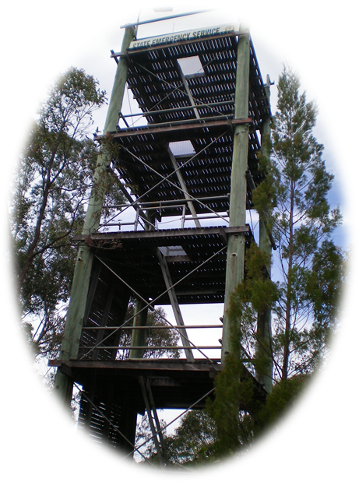

Figure 2: Site Topography
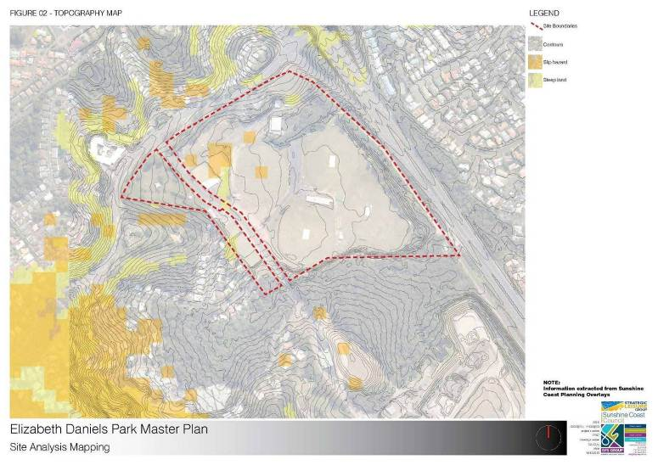

Figure 3: Open Space Map
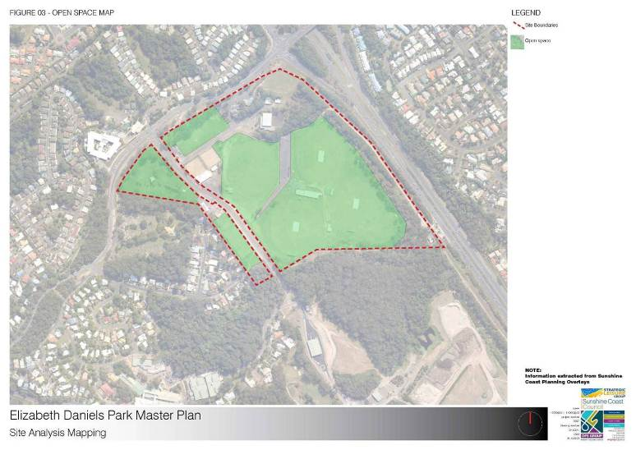

Figure 4: Hydrology Map - Including Flood Prone Areas & Wetland Mapping
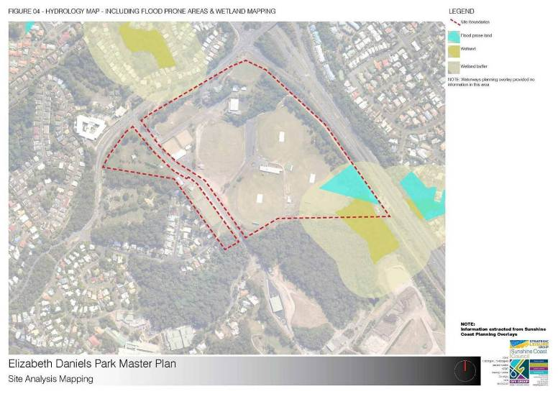
Figure 5: Infrastructure Map
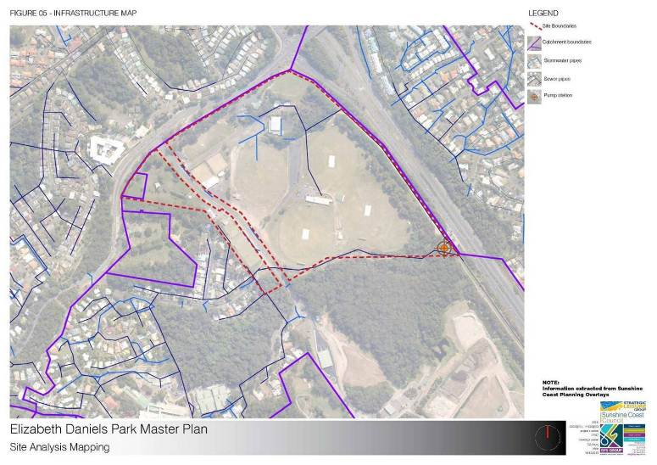
Figure 6: Existing Pathways Map
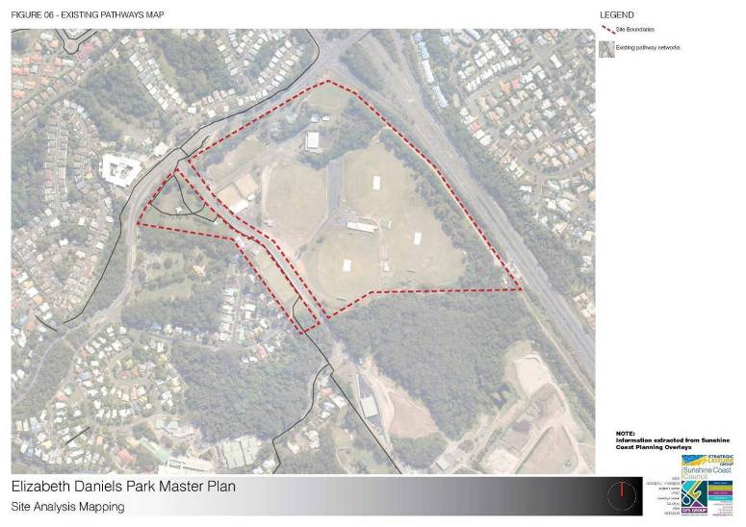
Figure 7: Vegetation Management Map
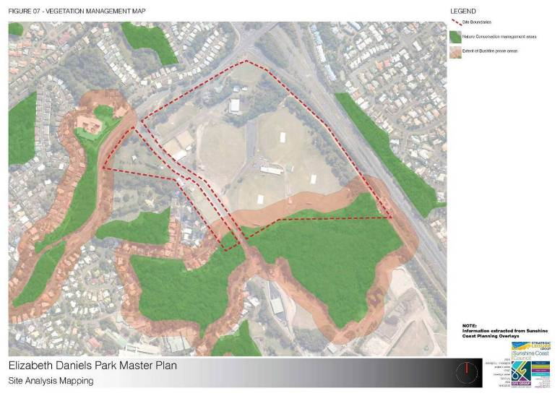
Figure 8: Koala Management/Protection Area Map
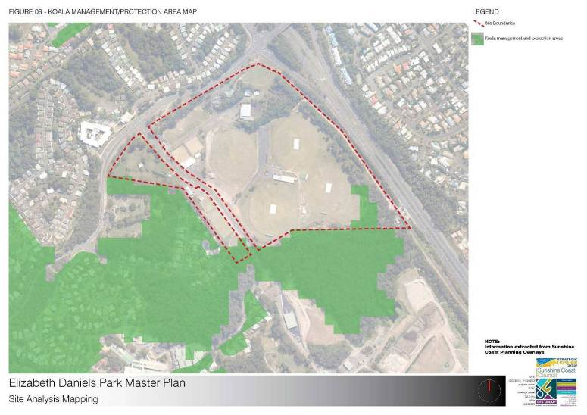
Figure 9: Easements Map
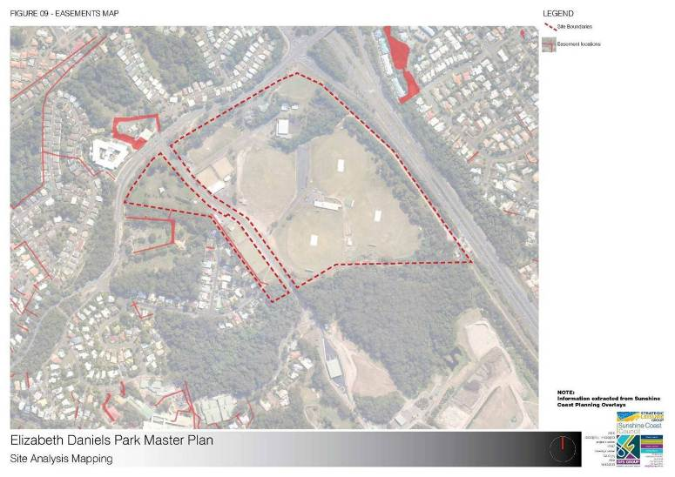
Figure 10: Precincts Map
