Elizabeth Daniels Sports Complex Master Plan 2013 – 2028: Part 2

Consultation
Further to the direct consultation undertaken with current Complex user groups, interviews were conducted with the Division 6 Councillor, several internal council officers, potential new users and the Department of Transport and Main Roads (DTMR).

4.1. Council
The key themes and considerations from the council consultation include:
- The Complex is situated on a former landfill site which was decommissioned many years ago. As such it is unlikely that the site was "capped" in a fashion as considered acceptable in current times. The site is more likely covered with little more than "urban fill". Recent investigations have found capping less than 1/2 metre of depth in some areas. The surrounding environment may be susceptible to leachate impacts due to site being a former landfill;
- There is no historical mapping available for the site in use as a landfill, however it is assumed that the southern end was landfill, extending to the dog off leash area on the eastern side of Syd Lingard Drive and incorporating the croquet club on the western side;
- The study should reflect the intention in the Sunshine Coast Open Space Strategy to maintain the function of the local recreation park across the Syd Lingard Dr from the dog off leash park for the purpose of local recreation park;
- Council is progressing the development of a Maroochydore Indoor Court Facility Feasibility Study. At the time of this report, the findings of this study are unknown;
- Council has recently extended the current bowls car park south to accommodate the needs of the new cricket oval and other site users;
- There are a number of natural drainage lines which traverse this site, and suitable accommodation of these should be made during any redevelopment considerations;
- Council does not support a reduction of open space as noted in the Sunshine Coast Open Space Strategy 2011;
- Funding is committed to upgrade the toilet block located behind the Gem & Fossicking Club building in 2013/14;
- The Complex is bordered by Buderim Cemetery to the west which is near capacity. Of the 19 regional cemeteries, council have most enquiries about cemetery sites that are located at Buderim Cemetery. Cemeteries are not regarded as open space in the Sunshine Coast Open Space Strategy 2011;

- The Sunshine Coast Sport and Active Recreation Plan 2011 – 2026 includes a set of Guiding Principles for council involvement in sport and active recreation intended to give effect to council’s ‘vision’ for sport and active recreation and guide the future planning and management of facilities and opportunities. They are consistent with other planning within council and should be used as a reference point for future development. The guiding principles comprise:
  - Economic and environment sustainability
  - Infrastructure provision and club sustainability
  - Accessibility and mobility
  - Urban character and amenity
  - Social equity
  - Community involvement and inclusion.
  - Community/School Consultation
An online community survey was prepared as part of the study, however with only six responses received, this number is considered inadequate and not sufficient to be statistically valid. The primary responses of this small sample related to improving the facilities to meet the recreational needs of young children.
Further, a schools survey was prepared and forwarded directly to schools within the catchment. Only two surveys were returned, with this sample considered insufficient to be statistically valid. No essential new facilities or other improvements were proposed within the two survey returns.
  - Community Groups
The following groups were interviewed following their expression of interest in accessing the Complex for their future facility needs:
- Buderim Men’s Shed;
- Mooloolaba Lions; and
- Buderim Billiards and Snooker.

Buderim Men’s Shed
The existing Buderim Men’s Shed site is approx 0.62 ha with a building footprint of 650m². The club has grown rapidly since its inception and is considered to have already reached its capacity with a membership of 270. The group is seeking a permanent base sufficient in size to meet its current and future needs. The club estimates the required building footprint at a new site is 1100m² excluding parking, access and external garden areas. On this basis, the club is seeking to identify an alternate, new permanent site and is interested in the potential to be situated at the Complex.

Mooloolaba Lions Club
Mooloolaba Lions Club has expressed an interest in obtaining a lease over a parcel of land adjacent to the Gem & Fossicking Club building. The club currently meets in an industrial shed located on Brisbane Road, Buderim, however planned expansion of the road will impact adversely on this building. Current membership of the club is 37, with an additional 18 Lioness and 23 Leos (Students).
The club is seeking access to the land only and intends to attract third party grant funding to develop a building. The location of the Complex is considered central to the club’s membership. It is anticipated that other community groups could have access to the Lions Club building, however the club is seeking primary tenancy.
The club is seeking sufficient land for a 12m x 12m block style building, incorporating toilets, store, office, kitchen and open space meeting area. Additional space for car parking and access will be required. Following recent discussions, agreement could not be reached between the Lions Club and Maroochy Cricket for Lions to access to the old netball clubhouse.

Buderim Billiards and Snooker
The Buderim Billiards and Snooker Club has been located at the Buderim Community Centre since the 1960’s. The club has advised it has outgrown its current club facilities at the Community Centre.
The Club is seeking sufficient land to develop a building 10m x 29m, including toilets, storage and large open space for billiard and snooker tables. A block building structure is preferred, with a veranda area for BBQ’s and social activities.
The club advised that the development of the building would support membership growth; opportunities for events; and introduction of new junior based programs. It is anticipated that the new building would support an increase from two to four full-sized tables.
The club has a current membership of 110 with approximately 75% active. Should an expanded building be developed, the club estimates membership will grow by approximately 60 people therefore totalling 170 members.
A facility of this scale would attract occasional major events attracting up to 100 persons, however the majority of usage would not be intense.
There would be opportunities for co-location with other community groups, however the minimum dimension outlined above would need to be available exclusively for billiards and snooker given the difficulty in moving their tables.

Implications for Master Plan
The funding environment for the development of community, sport and recreation facilities is as difficult as ever. In particular, State funding programs have reduced or in some cases ceased and Federal Government opportunities are focussed on large, regional scale developments. At a Local Government level, councils are finding it increasingly difficult to allocate funds to new sport and/or community infrastructure in an environment where there are competing priorities and reducing available budgets.
The Elizabeth Daniels Sports Complex is located within a part of the Sunshine Coast recognised in its Open Space Strategy as having poor provision of local recreation parks west and north west of Buderim. Further, the potential future impact of the CAMCOS development limits any developable land area on the site.
It is estimated that a large footprint of up to 1500m² may be required to service the needs of the potential new community groups explored as part of this study.
Based on the current funding environment, the scale of development, lack of new developable space on site and advice from council, it is considered that:
- A development of this type and scale is outside internal and external funding opportunities in the current economic climate and in the foreseeable future;
- A Men’s Shed regional strategy should be considered to identify if one large facility structure could be replaced with several smaller, satellite facilities. Smaller facilities will likely be able to be sourced more readily;
- Any development of this nature within an existing open space area is inconsistent with council’s advice that open space areas should be protected;
- Elizabeth Daniels is not an identified site for the development of a new community facility within council’s Social Infrastructure Strategy 2011; and
- Any future development to service any potential community and/or sporting groups outlined above should only be considered as a joint partnership.
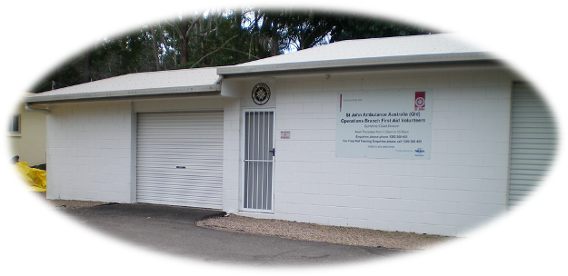
On this basis, any future development of new community infrastructure at the Elizabeth Daniels Sports Complex should be subject to a separate detailed investigation in order to determine the potential benefits and any adverse impact of this form of development on the site. Additionally, should it be determined that land could be developed for community and/or sport use, it is recommended an Expression of Interest process be undertaken to ensure equity and transparency.

Traffic Advice
MRCagney, Transport and Planning Consultants have provided the following situational advice on the Complex and the impacts of the Department of Transport and Main Roads (DTMR) Multi Modal Transport Corridor (MMTC) and the Caloundra to Maroochydore Corridor Options Study.
  - Transport
The whole site is subject to further investigation of transport needs as DTMR have a long standing interest in this site. It is adjacent to the Sunshine Motorway and the Buderim/Mooloolaba Road Interchange. There have been studies done, although none particularly recently, to determine the future of this interchange. The additional complications have been the uncertainty surrounding the Nicklin Way extension and the CAMCOS rail corridor.
The DTMR website shows the current preferred outcome(s) of the most recent studies with the rail corridor drawn on either the western or eastern side of the motorway (see Figure 1 and Figure 2).
Figure 1: MMTC Project Eastern Rail Option – Buderim Mooloolaba Rd Interchange
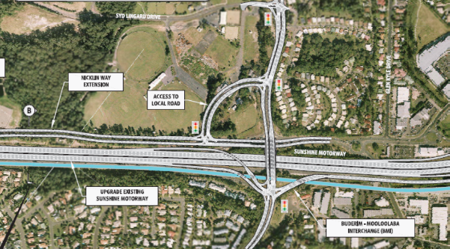
Source: DTMR website – 1 July 2013

Figure 2: MMTC Project Western Rail Option – Buderim Mooloolaba Rd Interchange
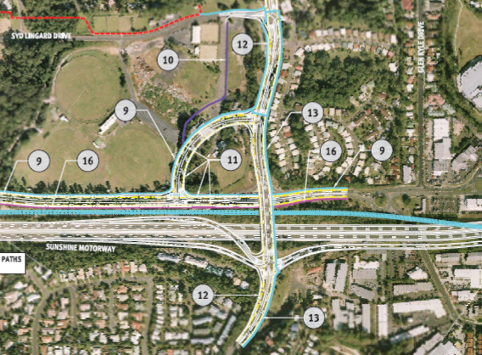
Link Road
Source: DTMR website – 1 July 2013
The layouts (refer Figure 11 and Figure 12) have not been refined any further at this stage although there is some suggestion that the link road highlighted above may not be appropriate due to potential impacts on the interchange via the signals. Suggestions are that perhaps an alternative may be found clear of the Elizabeth Daniels Sports Complex site (to the south).
Based on the above concept, DTMR have provided some clarity on their future requirements for the Complex site as illustrated at Figure 3. This is a significant impact especially for the cricket fields. Timing for any works is not certain, however the project has some ‘pre-project’ funding from 2015. DTMR advised Council that planning projects for the upgrade of the Sunshine Motorway between the Mooloolah River Interchange and the Maroochydore Principal Activity Centre are progressing. The planning projects will develop a staging strategy for upgrades over a period of 20 years or more. Until these planning projects reach conclusion in mid-2015 there will be no update of current road corridor requirements, which were identified approximately five years ago. Therefore, at this stage DTMR do not expect works to impact Elizabeth Daniels Sports Complex within 10 years, however this will be confirmed on completion of the planning project in mid-2015.

Aside from the obvious land take issue, this will not impact on the access to the site, as it will remain via Syd Lingard Drive. If there is a connection road to the south this may provide some additional access from Mountain Creek, however the form of this access has not been determined. To maximise the long term flexibility of this site as a sport and recreation facility, traffic advice suggests that council should push for connection from the south of the Complex adjoining Syd Lingard Drive.
Figure 3: Multi-modal transport corridor impact
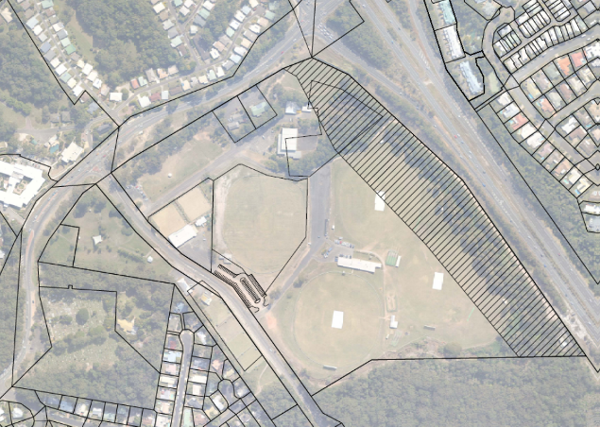
DTMR land requirements
Source: DTMR website – 1 July 2013
As a result of the most recent discussions between the project traffic consultant and DTMR, the indications are that it is unlikely that any expansion works along Sunshine Motorway will occur within the life of the Master Plan (to 2028). The Master Plan has ensured no new building infrastructure is developed within the area of the site potentially affected by any future works along the Sunshine Motorway. However, as confirmation of project approval, timing, funding and design is not available, the Master Plan does not give consideration to any potential impacts on existing building infrastructure and activity facilities.

  - Internal Movement
The site generates very little traffic on an average annual basis, however as with all such venues there are significant peaks for special events. These events anecdotally only cause minor traffic disruption however access to parking is awkward for patrons and particularly buses. Entering from either the north or the south entrance from Syd Lingard Drive necessitates an exit from the same access/egress.
One option may be to explore a formalised internal circulation driveway as shown below to allow access to all parking from either exit and allow buses to enter and exit much more readily in a forward direction. However, there will need to be additional investigation into whether this should be a one way or two way facility. A two-way would provide more flexibility and be the preferred solution.
  - Pedestrian Access
The site is divided by Syd Lingard Drive, and patrons may wish to cross Syd Lingard Drive from time to time, mainly one would suspect to access parking. There is a pedestrian refuge facility, constructed as per the Manual of Uniform Traffic Control Devices (MUTCD) which is considered an appropriate solution. Outside of that, patrons can easily cross due to the low volume of traffic. Speed has not been reported as a significant problem, however the design of Syd Lingard Drive makes it susceptible to speeding and this should be monitored.
It has been questioned as to whether it is appropriate to have turning traffic, accessing the Croquet Club driving across the constructed walkway, which is also assumed to be used a bikeway. It is not considered this is a particular hazard, being a common event for driveways to cross footpaths throughout the coast.
General pedestrian access to the site from surrounding areas is prohibitively difficult. The Syd Lingard Drive/Mooloolaba Road intersection being virtually unusable, having a free high speed left turn and as a result pedestrian crossings on only 3 of the 4 legs. This likely motivates people to drive from the nearby Buderim retirement village rather than walk. It should be recognised that it is a health issue, preventing those people from enjoying the exercise from walking. It is not something that necessarily creates a traffic issue.
  - Parking
Parking is considered sufficient, except for event days of course when the venue is full. Council has formalised some more parking at the southern end of the site on the eastern side of Syd Lyngard Drive, shown in Figure 14.
Figure 4: Extended Car Park by council
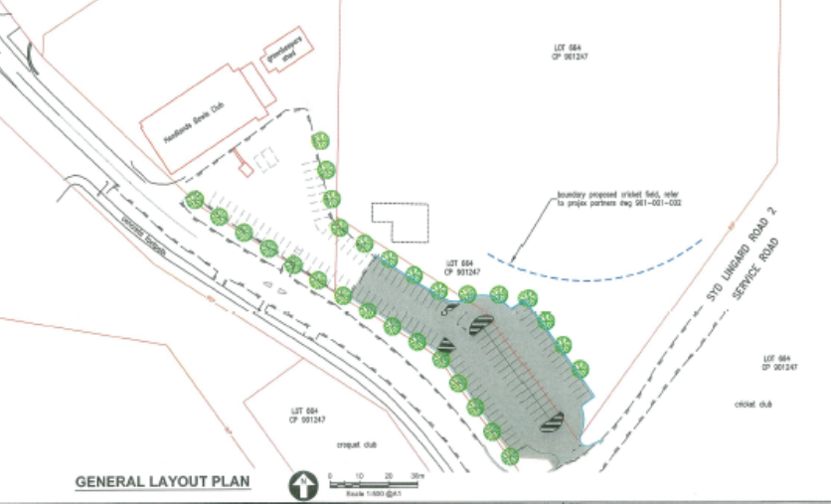
The adjacent private hospital has been using the site as a temporary park’n’ride whilst construction has been going on their site. However, any permanent presence by the Hospital at the car parks will take away from the ability of the site to function in accordance with council’s desired car parking and access outcomes.
  - Implications for Master Plan
Whilst further discussions have been held with the Basketball Association in relation to their desire to expand their facility, the latest advice from DTMR is that they are unable to confirm detail on the timing, design or impacts of any potential works along the Sunshine Motorway which have the potential to impact on the Complex as a result of the CAMCOS development. On this basis, the Master Plan is unable to factor in the impact and timing of these works within the recommended design as they are unknown. However, as DTMR have a current concept design publicly available and have provided an overlay of the potential extent of impact on the Complex, the Master Plan recommends at this time no new built infrastructure is incorporated along the eastern or north eastern parts of the site, with the exception of the potential for an expansion of the basketball facility, subject to confirmation from DTMR that that the identified expansion area will not be affected by any future CAMCOS works.

