

GOLDEN BEACH, BEACH NOURISHMENT AND DREDGING WORKS QLD (EPBC 2012/6397)
COMPLIANCE REPORT 2014

SUNSHINE COAST COUNCIL
COASTAL & CANALS UNIT

Prepared by Gavin Leese, December 2014
1. PURPOSE

As a condition of the approval EPBC 2012/6397 Sunshine Coast Council is required to submit and publish a report detailing compliance with all sections under the approval.

2. DETAILS OF COMPLIANCE

- The disturbance area was limited to the area depicted in drawings dated 04/05/2012 as provided to the Australian Government Department administering the Environment Protection and Biodiversity Conservation Act 1999. This disturbance area can be confirmed by GPS coordinates provided by the contractor during works.
- The project was limited to a 10 year period from the date of the approval, the date of the expiry of the approval being 31/12/2022 and the date of works being within the 2014 calendar year.
- The dredging contractor provided details of a maximum 20m³/hour dredging capability (ideal conditions) with maximum 8 hours of dredging being performed each day for the 29 days dredging activity. The quantity, therefore, was worked out to be 4,640m³, below the 10,000m³ maximum.
- Dredging occurred on 29 separate days in the 2014 calendar year; this was confirmed on site as well as the details provided by the dredging contractors.
- Seagrass surveys provided in the original permit application in the areas proposed to be dredged confirmed the location and extent of seagrass. Results of this survey have been maintained and will continue as required.
- Dredging activities were not conducted within 50 metres of seagrass identified in seagrass surveys provided in the original permit application.
- The monitoring plan, detailing how the Sunshine Coast Council will monitor seagrass for impacts of dredging, was approved by the Minister in January 2014. Sunshine Coast Council have committed to implement these measures during the current dredging calendar year.
- The Sunshine Coast Council managed potential or actual acid sulphate soils as described in the Queensland Acid Sulfate Soils Technical Manual Soil Management Guidelines version 3.8, Queensland Government and in the Instructions for the Treatment and Management of Acid Sulfate Soils, 2001, Queensland Government by providing these documents to the experienced dredging contactor carrying out the works and ensuring their understanding of these documents.
- The action was not undertaken within 100m of the bed or banks of Bells Creek or within 50 meters of previously identified potential or actual acid forming material. GPS coordinates recorded by the dredging contractor have confirmed this.
- The dredging contractor provided Sunshine Coast Council with the details of daily pH and turbidity testing during all dredging activities.
- Daily monitoring of pH and turbidity as required in condition 10 was undertaken as described in Schedule C – Table 1 of EHP Permit number SPDE042884412 (Attachment 2).
- No acid sulphate soils were detected during dredging activities, a spotter was provided by the dredging contractor during all dredging activities.
- The Dredge operator is competent and capable of identifying turtles and dugongs and did not see any during dredging operations.
- Dredging occurred in the months of May (7 days), September (7 days) and October (15 days).
- A minimum 20m buffer between the dredge channel and the marine park conservation zone as shown in Drawing C017 (Attachment 1) was adhered to at all time, details can be provided in GPS coordinates recorded by the dredging contractor.
- The Australian Government Department administering the Environment Protection and Biodiversity Conservation Act 1999 was informed in writing prior to the commencement of the action.
- Revisions that were made to the monitoring plan that was approved in January 2014 were approved by a delegate of the Minister.
- No varied activities were carried out during the dredging activity.
- No audit has been asked for by the Minister or a delegate of the Minister.
- Accurate records substantiating all activities associated with or relevant to the conditions of approval have been maintained.
- This Compliance Report was published on the Sunshine Coast Council’s website by 23/03/15. Documentary evidence providing proof of the date of publication has been sent to the Department.
- Commencement of the action was undertaken before 3 years from the date of the approval. The monitoring plan referred to in these conditions of approval has been uploaded to Sunshine Coast Council website.

Approved by:

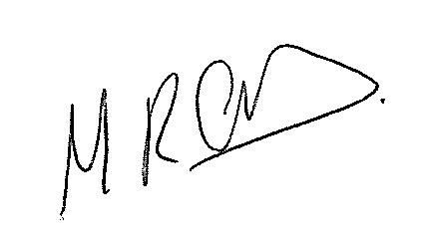
Michael Anderson
Manager Environmental Operations (backfill)

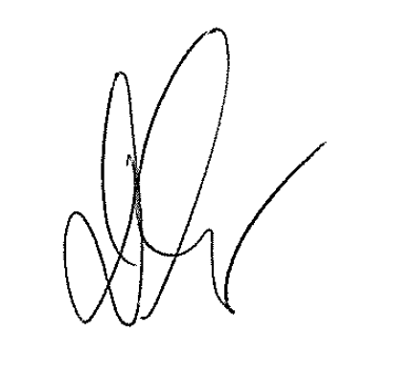
Denis Shaw
Principal Engineer, Senior Coastal Constructed Water and Planning Sunshine Coast Council

