Elizabeth Daniels Sports Complex Master Plan 2013 – 2028: Part 3

Catchment
  - Population/Membership
Based on 2011 Census data and information supplied by Elizabeth Daniels users, Map 1 demonstrates where the membership catchment for the site is derived.
Map 1: Elizabeth Daniels Sports Complex membership catchment
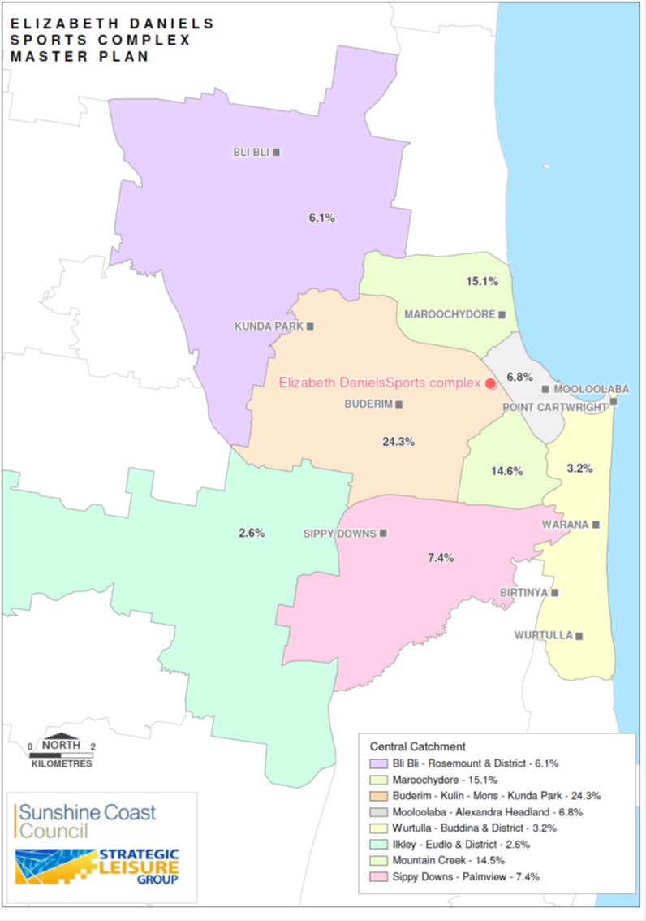
By applying these catchment rates to the estimated 2026 population (supplied by Sunshine Coast Council, Community Planning and Strategy and drawn from ABS Estimated Resident Population 2011 with forecast figures based on Sunshine Coast Council Population Mode), a projected number of future users from these areas can be calculated. This would be considered to be a maximum figure because it assumes:
- A linear projection of age breakdown (when in fact it is known that the median age of the Sunshine Coast is predicted to rise from 41 as at 2006 to 44 by 2026 – both figures being higher than the state average of 36 and 41 respectively); and
- No new playing areas are developed within the catchment which, if they were developed, would reduce pressure on utilisation of the Complex.
It should be noted that an age breakdown of population projections by locality is not available.
Table 14: Elizabeth Daniels Sports Complex Membership Catchment Projections*
Catchment Localities | Population 2011 | Current Catchment Membership |  | Projected Population (2026) | Projected Catchment Membership
Catchment Localities | Total | No of Users | % | Total | No of Users | %
Bli Bli - Rosemount & District | 10,394 | 130 | 6.1% | 12,919 | 162 | 4.9%
Maroochydore | 14,922 | 323 | 15.1% | 23,716 | 513 | 14.5%
Buderim - Kuluin - Mons - Kunda Park | 31,014 | 520 | 24.3% | 40,839 | 685 | 21.2%
Mooloolaba - Alexandra Headland | 11,424 | 145 | 6.8% | 15,090 | 192 | 4.7%
Wurtulla - Buddina & District | 21,819 | 68 | 3.2% | 21,999 | 69 | 2.5%
Ilkley - Eudlo & District | 4448 | 56 | 2.6% | 5374 | 68 | 1.8%
Mountain Creek | 7190 | 310 | 14.5% | 11,643 | 502 | 16.6%
Sippy Downs - Palmview | 10,043 | 158 | 7.4% | 27,764 | 437 | 13.8%
Other |  | 429 | 20% |  | 657 | 20%
Total: | 111,254 | 2,139 | 100% | 159,344 | 3,285 | 100%
* Figures are based on membership data supplied by existing users. Some users may be a member of multiple clubs and therefore could be counted more than once. The “No of Uses” is exclusive of Art Group as data was not available and does not include Sunshine Coast Cricket Association considering the site is the home of Maroochy Cricket.

The individual catchments of each sporting club was consistent with the overall Complex catchment outlined in the table outlined above with the high majority of members coming from the Maroochydore, Buderim and Mountain Creek localities of interest.
  - Catchment Facilities
The following outdoor sport and recreation facilities are located within the primary localities of interest of Maroochydore, Buderim and Mountain Creek:
- Maroochydore Multi Sports Complex, Fisherman’s Road, Maroochydore;
- Maroochydore Rugby Union, Beach Parade, Maroochydore;
- Ballinger Park Sports Complex, Ballinger Road, Buderim;
- Maroochy Beach Gymnastics, Wises Road, Buderim;
- Maroochydore Junior Rugby League Club, Wises Road, Buderim; and
- Martins Creek Sports Complex, Maroochydore Road, Kuluin.
Recommendations from the Sunshine Coast Sport and Active Recreation Plan 2011 -2026 for the above similar facilities within the Complex catchment, included:
- Seek additional land to service population growth in Maroochydore;
- Adopt and progressively implement the Master Plan for Maroochydore Multi Sports Complex;
- Prepare a Master Plan for Cotton Tree Park which addresses site integration and investigates opportunities for expanding support amenities for rugby union;
- Ensure that the Maroochydore Junior Rugby League Club premises at Wises Rd, Maroochydore is correctly zoned for sporting purposes and work with the club to facilitate planning approvals for club improvements at this venue;
- Support the development of an additional cricket oval at Elizabeth Daniels Reserve (completed);
- Support the upgrading of facilities on the main cricket oval at Elizabeth Daniels Reserve (spectator seating, sightscreen) in keeping with the venue’s regional status;
- Upgrade signage from the Sunshine Motorway to Elizabeth Daniels Reserve;
- Liaise with stakeholder clubs and undertake a Master Plan for Elizabeth Daniels Reserve;
- Liaise with stakeholder clubs and prepare a Master Plan for Ballinger Park Sports Complex;
- Recognise Martins Creek Sports Complex as the regional headquarters for Federation Soccer on the Sunshine Coast. Extend playing fields to the west as demand warrants; and
- Determine how best to utilise the proposed sports reserve land shortly to be provided from developer contributions. Seek opportunities to secure additional land in this locality over time.
Given the proximity of Ballinger Park to Elizabeth Daniels Sports Complex, this master plan will investigate any unmet opportunities arising from the Ballinger Park Master Plan and ensure solutions do not result in unnecessary duplication. The Ballinger Park Master Plan was recently endorsed by council with the key recommendations, including:
- Improved community pedestrian/cycle access;
- Investigate future (long term) relocation opportunities for Alcooringa/Fusion to a more central location;
- New multi-use junior sized cricket oval (80 metre diameter);
- Investigate potential to expand archery range to meet regional standards;
- Expansion area for second synthetic hockey surface;
- Area suitable for continuing Pony Club use; and
- Provide opportunities for future connections to Regional Trail Network.
Sunshine Coast Council is currently undertaking a feasibility study to determine the site, location, facility mix, indicative capital costs, concept plans, financial projections, potential partners and management arrangements for the development of a multi court indoor sporting facility at the Maroochy Multi Sports Complex or an alternative site in the Maroochydore/Buderim area. The outcome of this study will assist to inform council’s priority location for the development of new multi-purpose indoor courts within this part of the region.
The Sunshine Coast Social Infrastructure Strategy 2011 includes recommendations for the planning and delivery of community infrastructure within the Buderim and adjoining Mountain Creek locality of interest. It does not identify Elizabeth Daniels Sports Complex as a specific location for this type of development.

Trends Analysis
  - Participation Trends
Annual surveys of participation in exercise, sport and recreation by Australians aged 15 years and over, are undertaken under the auspices of the Australian Sports Commission. The most recent 2010 survey revealed the following participation rankings for Queenslanders aged 15 and over in respect of activities conducted at Elizabeth Daniels Sports Complex:
- Walking: 1st (35.0% participation in previous 12 months. Consistently the most frequently participated in exercise, sport or recreation activity over the last decade);
- Basketball: 16th (2.7% participation in previous 12 months. Slight increase over last decade);
- Cricket: 17th (2.6 % participation in previous 12 months. Relatively static over last decade);
- Lawn Bowls: 23rd (1.6% participation in the previous 12 months. Decline over the last decade);
- Croquet: No data available.
The Australian Bureau of Statistics compiles data via triennial surveys on participation in leisure and sport by children aged 5-14 years. Data is analysed at a national level only, not on a state by state basis. In the most recent (2012) survey it is estimated that:
- 60% of children participated in organised sport outside of school hours (this represents a slight decline over the last decade);
- Boys had a higher participation rate in organised sport compared to girls overall (66.4% compared with 53.6%) and across all age groups; and
- Participation was higher for children born in Australia (61%) compared with those born overseas (52%) and higher for children in couple families (64%).
In the four surveys conducted over the last decade some participation trends at the national level are evident among young people aged 5-14 years:
- Gymnastics has increased very substantially;
- Martial arts has increased significantly;
- Basketball has increased slightly;
- The traditional sports of netball, tennis and cricket have declined; and
- Indoor soccer participation has declined.
  - General Trends
Strategic leisure studies over the last decade have revealed a number of trends that are impacting on participation in sport and recreation that are relevant to Master Planning studies such as these.
- Changing patterns of work and declining availability of "uncommitted time" is changing patterns of participation in sport and recreation.
- For many, the leisure experience is one of limited time availability with an expectation of "instant gratification". This is evidenced by a desire for participants to "turn up and play" where minimal extra commitments are involved. In many cases the participants are willing to pay extra for this service which has created some opportunities for commercial provision.
- Participation in organised sport is static and there is greater demand for social forms of participation.
- There is a greater demand for floodlighting of outdoor facilities so that people can participate at times that are convenient to them or (especially in sub-tropical or tropical climates) and/or to reduce exposure to the sun.
- Similarly, there is growing demand for covered or indoor facilities for reasons of greater flexibility of use, improved comfort or better safety.
- Volunteerism is declining in many sport and recreation organisations. This is placing greater pressure on the remaining volunteer base and may impact on participation levels and/or costs in future if services that were once provided voluntarily need to be paid for.
- Declining volunteerism is also placing greater pressure on councils in terms of the way they manage sports facilities on their land.
- The availability and/or cost of insurance often impacts on clubs.
- Local governments are recognising the importance of creating environments to enable people to lead active and healthy lives, placing greater focus on the importance of the provision and/or connectivity of walk/cycle paths, safety, urban design, services and programs (especially in areas or populations with lower levels of engagement) and open space planning.
- Walking is consistently identified as the most popular form of active recreation and walk/cycle paths are consistently at the forefront of public demands for recreation facilities.
- There is an awareness of the importance "risk management" and the need for a "whole-of-life" approach to facility development and asset management.
- The availability of government funding to develop sporting facilities has diminished with more competition for scarce available funding.
- The difficult economic environment is influencing the need for sporting organisations to diversify their income stream, including expanding the use of their facilities to include other groups.
Cricket is the largest user of land at the Complex and as a sport is increasingly seeking to introduce new forms of the game aimed at combating the changing trends outlined above. In particularly the introduction of shorter forms of the game and increased night competitions have been introduced in recent years. As the regional Sunshine Coast Cricket Association facility, the introduction of lighting at the Elizabeth Daniels Sports Complex would assist cricket to service this changing competition structure. Further, the introduction of lighting at the Complex may open up alternate activities such as touch football. The other primary implication of trends relevant to this study and the Complex is the popularity of recreational walking. On this basis any future facility layout for the Complex should consider a mix of sporting and recreational opportunities (e.g. walk/cycle pathway network).

Key Findings
This Study identified several findings relevant to informing the development of the Master Plan, including:
- Whilst, the potential impact of the planned expansion of the Sunshine Motorway as part of the Multi Modal Transport Corridor may have a significant impact on the site, including existing building infrastructure, cricket ovals and internal road network, indications are that it is unlikely that any expansion works along Sunshine Motorway will occur within the life of the Master Plan (to 2028);
- Recent discussions between DTMR and the Sunshine Coast Basketball Association have been unable to confirm the exact impact of any future potential infrastructure works in proximity to the basketball facility;
- Sunshine Coast Council is currently undertaking a feasibility study for the development of a multi court indoor sporting facility at the Maroochy Multi Sports Complex or an alternative site in the Maroochydore/Buderim area. The outcomes of this study will assist to inform council’s priority location for the development of new multi-purpose indoor courts;
- The Buderim locality of interest is estimated to grow by a further 27% to an estimated population of 38,273 in 2026;
- The estimated membership is estimated to increase from 2139 to 3753 by 2026. This will add increasing pressure on council to ensure adequate provision of sport and recreation facilities to service the current and future needs of the community;
- Situated on an old landfill site, the Complex is prone to land movement with the potential for refuse to rise to the surface posing a risk, whilst leachate is also a problem that needs to be managed;
- Council has recently expanded the existing bowls club car park south to service the new cricket oval and other user groups;
- The majority of users indicated that improved parking, access, signage and the internal road network requires improvement;
- The south east corner includes a small portion considered as wetland and being flood prone;
- Buderim Men’s Shed, Mooloolaba Lions Club and Buderim Billiards and Snooker Club have indicated an interest in being based at the Complex should land become available in future, however any future development of new community and/or sport infrastructure at the Elizabeth Daniels Sports Complex would require a separate detailed investigation in order to determine the potential benefits of development on the site and in consideration of any adverse impacts from DTMR’s traffic interchange outcomes;
- There are opportunities for increased sharing of resources across user groups to attract economies of scale benefits;
- Any future management model introduced for the Complex must be consistent with the outcomes of council’s review into tenure arrangements for not-for-profit clubs;
- Sporting trends indicate that there is increased demand for evening competitions generally which may necessitate the future development of lighting to the outdoor playing fields;
- There is an increasing need to provide leisure and recreational pursuits suitable to service the ageing population;
- Whilst it is acknowledged the Complex is the regional home of the Sunshine Coast Cricket Association, given the current difficult funding environment for community and/or sport infrastructure and the scale of the proposed spectator seating and supporting amenities, this development is considered outside the capacity of council;
- Funding is committed to upgrade the toilet block located behind the Gem & Fossicking Club building in 2013/14;
- The Sunshine Coast Cemetery Plan confirmed the Buderim Cemetery is closed to new burials and therefore the potential expansion into the Complex was not further investigated; and
- The availability of government funding to develop sporting facilities has diminished and therefore has increased the load on existing facilities.

Consultation on Draft Master Plan
Consultation on the Draft Master Plan was undertaken via the following methods during September 2013:
- Direct mail to current stakeholders;
- Media release informing the community of the draft being available on Council’s website and also of the “Meet us in the Complex” event;
- “Meet us in the Complex” event.
The key themes of the feedback obtained as a result of this consultation is summarised below:
- There is occasional conflict between differing size and behaviour standards of dogs and their owners within the existing dog park. This study considered these events to be a community management matter and not one to be resolved through design of the Complex.
- It was recognised that spill over, informal parking occurs adjacent to the dog park. On this basis, the final design does not restrict informal parking, however it does improve safety separation between pedestrians and vehicles.
- There was an overwhelming view that relocating the children's playground adjacent to the dog park would potentially create conflict between users. Further, it was identified from the consultation that the current playground location was effective, subject to improved toilets and car parking access.
- There were several responses suggesting a food van would add value to the site. This study recognises there is sufficient land area to accommodate a food van in future, however any future introduction would be subject to regulatory processes and approvals.
- It was highlighted that the site should incorporate current Council planning standards with regard to pathways and signage.

Proposed Facility Mix
Based on the analysis of background research, consultation and study objectives, the proposed elements of the Master Plan for the Elizabeth Daniels Sports Complex are described below.
The facility mix takes into consideration the potential impacts of any works in future adjacent to the Sunshine Motorway as part of any CAMCOS development. In particular, no new built infrastructure is recommended along the eastern or north eastern parts of the site until DTMR can confirm their land requirements for the site.
The facility mix recognises the strong current use of the dog off leash park by recommending further embellishment of this area to improve the recreational experience for community users. An alternate use of the currently underutilised north-west open space area is recommended in the form of park exercise stations and supporting equipment. There are clear synergies regarding the installation of this type of equipment within high population density localities similar to Buderim and where existing and proposed walk/ cycle opportunities exist.
The study has identified that peak usage varies across user groups and at differing times/days of the week. On this basis, an improved road and pedestrian network is recommended to allow spill over parking from one car park to other site car parks based on where the peak demand dictates at any given time.
Cricket is seeking the development of spectator seating and supporting amenities. Given the current difficult funding environment for community and/or sport infrastructure and the scale of the proposed spectator seating and supporting amenities, this development is considered outside the capacity of council. On this basis, should this development progress in the future, it is recommended that cricket seek to secure the necessary funding. An alternate design has been included in the Master Plan design whereby a network of platforms, supported by 3-phase and 10amp power and water are developed around the major cricket field to support the bumping in of temporary food, beverage and spectator facilities to service future major event needs.
The feasibility study for the development of a multi court indoor sporting facility at the Maroochydore Multi-Sports Complex or an alternative site in the Maroochydore/Buderim area is currently being undertaken by council and will assist to inform council’s priority location for the development of new multi-purpose indoor courts. Further, whilst there is potential to expand the current number of indoor courts, the basketball facility is situated within an area currently identified as potentially being affected from future CAMCOS works. Whilst there have been informal discussions between DTMR, Council and the Sunshine Coast Basketball Association about the potential to expand into this area, DTMR have indicated it is unable to provide formal confirmation that this area will be unaffected in future until further detailed analysis is undertaken. This is expected to be concluded by mid-2015. On this basis, it is recommended that no expansion of the basketball facility occur until surety is obtained that this land area will not be affected by any future CAMCOS works.
Based on the current funding environment, the scale of development required by the groups, lack of new developable space on site and advice from council that remaining open space should be protected, any potential new community infrastructure at the Elizabeth Daniels Sports Complex should be subject to a separate detailed investigation in order to determine the potential benefits and any adverse impact of this form of development on the site.
In consideration of the limited expansion opportunities as a result of the extent of current on site development and the potential risk of expansion of the road/rail network on the eastern side of the site, there is no recommended expansion of tenure areas for existing users.
Other minor facility improvements were proposed by existing user groups that are not included with the future Master Plan design, however these items were considered to be within the capacity of the user groups to fund and outside the responsibility of council to fund and/or partner.
The time frame for these recommended elements has been assessed as either:
- Short Term (within 5 years)
- Medium Term (6 – 10 years)
- Long Term (11 – 15 years).
Council does not have the capacity to and is not responsible for the implementation and funding of all development recommendations. Further, priorities may change over time subject to changes to demand and funding opportunities. Such master planning considerations are not essentially locked in, and as such, the final outcome may differ from what was originally intended or endorsed by council.
Opportunities for sustainable facility outcomes are recommended to be considered as part of the development of the major infrastructure items outlined below. Initiatives could include water harvesting, solar initiatives and sustainable lighting solutions.
Table 1 - Facility mix description, cost, timeframe and rationale
Master Plan Improvement | Concept Plan Reference | Indicative Cost | Timeframe | Rationale
Short Term (Within 5 years)
Undertake geotech, embankment, environmental, leachate investigations across the site to ensure there is a clear understanding of the subsurface integrity. | N/A | Professional fees - unknown | Short Term | Before any future expansion or new development to the Complex site occurs, it is important to understand the integrity of the land to confirm appropriate development locations.
Retain open space. Retain and upgrade playground equipment, replace shade sail and install exercise equipment. | 1 | $75,000 | Short Term | Consultation evidence identified the existing recreation park is underutilised due to a lack of direct access for families. The introduction of new and safer access/egress to existing car park in this area will provide improved access for families. Further, the upgrade of toilets and playground in this locality will improve the areas attractiveness for families. The intensive population density and current and recommended network of pathways and trails supports opportunities to enhance the community exercise experience through the installation of exercise equipment and stations within the Complex.
Demolition of existing toilets in recreation park and construction of CPTED style toilets close to proposed pedestrian crossing on Syd Lingard Drive. Incorporate notice board and adjacent seating. Connect to existing adjacent sewer. | 6 | $300,000 | Short Term | The proposed location will directly service the recreation park for families and other users, whilst its proximity to the new safe pedestrian crossing point will provide safe pedestrian access for users of the dog park.
Formalisation of parking and improved access (one-way) to eliminate dangerous multiple egress and open drain crossings. Closure of one existing driveway. | 11 | Combined with “10” | Short Term | Results in improved safety and increased parking spaces.
Provide new safe pedestrian crossing points. | 18 | $100,000 | Short Term | Improved safety access from eastern side of Complex to western facility elements.
Reinstate land slippage and stabilise (rehabilitate) steep embankments. | 21 | To be confirmed following specialist investigation | Short Term | To maintain environmental integrity of this area and ensure no net loss of useable land area for the Complex.
Provide improved directional signage | 22 | $20,000 | Short Term | Improve vehicle and pedestrian movement across this substantive site with multiple usages.
Potential future community and/or sport development zone (subject to detailed investigation). | 23 | To be confirmed in future following confirmation of demand | Short Term | Subject to further detailed investigation and an expression of interest process, a portion of the current open space may be suitable to service future community and/or sport infrastructure development.
Formalise drainage swale along eastern length of Syd Lingard Dr |  | To be confirmed following specialist investigation | Short Term | Reduce improve drainage and maintenance costs
Medium Term (6 – 10 years)
Retain dog park layout with expansions to the east and north west. | 2 | $8,000 | Medium Term | As a heavily utilised recreation park, it is recommended to expand the dog off leash park to the east and north east. Warning signage should be installed reminding users that dogs should remain under supervision and effective control at all times.
Potential portable tiered seating with light weight shade canopy (overlooking John Blanck Oval). | 3 | $60,000 | Medium Term | To service the spectator needs of the Queensland Premier Grade competition and other future events.
Potential future spectator seating and supporting amenities. | 4 | Scope unknown | Medium Term | As the regional cricket facility on the Sunshine Coast the spectator seating and supporting amenities are intended to service future major event needs.
Install lighting to western cricket fields (John Blanck and Kerry Emery Ovals). Incorporate 3-phase and 10amp power points, water connection and adjacent concrete hard stand for temporary event facilities. | 5 | $450,000 | Medium Term | To service the growth in shorter versions of cricket and night competitions. It is recommended that no major embellishments on the eastern side of cricket facility occur until surety is obtained that this land area will not be affected by any future CAMCOS works.
Improve vehicular and pedestrian circuit with road widening and formalised parking. | 7 | $1,400,000 | Medium Term | Supports the development of an internal loop road to allow spill over parking to service peak demand fluctuations. This development will also result in improved safety and increased parking spaces.
Widening and formalisation of narrow section of road. | 7a | Included above | Medium Term | Supports the development of an internal loop road.
Future potential expansion of indoor court facility. | 9 | To be confirmed following detailed feasibility and design investigation | Medium Term | It is recommended that no major expansion of the basketball facility occur until surety is obtained that this land area will not be affected by any future CAMCOS works.
New and safer access/egress to existing car park. Potential car park expansion for access to the open space, playground and the Sunshine Coast Gem & Fossicking Club / Headland Buderim Croquet Club. | 10 | $250,000 | Medium Term | Results in improved access for families to the recreation park and improved safety and increased parking spaces for users of facilities on this side of Syd Lingard Drive.
Adjust car park layout to incorporate additional disabled spaces. Possible expansion of parking eastwards if warranted. | 12 | $250,000 | Medium Term | Results in improved safety and increased parking spaces.
Improved access/egress to Syd Lingard Drive and additional parking spaces. | 13 | $115,000 | Medium Term | Results in improved safety and increased parking spaces to service anticipated community use increases of the adjacent recreational facilities.
New shared path. | 14b | $70,000 | Medium Term | Supports safe connectivity with Mooloolaba Road.
Pedestrian path network. | 15 | $75,000 | Medium Term | Supports connectivity to and around site, including access to proposed exercise fitness area.
New shared path. | 15b | Combined with 15 above | Medium Term | Improves internal connectivity from car parks to activity areas and creates a continuous loop for recreational exercise.
Provide break in fence and pedestrian path connections to Mooloolaba Road in south west corner of open space. | 16 | $4,000 | Medium Term | Improved site connectivity for the north west community.
Long Term (11 – 15 years)
Investigate potential ramped access between lower car park (adjacent to Maroochydore Eagles Basketball) and Sunshine Coast Contract Bridge Club to compliment existing stair access. | 20 | $15,000 | Long Term | Supports ability for basketball car park to service spill over needs associated with Bridge and Art activity.
Investigate and consider upgrade to mains sewer network throughout applicable components of the Complex | N/A | To be confirmed following specialist investigation | Long Term | To cater for increased growth and ongoing operational and maintenance issues associated with septic sewerage.
Formalisation of existing car parks to improve efficiency and safety. | 8 | N/A | N/A | Completed works have resulted in improved safety and increased parking spaces.
Shared pedestrian and cycle path. | 14 | N/A | N/A | N/A
Existing shared path. | 14a | N/A | N/A | N/A
Existing shared path. | 15a | N/A | N/A | N/A
Existing pedestrian crossing point retained. | 17 | N/A | N/A | N/A
Informal pedestrian walking trail within Complex. | 19 | N/A | N/A | Larger recreational exercise loop option for community.
Large dog off leash enclosure. | 2a | N/A | N/A | N/A
Small dog off leash enclosure. | 2b | N/A | N/A | N/A

The indicative cost associated with the recommended staged development of the Elizabeth Daniels Sports Complex is summarised below:
- Short term (1 – 5 Years): $495,000
- Medium Term (6 – 10 Years): $2,682,000
- Long Term (11 – 15 Years): $15,000
- TOTAL $3,192,000.
The above indicative costs exclude the items listed below. These items will require further investigations to determine detailed costings and appropriate funding source:
- Reinstate land slippage;
- Potential future community and/or sport development zone;
- Formalise drainage swale;
- Potential future spectator seating and supporting amenities;
- Upgrade to main sewer network;
- Future potential expansion of indoor court facility;
- Council project management fees;
- GST;
- Future cost escalation;
- Headworks;
- Design, development and construction contingency;
- Stormwater management; and
- Upgrading existing site services infrastructure – hydraulics and electrics.

Master Plan Design
Figure 1 Elizabeth Daniels Sports Complex Master Plan Concept
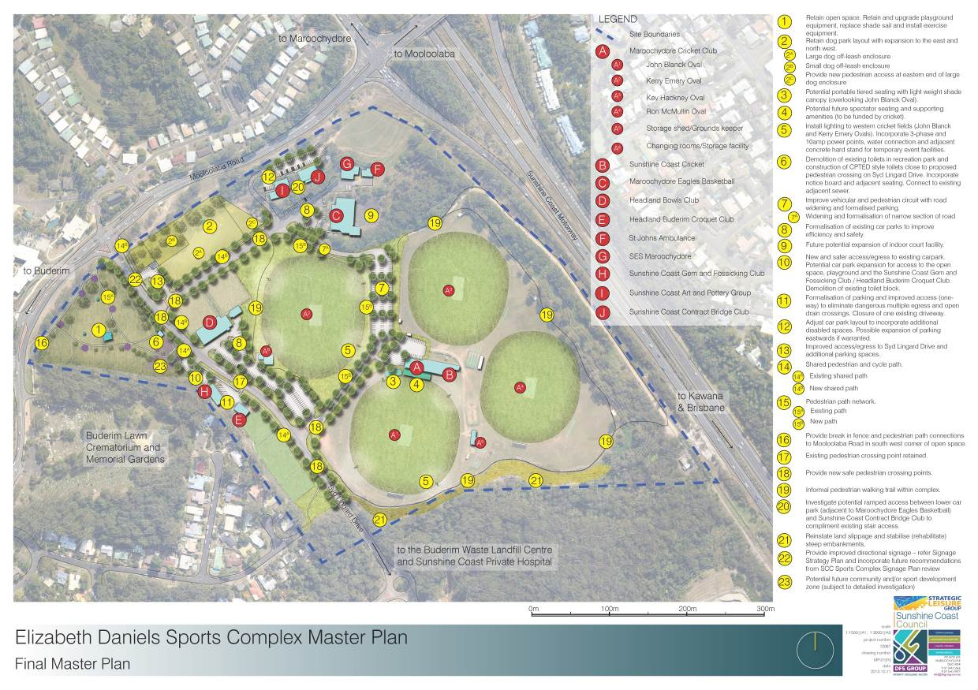
Figure 2 Elizabeth Daniels Sports Complex Master Plan Concept - Detail Area
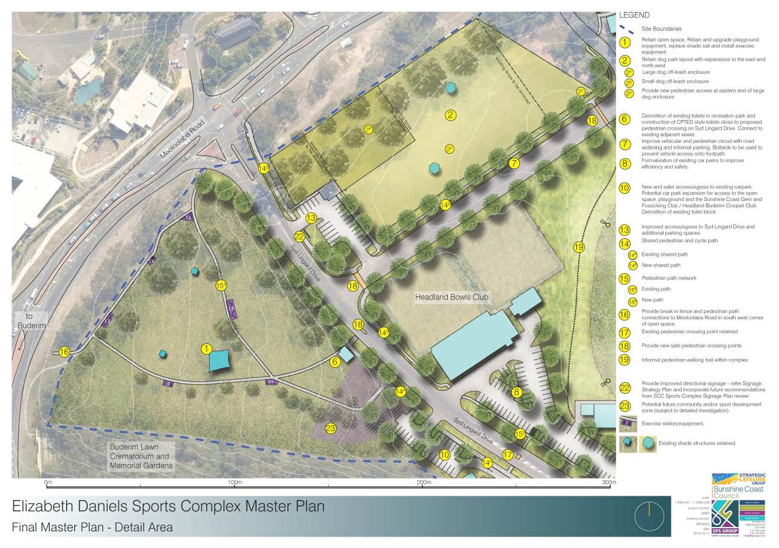

Figure 3 Elizabeth Daniels Sports Complex Master Plan Signage Strategy Plan
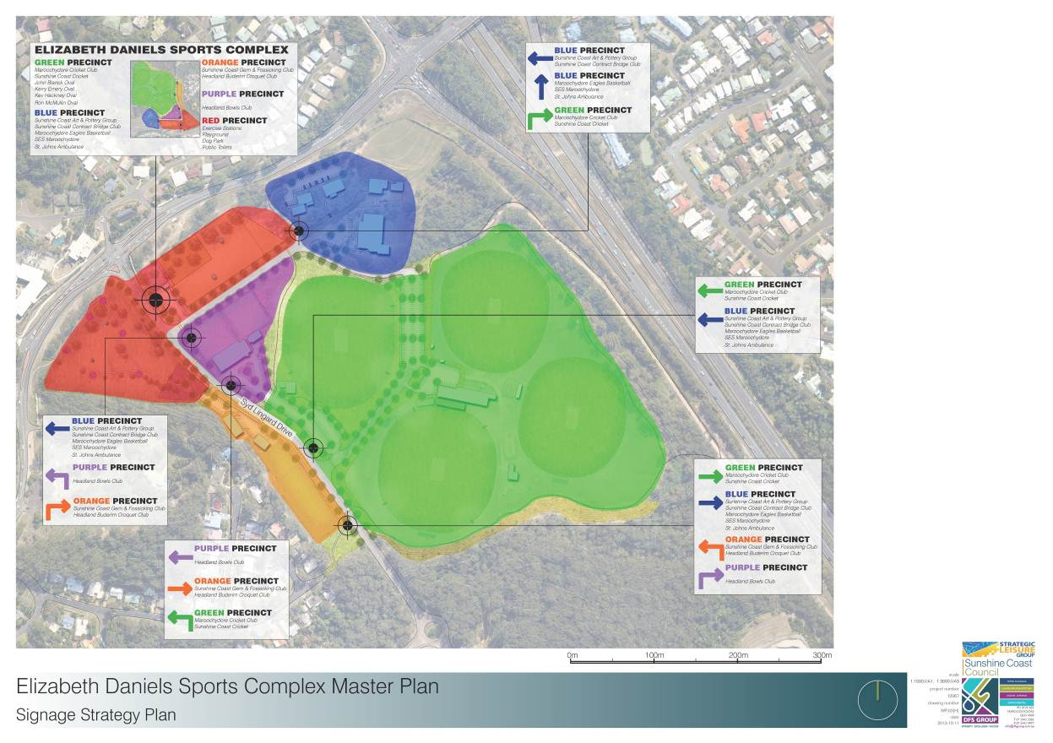

Management/Tenure Analysis
  - Current Arrangements
All user groups are provided tenancy of the Complex via a lease arrangement. The term of existing lease arrangements are outlined in Table 15.
Table 2 - Lease Arrangements
Elizabeth Daniels Sports Complex
Sunshine Coast Contract Bridge Club | - Lease expired 30/06/10
Sunshine Coast Art Group | - Lease expired 30/06/10
Headland Bowls Club | - Lease expires 30/06/16
Sunshine Coast Gem & Fossicking Club | - Lease expires 30/06/15
St John Ambulance | - Lease expired 30/06/10
Maroochydore Cricket | - Lease expires 30/06/23
Sunshine Coast Cricket Association | - Tenure under Memorandum Of Understanding with Maroochydore Cricket
Headland Buderim Croquet Club | - Lease expires 30/06/18
Maroochydore SES | - Ongoing access arrangement
Maroochydore Eagles Basketball Assoc. | - Lease expired 30/06/10
It is understood that those leases that have expired are being renewed on a year by year basis in the interim of council finalising its review into the tenure arrangements for not-for-profit clubs. Each lessee is responsible for the maintenance and development of their sites. In some cases, the user groups attract third party funding to upgrade, expand and further develop facility infrastructure.
Council currently provides funding as a contribution towards, but not a full reimbursement of, field maintenance costs through its Sports Field Maintenance Funding Program to those clubs with sporting fields. User groups with specialised surfaces, indoor facilities and/or recreational activities are able to seek funding via council’s Community Partnership Funding Program. This program offers up to three-year funding towards operational expenses. Organisations eligible for the Sports Field Maintenance grant are unable to apply for the Community Partnership Program.
Potential opportunities to benefit from economies of scale through shared resources are not being realised across the sites (e.g. equipment, food and beverage purchasing, labour, sponsorship etc.). Each user group is operating their facility and site largely in isolation from other groups. Management of multi-use sporting precincts such as the Elizabeth Daniels Sports Complex requires an approach that balances the availability of resources against community expectations. The four most commonly used management models for contemporary outdoor sport and recreation facilities are:
- Lease of specialist playing areas and/or building footprint, and Right of Use (ROU) over other playing areas;
- Lease building footprint only and ROU over playing areas;
- Lease over all playing areas and buildings; and
- Lease to one entity with ROU granted to individual clubs.
In determining its preferred approach for the undeveloped land, council should consider:
- Whether entities have the appropriate capacity and resourcing to undertake management in terms of its ability to remain viable and adequately fund a high standard of playing fields/courts and buildings in the long term;
- Fees and charges (model must be equitable in consideration of the extent of maintenance responsibilities placed upon the lessees);
- Rebates and concessions (continuation, refinement or expansion of the Sports Field Maintenance Funding Program and Community Partnership Funding Program);
- Shared facilities use (e.g. car parks);
- Granting of tenure (local planning considerations; appropriateness of user group/type; site capacity; community demand); and
- Agreement terms and conditions (what are the minimum expectations of council to the lessees).
Council is continuing its review into the tenure arrangements for not-for-profit clubs and is anticipated to be finalised in early 2014. Any future management model introduced for the Complex must be consistent with the outcomes of this review.
The current tenure and management arrangements have been functioning effectively for many years. In particular, the provision of exclusive access to clubs has resulted in:
- Strong levels of motivation from club volunteers given their sense of ownership over their leased area;
- Generally good standards of facility and grounds maintenance;
- A largely positive relationship amongst user groups; and
- Expansion and improvement to the facility mix through direct internal and other third party funding.
However, there are some disadvantages to the current arrangements, most notably:
- The standard of internal access roads and some car parks are poor as users concentrate their funding and resources towards playing fields and facilities; and
- Users are not benefiting from potential operating savings and increased revenue streams through partnership opportunities.
  - Future Tenure and Management
Arrangements

Car Parking and Internal Road Network
As outlined above, current users are concentrating their resourcing towards facility improvements to their playing fields and supporting amenities. Given the Complex is situated on a former landfill site, it is prone to land movements causing undulations to the internal roads and car parks. The most common future improvement priority to the Complex across user groups obtained through earlier study consultation, was improving the internal road network and car parking.
Given the quantum of the recommended road network works to improve functionality and due to the standard of existing roads as a result of the site’s former use as a landfill site, it is considered to be beyond the tenants capacity to fund the development and ongoing maintenance of these areas.
Further, in a shared use environment such as this Complex, there can be a sense of ownership by individual user groups where car parking and/or internal roads form part of their lease area. In some circumstances these groups may feel it appropriate to restrict access to other site users. The removal of car parking and internal roads from lease areas results in a site being able to adapt to peak demands more effectively. For example, in the context of the Elizabeth Daniels Sports Complex, if there is a major cricket competition on a Saturday the majority of car parks can support this event, whereas the following day a major basketball event may be held requiring additional car parking.
On this basis, it is recommended council seek the excision of car parking and internal roads from any existing lease areas that includes these elements. It is recognised that council would inherit the cost and responsibility of car parks and internal roads, however as outlined above, this acknowledges the difficulties associated with the site’s former use as a landfill site and would result in a better quality parking and internal movement arrangement.

Establishment of Advisory Group
As outlined above, the existing tenure and operating arrangements are functioning effectively, however user groups are not benefiting from potential operating savings and increased revenue streams through partnership opportunities.
One method to improve the identification of economy of scale savings and new revenue opportunities is through the establishment of a Complex Advisory Group. It is not considered necessary for this group to be a formal entity. However, it is recommended that a Terms of Reference be established to articulate the roles and responsibilities of the advisory group. These could include:
- Any dispute between user groups will be resolved by the advisory group in the first instance, and if unresolved council will act as final arbitrator;
- Collectively identify, develop and implement strategies to increase the sustainability of the Complex and its users;
- Support funding applications lodged by individual user groups;
- Act as the communication link between user groups and council;
- Explore new revenue and cost minimisation opportunities for individual clubs and/or for the benefit across the Complex;
- Explore opportunities for joint sponsorship relationships aimed at increasing the level of support in consideration of the combined exposure to sponsors that multiple user groups provide;
- Investigate opportunities for shared equipment and volunteering resourcing;
- Assist with planning for major events through the establishment and management of a Complex events calendar; and
- Confirmation of access outside of approved tenure to support opportunities for major events and/or carnivals by clubs.
It is anticipated that this model would:
- Facilitate an environment to maintain positive relationships between user groups by providing a conduit that supports regular, effective communication;
- Encourage continued involvement and support from volunteers to maintain a cost effective delivery outcome;
- Stimulate future sharing of capital development, maintenance and volunteer resourcing across multiple user groups;
- Provide clear direction in terms of access, maintenance, management and development of shared facilities;
- Support identification of increased event/carnival and other usage opportunities;
- Increase opportunities for sponsorship revenues and grant funding; and
- Reduce capital development and operating costs through economies of scale savings achieved with an improvement in shared strategic decision making and sharing of facilities and resources.

Funding Opportunities
The following potential funding sources is provided as a guide only. Sunshine Coast Council should not rely on any of the following information without first making its own investigations into the relevance, suitability and currency of the funding strategies, grants and subsidies described here. The nature of projects will influence the eligibility, scope and level of external funding that can be achieved.
Several of the funding sources can be applied for by the Complex user groups and should not be interpreted as being council’s sole responsibility to attract funding to develop the recommended facility mix.
  - Council Grant Opportunities
There are a number of different council grants available to not-for-profit organisations. For more information, it is advised to go to the following website and then talk to a council officer about your proposed project:
http://www.sunshinecoast.qld.gov.au/sitePage.cfm?code=grants

Sports Field Maintenance Funding Program
By way of assistance to the sites, council offers the Sports Field Maintenance Funding Program which aims to provide consistent, equitable and appropriate support for sports field maintenance across the region for up to a three year period.

12.3.2 Community Grant Program
Grant types include:
- Individual development grants – up to $500
- Minor grants – up to $2000
- Major grants – over $2000 and up to $50, 000.

Community Partnership Program
Council’s Community Partnership Funding Program currently offers up to three-year funding towards operational expenses. Organisations eligible for the Sports Field Maintenance grant are unable to apply for the Community Partnership Program.
  - External Funding Sources
Possible external funding sources are as summarised below.

Federal Government
The Commonwealth Government through GrantsLINK provides a comprehensive website maintained by the Commonwealth Department of Infrastructure, Transport, Regional Development and Local Government offering direct links to existing information on Commonwealth Government grants programs.

Regional Development Australia Fund
The Regional Development Australia Fund (RDAF) is a national program to support Australia’s regions and enhance the economic development and liveability of their communities. The program is administered by the Department of Regional Australia, Regional Development and Local Government (the Department). The program aims to support localism, and to leverage and better coordinate state, commonwealth, local government and private (including not for profit) investments for the long term benefit of communities. The following organisations are eligible to apply for funding:
- Local government bodies; and
- Incorporated not-for-profit organisations.
These organisations can apply in their own right or as a member of a consortium. For-profit organisations can participate in applications for funding where they are a member of a consortium. Rounds Three and Four of the RDAF have closed with Expressions of Interest assessed. Successful organisations have been invited to submit a detailed application for consideration by Regional Development Australia committees. Round Three will provide $50 million for projects in small towns, while Round Four will provide $175 million for strategic infrastructure projects in regional Australia.

Queensland State Agencies
The Queensland State Government has links to funding sources for community groups and projects from federal, state and local government as well as some philanthropic funds and companies. These can be found at www.smartservice.qld.gov.au/services/grants/discoverbywizard.action.

Get in the Game
The recently released Queensland Government’s ‘Get in the Game’ initiative aims to support sport and recreation at the grassroots level. Get in the Game comprises three new funding programs worth $18 million over the next three years. Get Started, Get Going and Get Playing are designed to get more people, especially children and young people, playing sport and involved in recreation activities.
Get Started – funding to help kids participate
Get Started aims to assist children and young people who can least afford to join a sport or recreation club. Eligible children and young people are provided with a voucher of up to $150 to help pay for club membership and participation fees. The vouchers can be redeemed at a sport or recreation club registered with the program.
Get Going – funding to help clubs grow
Get Going aims to support local sport and recreation organisations with funding of up to $10,000 for projects that create opportunities for more Queenslanders to become members.
Get Playing – funding to improve facilities
Get Playing provides up to $100,000 in funding and aims to assist local sport and recreation organisations with facility development so more Queenslanders are encouraged to become involved in the sport or recreation activity of their choice.

Gambling Community Benefit Fund
Funding assists not-for-profit community groups to provide services and activities through the provision of a one-off grant. Funding may be provided for the following purposes:
- Equipment needed to carry out activities
- Special one-off events
- Community and organisational development projects
- Minor capital works
- Motor vehicle purchase costs
Applications for up to $30,000 are encouraged, but applications for larger grants will be considered. Unincorporated organisations can attract a maximum $5000 in funding.

Jupiter Casino Community Benefits Fund
The Queensland Government established the Jupiter’s Casino Community Benefit Fund (JCCBF) to provide funding to community groups in Queensland. The JCCBF receives money from taxes on casinos. It distributes these funds to not-for-profit community groups on a quarterly basis. The JCCBF is just one way the Government returns taxes from gambling activities and plays an important role in ensuring, on balance, the whole State benefits from gambling in Queensland.
One-off grants of up to $150,000 are allocated to approved not-for-profit organisations to help them provide community services or activities that benefit the community. These grants are not intended to replace existing sources of support for these organisations. The JCCBF has four annual funding rounds. The closing dates for applications are 28 February, 31 May, 31 August and 30 November each year.

Non-Government Organisations
A range of non-government philanthropic funding programs exist. While generally not appropriate for large capital projects, by working with community groups, council could possibly obtain smaller amounts of funding for specific elements of upgrades. The following is a generic list of available programs:
- Caterpillar Sponsorship Program seeks to provide sponsorship to connect with customers, give back to communities, and improve the quality of life in a more efficient, environmentally sensitive manner.
- The Cheaperthanhotels Fundraising Program aims to offer an innovative fundraising program for community groups, non-profit organisations, schools, universities and sports clubs.
- Commonwealth Bank Staff Community Fund Local Grants Program aims specifically to assist community groups with projects that improve the health and well-being of children and young people nationally.
- QR National Community Giving Fund aims to work in conjunction with the Charities Aid Foundation to provide cash grants to charitable projects aimed at improving health and wellbeing, community safety and education in the areas in which its operations and employees reside.
- ANZ Trustees provides a listing of a wide number of funds/foundations providing grants in different areas.
- Fosters Community Grants for specific projects run by community groups and charities.
- The Foundation for Rural and Regional Renewal aims to take a leadership role in assisting regional, rural and remote communities to respond to social, cultural and economic change. The FRRR administers a number of funding programs and grants.
- The Foundation for Young Australians is a not-for-profit organisation committed to investing in excess of $3 million each year on providing opportunities for young people with specific funding for projects involving Indigenous youth.
- The Givewell site provides a comprehensive database of Australian charities, giving strategies, bequests, charitable trusts and corporate philanthropy, as well as links to charities and related sites.
- Peter Brock Foundation provides funding and support for community groups and organisations with a focus on welfare services, social issues and community programs.
- The Reichstein Foundation funds projects aimed at assisting disadvantaged communities.
- The Telstra Foundation provides community development grants for projects particularly aimed at children and young people. They also provide assistance through their Indigenous Community Development program and Social Innovation Grants.
- Wesfarmers makes contributions to community-benefiting activities through its corporate office and through subsidiary businesses.
- Tennis Australia has the National Court Rebate Scheme which provides funding towards developing or upgrading courts and associated infrastructure.
- Woolworths provides support to local community organisations and charities.
  - Business Plaza
Business Plaza is a community based advertising and business development program that provides regular income for sporting clubs and schools, provides cost effective market reach and frequency for advertisers and provides discounts and benefits to members of each participating sporting club or school. Prevalent in New South Wales and soon to launch in Queensland, the Business Plaza program is a progression of sponsorship management - working with sporting organisations (mainly junior) and private schools to develop recurring revenue for those clubs and schools. It evolved as a result of many community based businesses wanting to support their local sporting clubs and schools, but not being in a position to pay the higher amounts normally associated with sponsorship. The Business Plaza program provides entry level to local businesses as advertisers with the advertising fee being shared with the sporting club or school, making the advertiser a form of sponsor and fast-tracking revenue for the club or school.
  - Commercial Sources
A number of commercial enterprises provide assistance and advice on grant availability via subscription services to databases and printed materials. These include:
- Grantsearch Australia who publish the Grants Register.
- Easygrants newsletter published by ourcommunity.com.au.
- Pathways Australia provides a database of corporate and government fundraising opportunities for not-for-profit organisations.
- Philanthropy Australia publishes the Australian Directory of Philanthropy.

Elizabeth Daniels Sports Complex Master Plan 2013 - 2028


Projections supplied by Sunshine Coast Council, Community Planning and Strategy and drawn from ABS Estimated Resident Population 2011 with forecast figures based on Sunshine Coast Council Population Mode.
Australian Sports Commission. Participation in Exercise, Recreation and Sport Survey 2010. Annual Report 2011. Standing Committee on Recreation and Sport
Australian Bureau of Statistics. Children’s Participation in Cultural and Leisure Activities, October 2012
Will be prepared by Johnson and Cumming Quantity Surveyors upon finalisation of Master Plan – Considered indicative only
Indicative Cost Estimate prepared by Johnson and Cumming Quantity Surveyors, Construction Cost Managers, 11th October 2013

