Making the Invisible Visible: How Inclusion Helps Your Business Thrive

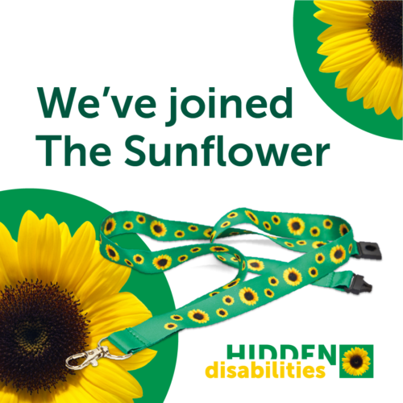
Sunshine Coast Council is committed to improving access and inclusion across our buildings, venues and events. As part of this commitment, we’re a proud member of the Hidden Disabilities Sunflower Initiative - a simple yet powerful way to help create a more welcoming community for everyone!

What is the Sunflower?
The Hidden Disability Sunflower is a discreet symbol worn by people with non-visible disabilities. When a customer or visitor chooses to wear the Sunflower, it indicates that they may appreciate more time, patience, or support during their experience.

With 1 in 6 Australians living with disability, and many of these being non-visible, the Sunflower is becoming an important way to create positive and inclusive customer experiences.

Why businesses are adopting the Sunflower
Businesses across Australia and globally are embracing the Sunflower because it delivers real benefits — for customers, staff, and the brand.
Key benefits include:
- Improved customer service and smoother, more considerate interactions
- Stronger brand trust and loyalty from customers who feel understood and welcomed
- Increased staff confidence when supporting people with diverse needs
- A low-cost, high-impact initiative that demonstrates genuine commitment to inclusion

Local Spotlight: SEA LIFE Sunshine Coast
SEA LIFE Sunshine Coast remains an active member of the Sunflower community. Their front of house team proudly wears the Sunflower badge as a clear symbol of support for visitors with non-visible disabilities.

This initiative has been a meaningful way for SEA LIFE to champion accessibility, remove barriers, and ensure every visitor feels genuinely welcomed and supported throughout their visit - a powerful example of inclusion in action.

What are hidden disabilities?
Many disabilities are not visible. A customer or staff member may be living with a condition that affects how they communicate, move, process information or interact — even if they appear outwardly fine.

Hidden disabilities can include:
- chronic health conditions
- sensory sensitivities
- neurodivergence
- anxiety
- pain
- vision or hearing challenges.

The takeaway is simple: you can’t always see when someone needs extra support, but being flexible, patient and understanding ensures everyone feels welcome.

How to get involved?
Businesses of all sizes can take simple, practical steps to support people with non-visible disabilities. Getting involved in the Hidden Disabilities Sunflower Initiative is easy.

- Become a member of the Hidden Disabilities Sunflower Initiative - join the global network of organisations committed to recognising and supporting people with non-visible disabilities. Membership gives you access to resources, tools and Sunflowers products for your staff and customers.
- Provide awareness training - equip your team with the knowledge and confidence to recognise the Sunflower and respond with empathy and understanding.
- Embed the Sunflower initiative into your customer service culture.

Taking these steps helps to build a more accessible, welcoming and inclusive Sunshine coast community.

Learn more by visiting Hidden Disabilities Sunflower.

Other Sunshine Coast Members
Local businesses already leading the way include:
- Sunshine Coast Airport
- Stockland Baringa Shopping Centre
- Optus
- Bras N Things
.

