Managing beach erosion

Beach erosion is part of a natural cycle whereby sand is constantly building up or being eroded by waves, wind and tides. It is preferable to allow these natural processes to occur without interference. However, if beach erosion threatens community infrastructure such as public buildings and roads, depending on the circumstances, council may consider a range of management options.
This fact sheet outlines various options for managing beach erosion and includes a look at the main advantages and disadvantages of each option.
Beach scraping
Beach scraping is the process of re-shaping the beach profile. Machinery is used to move sand from the lower part of the beach to the upper part of the beach. This improves beach amenity and enables the beach to better withstand the potential impacts of storm events. The advantage of beach scraping is that local sand sources can be used. The main disadvantage is that it is temporary and eventually the profile of the beach will change and further scraping may be required.
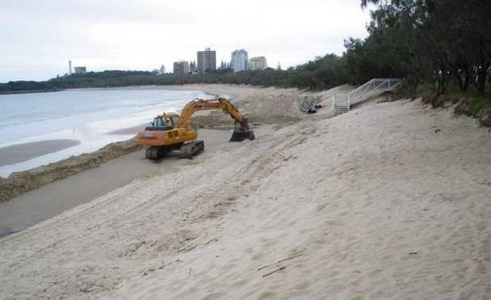
Beach scraping at Mooloolaba.
Dune building
This is the process of reinstating dunes that have eroded. It is a practical solution that works in harmony with natural coastal processes. Dune building may require a combination of beach scraping and sand nourishment, and revegetation with native coastal species. Dune vegetation cannot withstand severe erosion events, but the vegetation does trap wind-blown sand, increasing the volume of the dune buffer, and thereby making it more resistant to future erosion events.
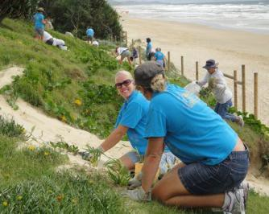
Dune revegetation
Beach nourishment
Nourishing a beach involves relocating sand from a river estuary, marine sand bank or from another beach. Beach nourishment increases the depth of sand and beach width and builds resilience to erosion by increasing the buffer between the shoreline and infrastructure. The greater volume of sand deposited, the more resistant the beach is to erosion. Sand nourishment increases the beach buffer, however, it can be expensive and is not always a long term solution.
Sand recycling
Beaches nourished with sand may eventually erode to a point where further beach nourishment is required. A long term solution is the introduction of a sand recycling system that returns sand transported by the longshore drift back to the original beach. This can be an expensive option, so consideration needs to be given to the social, economic, environmental and amenity values of the beach.
Groynes
Groyne walls placed perpendicular to the shoreline trap beach sand and can reduce shoreline erosion on the up drift side. However, sand is often eroded on the down drift side. Groyne material can be rock or geotextile bags. Groynes tend to be visually intrusive in a natural beach environment.
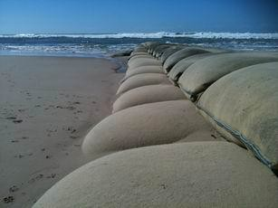
Groyne at the entrance to Maroochydore River
Seawalls
Seawalls are placed parallel to the shoreline and are an effective means of protecting assets and infrastructure from erosion. The main disadvantage of seawalls is that they reflect wave energy that can lead to more beach erosion in front of the wall and lock up sand behind the wall that would otherwise be available for the natural processes of erosion and accretion on the beach.
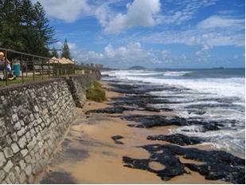
Seawall at Alexandra Headland
Artificial reefs
Artificial reefs are intended to replicate natural reefs in order to help protect beaches from the impact of storm waves. They do this by reducing wave energy before it reaches the shore. Artificial reefs can also offer marine habitat and recreational opportunities such as surfing and snorkelling. They can be an expensive option and if they aren’t designed well, can have a negative impact on natural coastal processes.
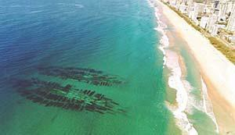
Artificial reef at Narrowneck on the Gold Coast (courtesy Gold Coast City Council)



