Sand movement on the Sunshine Coast

The appearance of our beaches changes constantly. Sometimes they are wide and sandy with gently sloping frontal dunes. At other times, especially after storms, the beaches appear narrower, have exposed coffee rock and present a sheer vertical face on the frontal sand dunes.This fact sheet describes the cyclic patterns of accretion (building up) and erosion (washing away) of sand on the Sunshine Coast.
What causes beach erosion?
Beaches are dynamic environments shaped by the prevailing waves, currents and winds. Erosion and accretion of sand on beaches are natural processes.
On the Sunshine Coast, beach erosion is mainly caused by cross-shore sand transport, whereby sand moves from the beach to the nearshore surf zone. This is most obvious when cyclones or east coast low pressure systems, create a combination of large, powerful waves and a rise in sea level, that often cause significant beach erosion, expose the underlying coffee rock and cut vertical scarps in the frontal dunes.

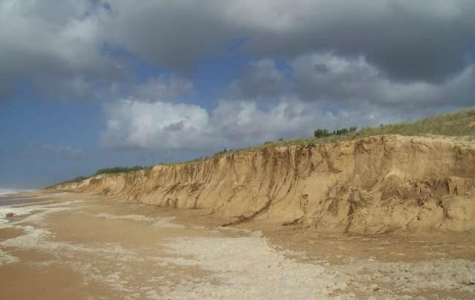
Vertical scarp eroded in frontal dune
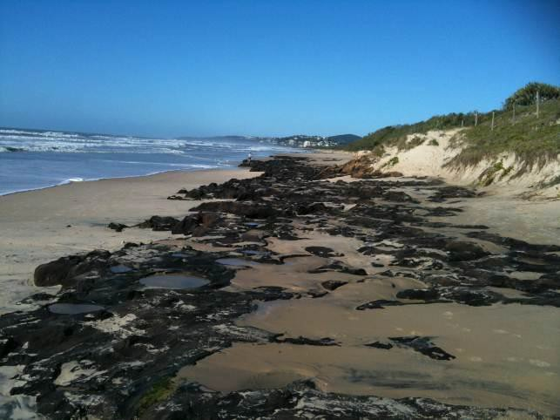
Coffee rock exposed by large powerful waves
Where does eroded sand go?
Sand that’s eroded by high energy wave conditions is washed into nearshore areas where it forms sand bars. In periods of low energy waves, sand is gradually washed shoreward where it once again builds up on the beach and dune system. Cross-shore sand transport is a natural cyclic pattern which results in sand moving from the beach to nearshore waters and back again.

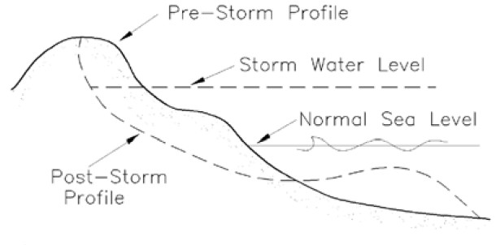
Cross shore sediment transport – the cyclic pattern of beach erosion and accretion (source: Coastal Engineering Manual 2008)
Where does the sand come from?
Offshore from the Sunshine Coast, the east coast longshore drift, transports sand along the coast from northern NSW into southeast Queensland. Over countless thousands of years, this current has created North and South Stradbroke Islands, Moreton and Bribie Islands, the Cooloola Sand Mass and Fraser Island.
Closer to shore, longshore sand transport is heavily influenced by the direction of the waves which is determined by the wind. When waves break at an angle to the shore they mobilise sand in the direction of the wave movement. The combined effect of cross-shore and longshore currents is to transport sand in a zig-zag pattern from beach to nearshore waters and back. The dominant wind on the Sunshine Coast is south-easterly, and as a result, the net movement of sand is in a northerly direction.
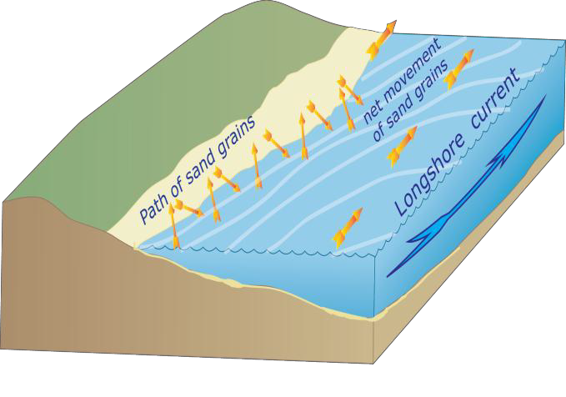
Long shore and cross shore processes combine to form a zig-zag pattern of sand movement (symbols courtesy of the Integration and Application Network 2013).
Beaches on the Sunshine Coast are somewhat sheltered from the east coast longshore drift by Moreton Island, and receive less than 25,000m3 of sand annually. Furthermore, the relatively straight alignment of the Sunshine Coast and the wide continental shelf causes incoming waves to change course and arrive almost parallel to the shoreline. The combined effect of sheltering from Moreton Island, wide continental shelf and straight alignment causes relatively weak longshore currents and correspondingly low rates of longshore sand transport.
The sheltering influence from Moreton Island progressively decreases to the north along the Sunshine Coast and results in a corresponding increase in longshore sand transport from an estimated 3,700m3/year at Currimundi Beach to 23,000m3/year at Sunshine Beach. By comparison the east coast longshore drift delivers an estimated 500,000m3 of sand to the Gold Coast each year.
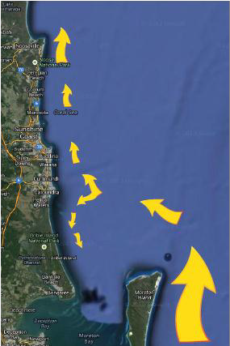
The east coast longshore drift moves large volumes of sand from NSW into southeast QLD, however very little of this sand reaches the beaches of the Sunshine Coast due to the sheltering effect of Moreton Island. The size of the arrows is indicative of the volumes of sand movement.
Historical beach erosion
Over the past 6,000 years the sea level has been relatively static, while the coastline has continued to be modified by natural coastal processes. It hasn’t always been static and over geological time, changes in sea level, caused by variations in climate, have significantly changed the coastline. During the last Ice Age, about 18,000 years ago, sea level was about 120 metres lower than the present level, and the coastline was some 40 kilometres east of its current position.
Over the past 40 years there has been many episodes of cross-shore erosion followed by sand build-up, however, in the context of historical beach erosion, there has been very little overall erosion of the shoreline.


