Tenancy Opportunity – Nirimba Sports Complex

Sports Drive, Nirimba 4551

Property Details

The Nirimba Sports Complex (Complex) located at Sports Drive, Nirimba is a vibrant sports hub in Caloundra South and is currently the home of Aura Netball and Nirimba Rugby League - refer to Image 1.

A Tenancy Opportunity exists for an interested party to utelise part of the Complex for the summer sports season from 1 October to 31 March.

The area available for the summer season includes 2 square fields (used for rugby league in the winter season 1 April to 30 September, field 2 has lights), the fields include a turf cricket wicket, cricket practice nets (unlit), and a Clubhouse incorporating home and visiting changerooms, referee room, storage shed and a canteen - refer to Image 2.

Council is owner of the land known as Lot 9071 SP 318117. The Tenancy Opportunity (Licence) is suitable for a not-for profit community and sporting organisations that is incorporated.

Council is calling for Requests for Proposals to activate the Complex for a summer sport, being 6-months of the year (1 October - 31 March).

Please note: Fields 3 & 4, public amenities, netball courts, rugby league and netball storage sheds and rugby league goal storage areas’ are not associated with this Licence.

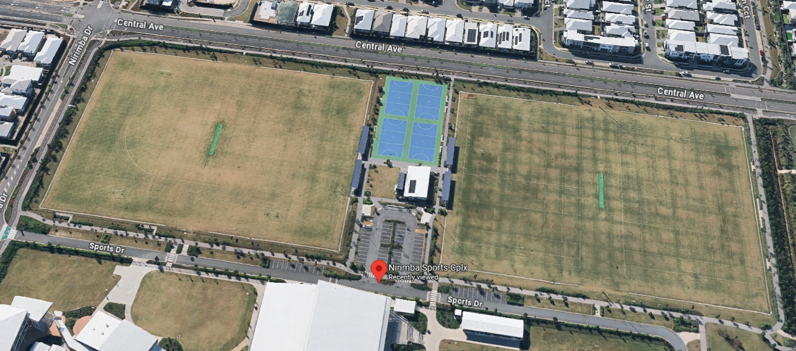

Licence Area - Image 2

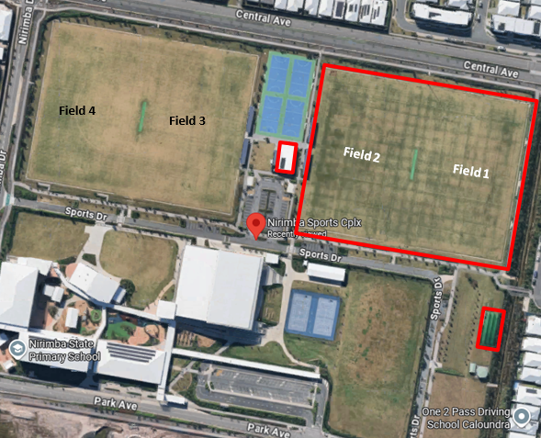

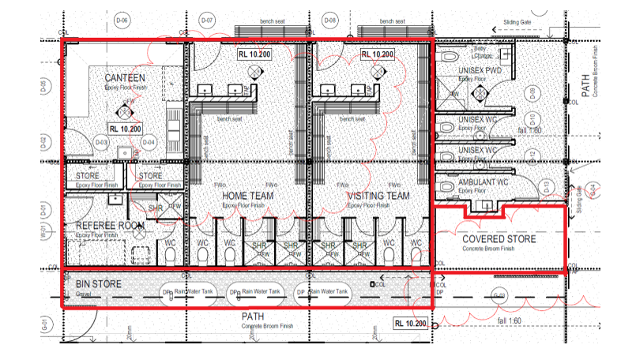

Key Features

This Licence includes Fields 1 & 2, cricket practice nets, Clubhouse incorporateing home and visiting changerooms, referee room, storage shed and canteen.

Indicative Agreement Details

* A Licence for the summer season being 1 October to 31 March over the next three-years is proposed.
* Applicants will be responsible for all outgoings and maintenance during the Licence period.
* Applicants may be eligible to receive sports field maintenance fuinding to assist with field maintenance expenses.
* Applicants must be prepared to work with the existing Tenants that hold Tenure at the Complex being Aura Netball and Nirimba Rugby League (winter seasonal Tenure being 1 April - 30 September). A shared user agreement is in place for the complex and the successful applicant will be required to adhere to the terms of the existing user agreement.

Application Details

Council will be accepting applications from suitable applicants, from Wednesday 3 September 2025 with the closing date for submissions being Wednesday 24th September 2025 at 5:00 pm.

An information session is scheduled at Nirimba Sports Complex on Thursday 11th September 2025 from 11:00 am to 1:00 pm. It is essential that applicants register interest in attending the information session, by emailing [communitysport@sunshinecoast.qld.gov.au](mailto:communitysport@sunshinecoast.qld.gov.au)

Applicants will be required to submit both:-

* The Offer: Tenancy Application Form in this information pack; and
* Documentation requested in the Application Requirements Table in this information pack.

Tenancy Application Form

|  |  |
| --- | --- |
| Land | Part Lot 9071 SP 318117 |
| Premises | Nirimba Sports Complex, Nirimba |
| Relevant Area | As per Image 2 |
| Owner | Sunshine Coast Regional Council |
| Applicant <insert> | ­­­­­­­­­­­­­­­ |
| ABN/CAN <insert> |  |
| Commencement Date | The date on which the Licence is singed by both parties. |
| Proposed Term <insert> |  |
| Proposed Annual Commencing Tenancy Fee Payable | $ plus GST  The AnnualTenancy fee is payable in advance in equal monthly instalments.  Council Rates, Land Tax and other Statutory Charges included in the Tenancy Fee |
| Bank Guarantee | A Bank Guarantee may be required being a minimum of $1,500 or equal to 3 months of the Annual Commencing Tenancy Fee whichever is greater. |
| Proposed Use <insert> |  |
| Liquor Licence Requirements (if any) <insert> |  |
|  |  |
|  |  |
| Outgoings and Utilities | The Applicant will be responsible for all outgoings and utilities for the Premises including but not limited to water, electricity, gas and insurances. |
| Details of any proposed repairs, maintenance orFit-Out to make the Licence Area fit for the proposed purpose |  |
| Estimated Fit-Out Cost <insert> |  |
| Estimated Fit-Out Timeframe <insert> |  |
| Applicants Proposed Special Conditions (e.g. liquor licence, outdoor seating licence, requirements incentives (if any) <insert> |  |

|  |  |
| --- | --- |
| Business Plan | Applicants should detail their vision for the Licence including:-   1. Current structure and background of the club/ organisation. 2. Outline your vision for the Licence area. 3. Proposed offering and proposed hours of operation. 4. Demonstration of financial viability of the club/organisation 5. Evidence of strong financial stability including all funding streams and their providers. |
| Experience and Referees | Describe your experience   1. What capacity as a club/organisation do you have to take on the maintenance and associated expenses with managing this site. |
| Insurance | Evidence of public liability to the value of $20,000,000 |

Contact Details

For further information on this property please contact Council’s Land Management team via email at [propertymanagement@sunshinecoast.qld.gov.au](mailto:propertymanagement@sunshinecoast.qld.gov.au)

Submissions to apply can be made to Sunshine Coast Regional Council attaching all required application materials via email to:

* Nirimba Sports Complex Application c/- Propertymanagement@sunshinecoast.qld.gov.au