Maroochy Arts and Ecology Centre

The Federally funded Maroochy Arts and Ecology Centre opened in August 2011. An exemplar of sustainable design, the Centre is energy and water efficient with solar panels, rainwater harvesting and use, and natural lighting and ventilation.

Solar Panels

An 8.2 kW solar panel system has been installed. Approximately 6kW of electricity on average will be produced per kW panel; therefore approximately 49.2kW will be produced each
day.

This production will likely exceed general day to day use, but will not match peak requirements. Excess power will be sold back to the grid.

At the front of the building located adjacent to the Green wall an LCD screen displays the energy use and production of the solar system.

Orientation

The building has been designed to take advantage of the site. Orientating the building to maximise sun and prevailing winds was an important an design element. Some of the features of the design are that;

the building is oriented north with shorter elevations east and west to limit hot summer sun and cold westerly winds

large areas of window at high and low level on Northern facade maximize solar access, breeze and views

existing trees to the west help to shade the building in the afternoon

open space at the eastern end allows for cool breezes in summer

Natural Light

Use of natural light within the building assists to reduce the need for artificial lighting. The building design utilizes;

white walls and glazing.

ceiling profile allows light to bounce from an apron screen deep into the building.

northern face opens to allow controlled sun penetration at certain times of the year, contributing to a light and airy feeling.

solar lighting with motion sensor, and solar lighting with motion sensor, and

solar tubes fitted with light diffusers within the Café and wet and dry workshop spaces

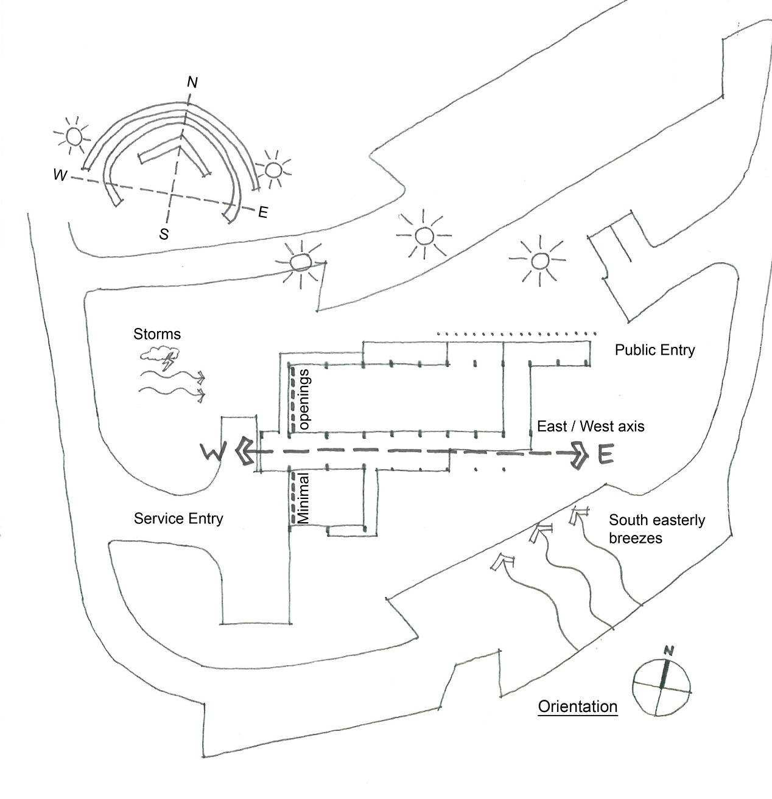


Thermal Mass

The use of concrete has provided a large thermal mass that helps to regulate the temperature within the building.

1 of 2 Maroochy Arts and Ecology Centre - Building Design and Energy Factsheet

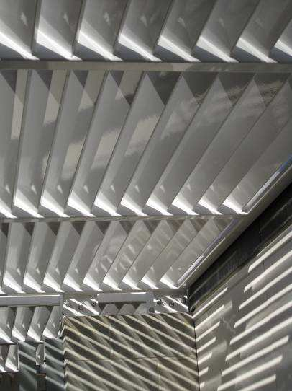
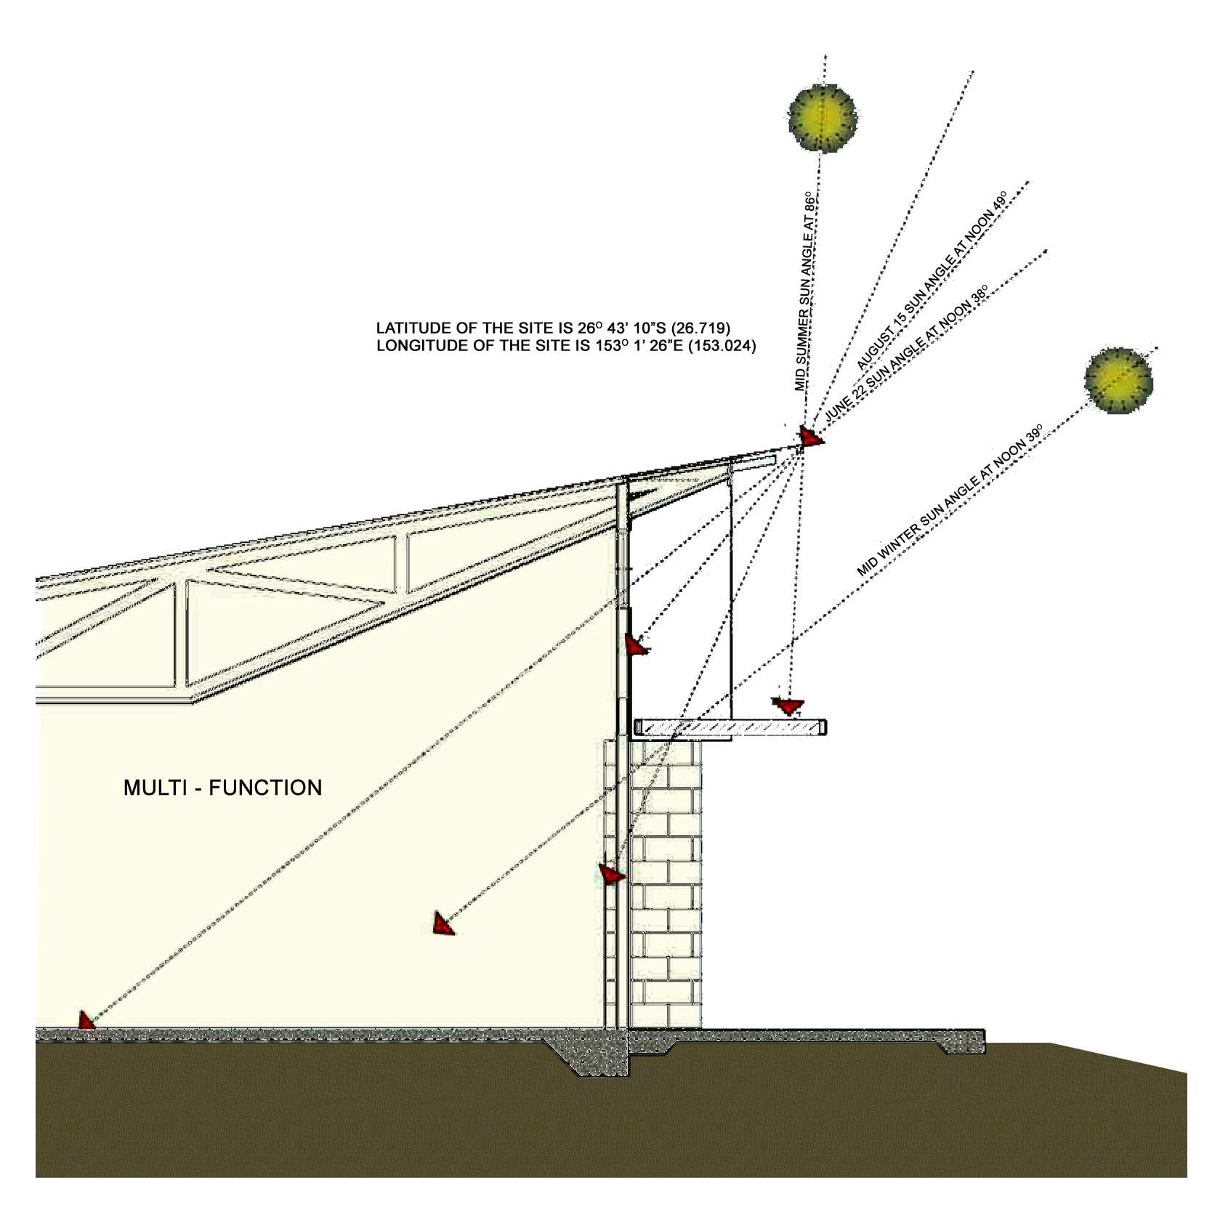


Utilising the heat from the sun this allows the material to warm-up during the day and release the heat in the evening. This helps to reduce the need for heating.

Sun Modeling

Sun modeling was used to design the elevations in relation to roof overhangs, extent of glazing, sun shading and paint finishes.

Wind rose modeling was also sourced from the Bureau of Meteorology to confirm the best setout of pavilions and ways to capture breezes

Heating and Cooling

Cross-ventilation by low louvres on cooler southern facades exhausting through higher automatic louvers on northern facade.

How do the automatic louvres work?

The system is quite simple. The louvres are connected to thermostats within each space which allows desired upper and lower temperatures to be set for opening and closing.

The louvres are connected to rain sensors so they will close during wet weather. Manual override is also provided so that the user can take control of the operation.

Some of the design features included to assist with heating and cooling of the building are;

internal fans to create air movement on calm days.

well-insulated

colorbond roofing which has a low solar absorbency

southern veranda protects building from inclement weather

2 of 2 Maroochy Arts and Ecology Centre - Building Design and Energy Factsheet

