S.S. Dicky Wreck Relocation Plan (update)

Project summary
The S.S. Dicky was an iron-hulled steamer, driven ashore at Caloundra during a cyclone in 1893. A number of efforts were made to re-float the Dicky but on each occasion it beached again and was eventually abandoned. The wreck has long been an attraction to both tourists and locals, however it was badly eroded by ex-tropical cyclone Oswald in 2013 and now critically weakened continues to deteriorate. Without action there will be a visible loss of this significant local heritage icon for the area. A long term management strategy has been identified to ensure the preservation of the values associated with this site.
S.S. Dicky Taskforce
In late 2013 council developed the S.S. Dicky Taskforce to evaluate and provide a recommendation on the long term option for management of the site. The taskforce includes a number of stakeholders from: council, state government, Community Heritage and the Dicky Beach SLSC. In March 2014, the Taskforce made a recommendation to council for the removal and relocation of the wreck ensuring that any project included community consultation, wreck conservation and the development of interpretation opportunities as key components to the wreck’s relocation.
Project Update
Three key pieces of documentation were completed to inform the preferred long term strategy for the wreck. These documents (now available on council’s website) include a Heritage Impact Assessment which looks at the wreck site heritage values and how they can best be preserved through the relocation process, and a Conservation Management Plan and Wreck Interpretive Plan which identify the options for the interpretive display and also how the different parts of the wreck will be conserved into the future once the relocation occurs. These documents will also support the application to the State Government seeking approval for this work.
On 18 June 2015 council endorsed the long term strategy for the wreck which includes:
- removal of the exposed stern, starboard and port ribs
- ongoing management of loose pieces as the wreck breaks up into the future
- main portion of the wreck to remain insitu
- delivery of a wreck interpretive display as part of a greater open space landscape plan for the area
- creation of a short film and mobile display that documents the community connection of the historic shipwreck to the area
- conserve remaining removed pieces.
The Taskforce has also received a grant from the state government to support the relocation efforts.
 |   A note from your local councillor  Council has now endorsed a range of actions for the preferred long term strategy for the S.S. Dicky. This will ensure the preservation of this local heritage icon and the values associated with the site.  Cr Tim Dwyer

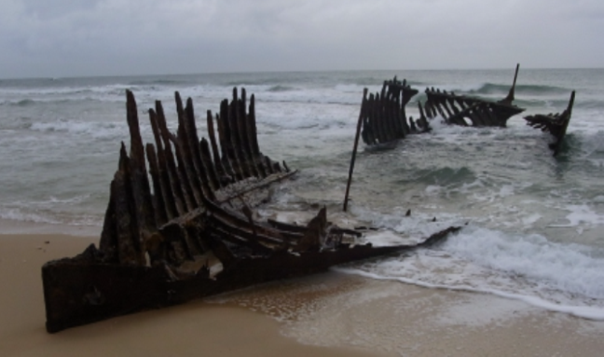
Figure 1: Exposed hull June 2012 (SCC)
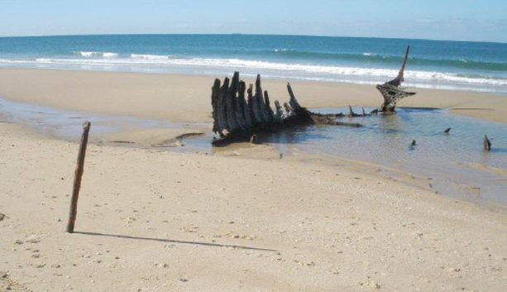
Figure 2: Exposed hull July 2013 (SCC)
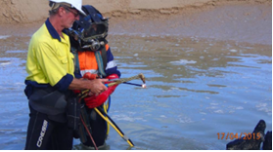
Figure 3: Divers trialling underwater cutting April 2015 (SCC)

Further information


