Maroochy Regional Bushland Botanic Garden
Japanese Tea Garden

Japanese Tea Garden

There has always been a wish to include a genuine Japanese Garden, created by a Japanese designer, in Maroochy Bushland Botanic Gardens. However, circumstances have not allowed this to happen so this Courtyard is an attempt to create a garden that uses the essence of a Soto Roji - outer tea garden - to honour the friendship that exists between our sister city Tatabayashi and the Sunshine Coast Region.

The Soto Roji is intended to lead the visitor on a journey away from the mundane world to a quiet and serene place and includes the following elements:

stepping stones to slow the visitors' advance as they move into the garden
a water basin for symbolic cleansing a waiting seat where the visitor rests
and calms their mind while waiting to be
invited into the inner tea garden
(Uchi Roji)

a light to guide the visitor

The plants chosen are all local native species and display some of the characteristics that their Japanese counterparts would have.

They are capable of being pruned to the desired shape and size, they have sculptural form, are evergreen and there is minimum of flowers to detract from the calm and serenity of the space.

On another level the garden has also been designed to represent the bio-geographic region of the Maroochy Regional Bushland Botanic Gardens. The tall standing rock represents our mountains, the water basin the river catchments and the stepping stones the coastal lowlands sweeping down to the sea.


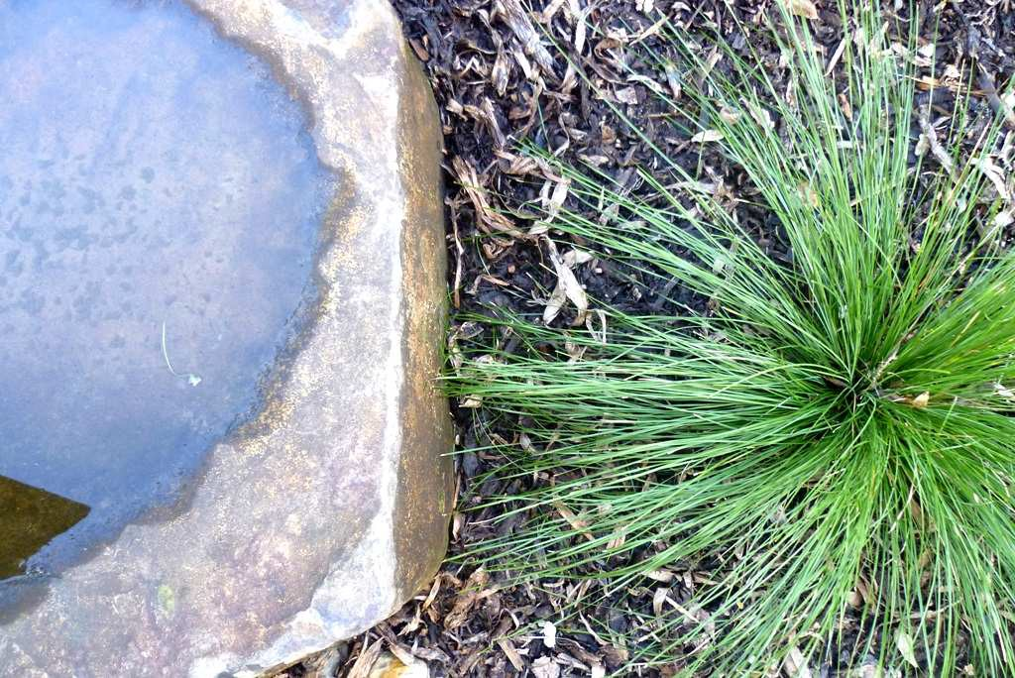
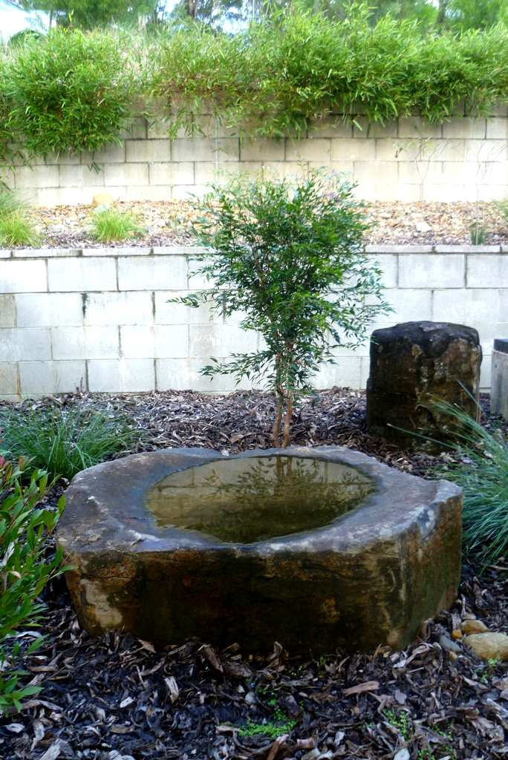


While this is not a genuine Japanese garden it is a genuine and heartfelt tribute to the friendship and understanding that has been fostered between these two different cultures.

1 of 1 Maroochy Arts and Ecology Centre – Japanese Garden

