Dicky Beach precinct update

There are a number of council initiatives occurring within the Dicky Beach precinct.
Precinct landscape plan
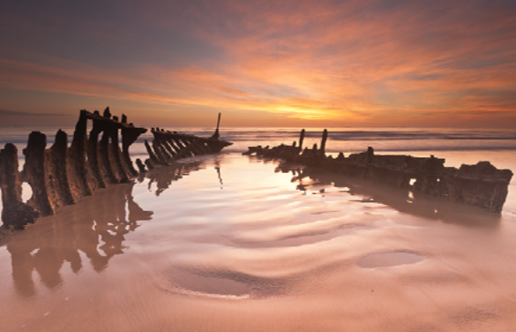
Council is developing the Dicky Beach precinct landscape plan to help retain the area’s identity following partial removal of the wreck in July 2015.
The landscape plan will inform future precinct improvements and identify interpretive elements that remember the SS Dicky wreck.
You are invited to share your views on how to improve the precinct area.
Complete the survey overleaf or visit http://tinyurl.com/DickyBeach to provide feedback online.
Beerburrum Street upgrade
Council will make minor improvements to refresh the existing streetscape and address pedestrian safety issues during the 2015/16 financial year.
These improvements include reducing the bollards, removing the shade arbours and reviewing the current speed limit. Removal of the shade arbours is a priority due to safety issues (ie. visibility issues for pedestrians and timber failure) and is likely to occur before Christmas 2015.
Council will consider replacing the centre median arbour with one that does not obstruct sightlines, as part of the opportunities to incorporate SS Dicky interpretive elements within the streetscape and parkland to ensure the strong identity is retained within the area.
SS Dicky Calendar
Council’s 2016 cultural heritage calendar commemorates the SS Dicky. Reflections – Remembering the SS Dicky provides a mix of past and present imagery of the wreck.
Calendars can be purchased from council’s libraries, library e-shop, Caloundra Gallery and customer service centres for just $6, and is also available at selected retailers.

Film tribute to the SS Dicky
The film Time and Tide - The SS Dicky Story was created through the Heritage Levy Program to celebrate the history and stories of the SS Dicky through the eyes of the community. The project was developed in partnership with the Friends of Caloundra Lighthouse and includes stories, images and footage about the wreck.
The film will be launched in late November, with a range of screenings throughout the holiday season. For details, contact cultural.heritage@sunshinecoast.qld.gov.au.
 |   A note from your local councillor  Dicky Beach is a beautiful part of the Sunshine Coast with a distinct character and I look forward to hearing your ideas on how council can help retain that character. This landscape plan will be a guide to help us maintain and improve the elements you love – and identify new ones – with future upgrades and improvements. If you have friends or family who visit Dicky Beach, please encourage them to complete the survey. They can complete it online or download a copy from council’s website.  Cr Tim Dwyer

Please share your thoughts on improving the Dicky Beach precinct

Council would like your input to guide the design of a landscape plan for the Dicky Beach precinct.
The development of a landscape plan provides an opportunity to review the precinct’s current layout and look at ways the area can be reorganised and improved to maximise the recreation, social, cultural and economic opportunities within the precinct.
This project aims to:
• create a safe and usable precinct area that is high quality, comfortable, accessible and inviting
• improve the open space, recreation and play, social gatherings and arrival experience
• develop the precinct’s identity to support and distinguish this important local centre.
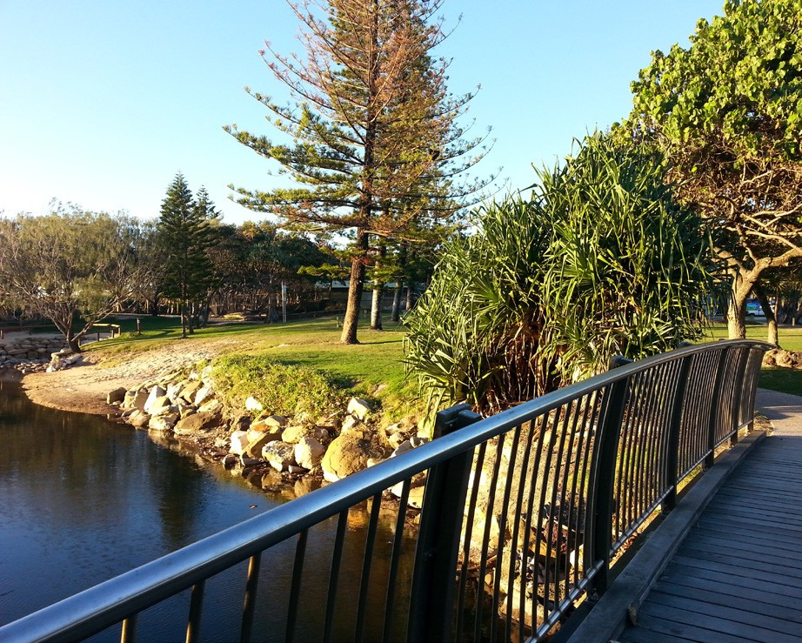
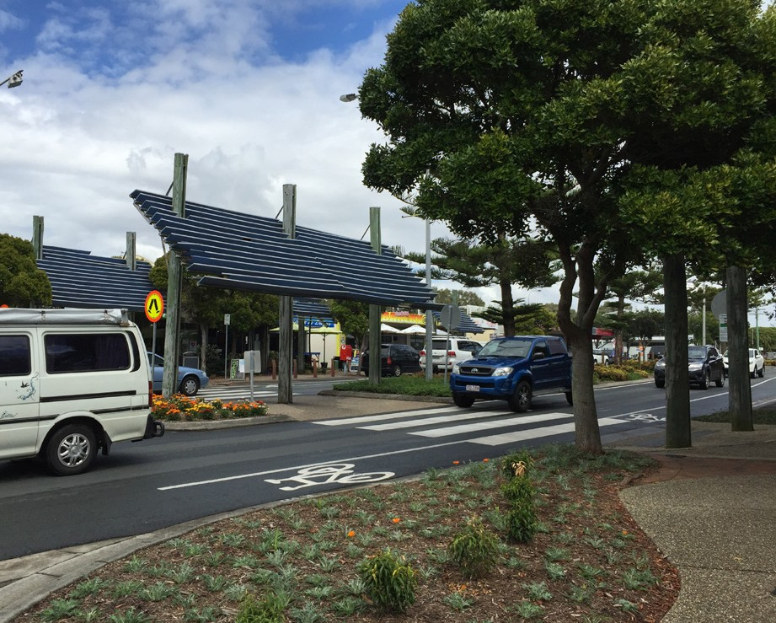

1. What do you love about the Dicky Beach precinct?

2. What would you change within the Dicky Beach precinct?

3. What should stay the same within the Dicky Beach precinct?

4. What other ideas / suggestions do you have for the Dicky Beach precinct?

5. How would you like to see the SS Dicky wreck remembered / interpreted within the precinct?

What is your gender?
- Male | - Female
What is your age?
- 0-18 yrs | - 40-49 yrs
- 19-29 yrs | - 50-64 yrs
- 30-39 yrs | - 65+ yrs
Which statement best describes you?
- I am a resident of Dicky Beach | - I work in Dicky Beach
- I am a business owner in Dicky Beach | - I live elsewhere in Australia and visit Dicky Beach
- I live elsewhere in the Sunshine Coast region and visit Dicky Beach

Please return the questionnaire by 11 December 2015
Mail: Sunshine Coast Council
Locked Bag 72
Sunshine Coast Mail Centre Qld 4560
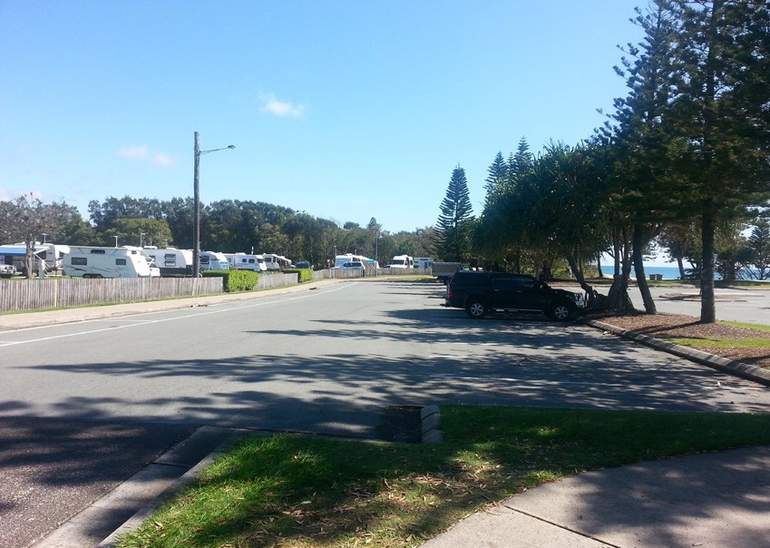
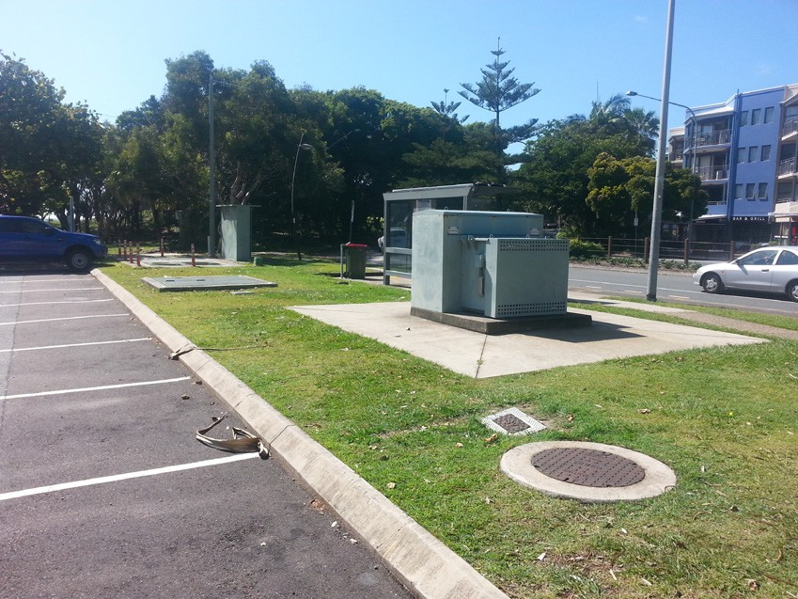
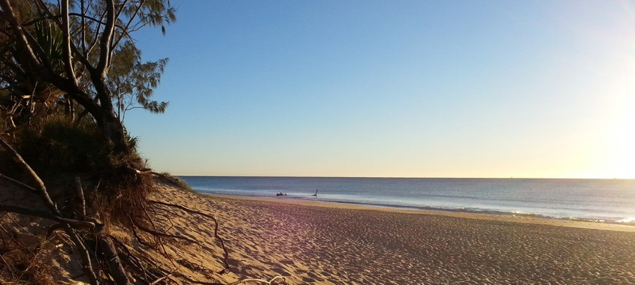
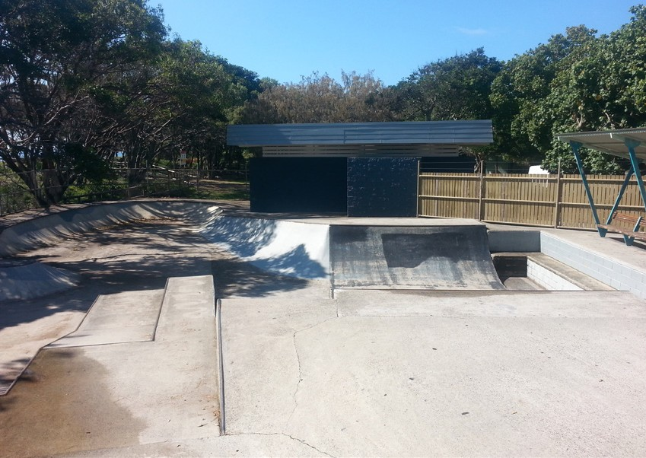
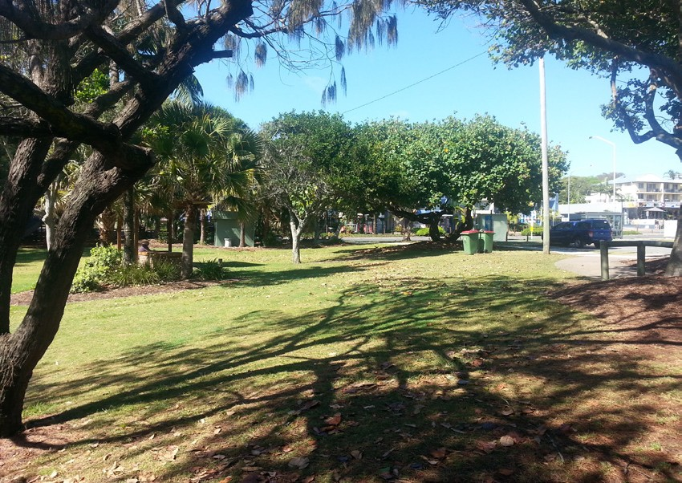
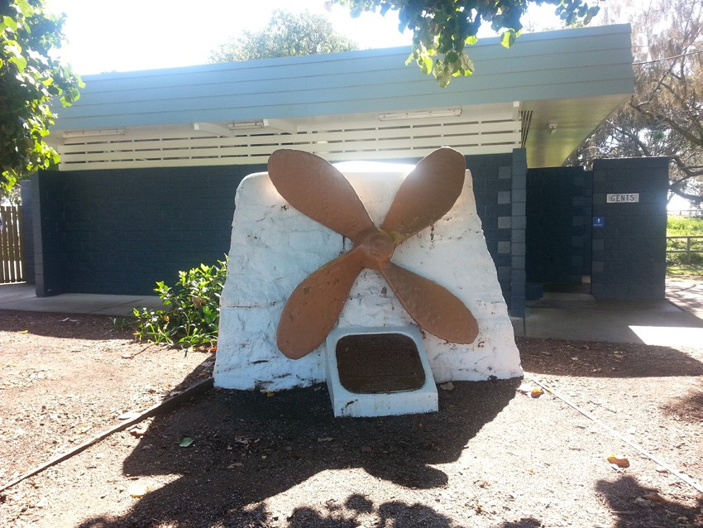
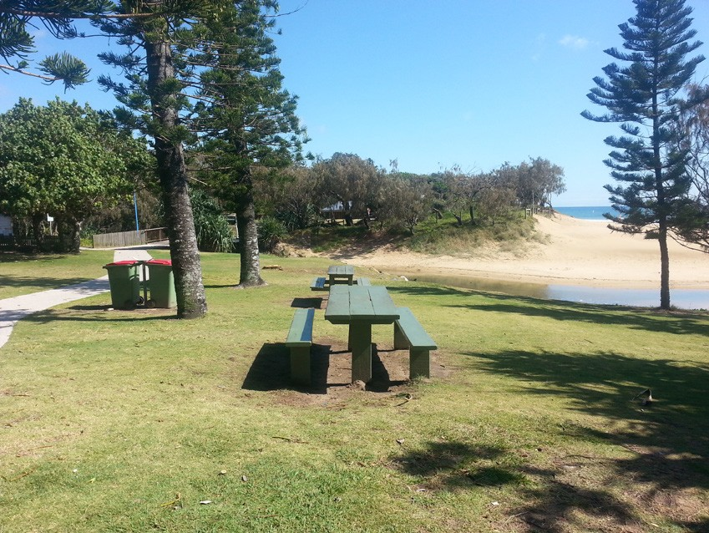
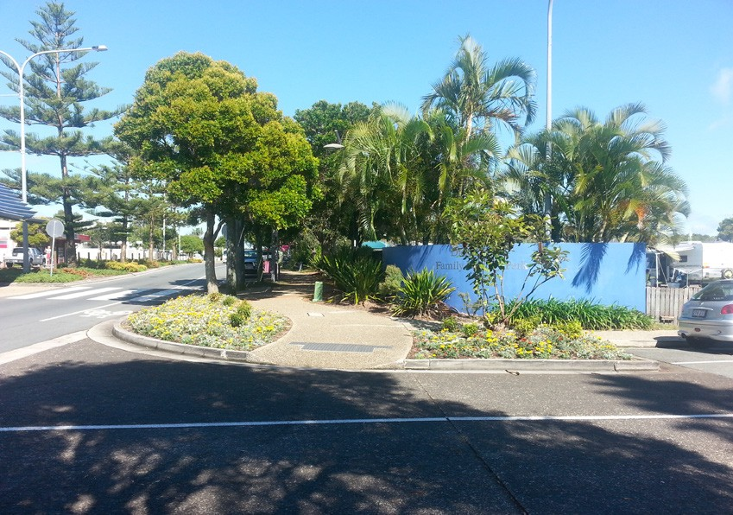
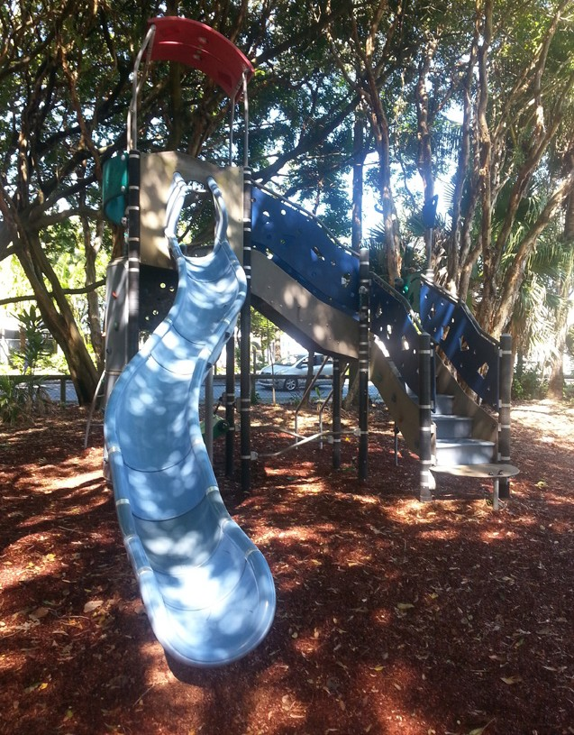
Email: parkscapitalworks@sunshinecoast.qld.gov.au
